**UW-Stevens Point Upward Bound Program**

**CampDoc.com Instructions**

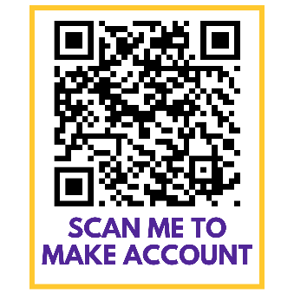**Please use this link to create your CampDoc.com account:** [**http://app.campdoc.com/register/uwstevenspoint**](http://app.campdoc.com/register/uwstevenspoint)

**Sign Up Instructions**

1. Click the **SIGN-UP** button.
2. In the **Email** box, type your *email address*.
3. In the **Confirm Email** box, type your *email address* in order to confirm.
4. In the **Password** box, type *the password* that you want to use.
5. In the **Confirm Password** box, type *the password* in order to confirm.
6. Click the **CONTINUE** button.
7. Add your participant’s name, gender, and birth date.
8. Click the **CONTINUE** button. The About You page will appear.
9. Add your name, phone number, and mailing address.
10. Click the **No** button to signal your preference for receiving text messages (Upward Bound uses a different platform for communication).
11. Add your mailing address. Click the **CONFIRM** button, and then click the **SAVE** button.

Note: If you already have a CampDoc.com account set up (for example you used CampDoc.com last year for another student of yours already in UB), you can skip steps #1 - #11 and proceed to the “To Add Additional Participants” step below:

**To Add Additional Participants in your family who also participate in Upward Bound:**

1. In the left column, click the **+ NEW PARTICIPANT** button.
2. Add the participant’s name, gender, and birth date.
3. Click the **CONTINUE** button.

Once you are done completing information for your Upward Bound student(s), you are finished signing up and can now register your Upward Bound student for Upward Bound sessions.

**Select Upward Bound Sessions**

1. In your student’s profile, click **Registration**.
2. Click the **NEW REGISTRATION** button.
3. Make sure the “Upcoming” box is checked. In box that says, “Select from Groups”, scroll down to the Upward Bound options
4. Check the following boxes to register for:

**All students:** Residential » 2025-2026 Upward Bound Academic Year » 2025 » Upward Bound 2025-2026 Academic Year

**8th grade students Only** Residential » 2025 Freshman Focus Week » 2025 » Upward Bound 2025 Freshman Focus Week

**9th – 11th graders** Residential » 2025 Upward Bound Five-Week Summer Session » 2025 » Upward Bound 2025 Five-Week Summer Session

**Creating Your Upward Bound Student’s Health Profile**

After logging into your CampDoc account:

1. Click the name of your student in the “Search profiles by name.”
2. Click **Health Profile**
3. In the right column, click the first step of the Health Profile.
4. Complete any fields in the step that have a red dot.
5. On the lower-right side of the page, click the **NEXT STEP**button.
6. Repeat Steps 3-5 until all of the steps are complete, with the following exceptions (if they appear):

a. Athletics – you can answer, put no or skip

b. Music – you can answer, put no or skip

c. Grant Based Programs – answer no or skip

](https://support.docnetwork.org/hc/article_attachments/115002154710/Completion.png)

1. **Electronic Signature:** We use electronic signatures, so there is nothing for you to physically sign. Just enter your name and relationship and click the ***Accept Authorization*** button. This will electronically sign and timestamp the authorization for you!
2. Repeat all steps above for each Upward Bound student in your family.

There is no submit button, and the information you enter is saved as you type it. Once your account is 100% complete and all steps are marked with a green ü, you are all done. A pop-up window also appears indicating that the profile is complete.

Immunization records for your students can be found through the Wisconsin Immunization Registry at <https://www.dhfswir.org/PR/clientSearch.do?language=en>.

Have questions? Please See CampDoc.com Support link or contact Upward Bound at [UpwardBound@uwsp.edu](mailto:UpwardBound@uwsp.edu).