ASI AT HOME RECORDING GUIDELINES
(Just a few rules, please read thoroughly!)

- Download the play-along track. This can also be found on the ASI website
- Practice your part with the play-along track. There are 8 clicks before you begin.
- Do some tests with whatever equipment you have (could be a zoom recorder, could be a smartphone, etc.). Play the softest and loudest passages using each device you could record on. Anything you can do to eliminate background noise and distortion in the recording, please do!
- When you record, you will need 2 devices: one to listen to the play-along track, and one to record yourself. Listen to the play-along track through the headphones so that you will be recording your sound only.
- Film in landscape (turn your phone or tablet on the long side). Your video framing should look as close to this as possible:
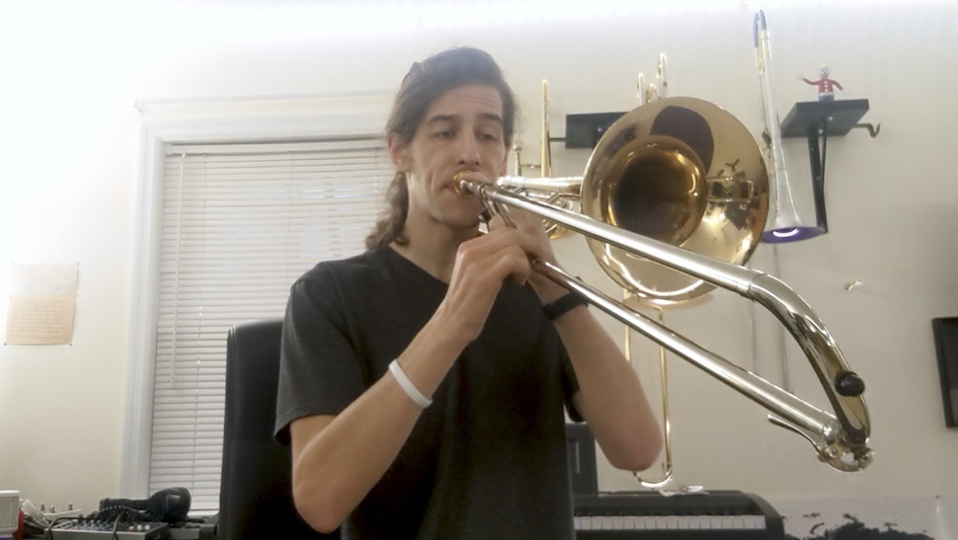
Please spend some time matching your framing up to this example.

- Record your video using headphones so that you can hear the play-along track.
- Upload your recordings/videos by July 9, 2020
- GAUNTLET
- PLINK, PLANK, PLUNK
- If you run into any issues, please email the Director at anovak@uwsp.edu
- Rename your file in the following format:
INSTRUMENT - PART - NAME
Ex: Violin 2 - Christopher Bill
- If you haven’t already, please fill out the Virtual Orchestra Registration Form:
1) Gauntlet
2) Plink, Plank, Plunk

Audio suggestions:
- ALWAYS USE HEADPHONES
- If you have access to an external microphone, that will usually yield better quality audio.
- Apps:
  - Plenty of folks just use their default phone camera app and experiment with placement, orientation, and room acoustics. You can angle away, but please stay true to the video framing!
  - Mideo Lets you record video and play an audio file simultaneously
  - Filmic Pro gives you improved advanced camera and audio controls.
  - Dolby On: gives you advanced control over your smartphone mic controls.
Video Suggestions
- Use a well-lit area so we can see your face and your instrument.
- Film yourself in from of a plain wall, or hang a sheet behind you.

