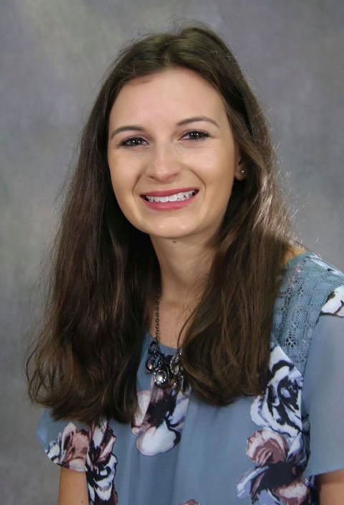
KELLY BROCHTRUP
Youth and Young Adult Coordinator at Holy Family Catholic Community

“The Philosophy/Religious Studies program at UWSP is more than just learning theories. Studying philosophy/religious studies provides training in logic and opens you up to thinking about the world through different lenses.”

2019 Graduate, Traditional Student Communications with Interpersonal/Organizational emphasis and Philosophy with Religious Studies Concentration

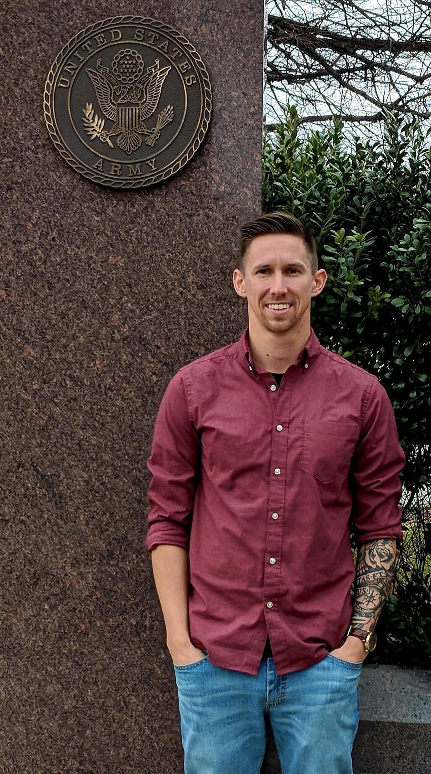
WESLEY SWEET
Army Artillery Officer Graduate Student in Theology

“Joining the Philosophy and Religious Studies department felt more like joining a family. Not only did this family welcome me in and was supportive, but challenged me to be better - a better learner, a better critical thinker, and a better individual who can think clearly, logically, and differently.”

2018 Graduate, Non-Traditional Student
Philosophy and Religious Studies, with a minor in Military Science


Jeremy Wolfe
Magazine Editor for Endeavor Business Media

"Learning Philosophy at UWSP gifted me with an immense and intimate appreciation for knowing, and I carry the value of that education everywhere."

2020 Graduate
Major in Philosophy and English

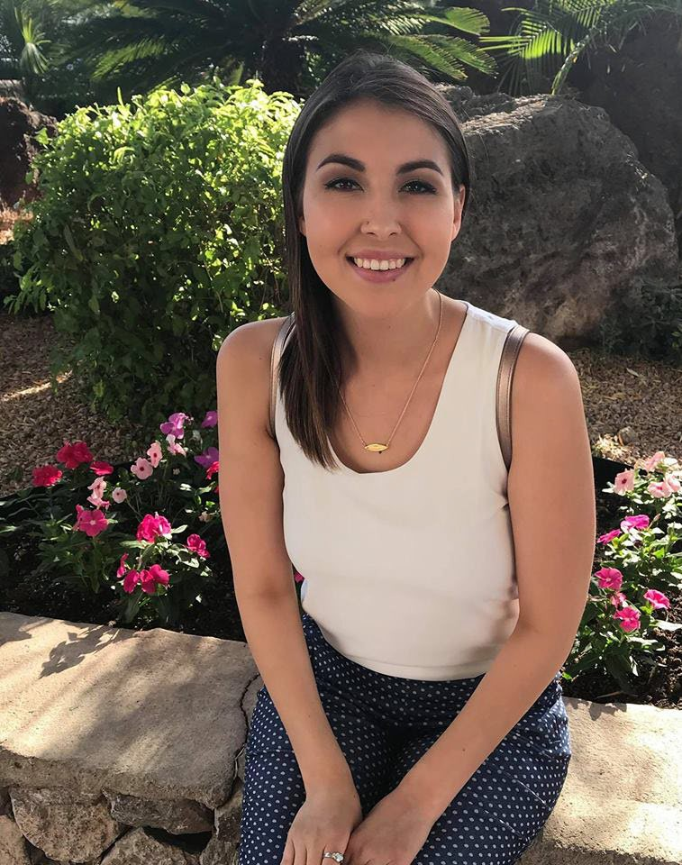
ASHLEE WEIDMAN
Marketing Specialist for University Advancement - UWSP

“[Philosophy] hasn’t just developed my professional skills but also strongly influences my personal decisions. There are a lot of things happening in the world right now that require a lot of thinking and approaching it from different aspects. Philosophy has helped me reaffirm or change my thoughts in a logical, well-informed way.”

2018 Graduate, Traditional Student
Philosophy and Communication Public Relations

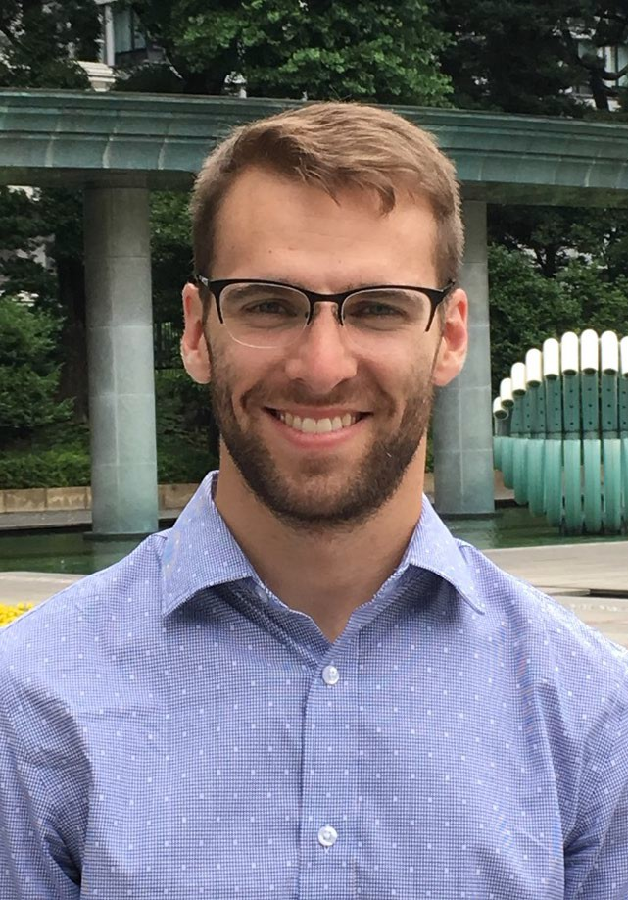
CONOR HANSON
Campus Pastor/Lay Catechist at UW Whitewater
“It was just a tight knit Philosophy Department community. There was so much interaction with the professors that I just loved. It helped me engage with the material more in depth and embrace the willingness to explore other things and perspectives. They were so supportive of whatever it was you were pursuing and wanted to facilitate the development of that passion and field of study, which was absolutely wonderful.”

2019 Graduate, Non-Traditional Student
Philosophy

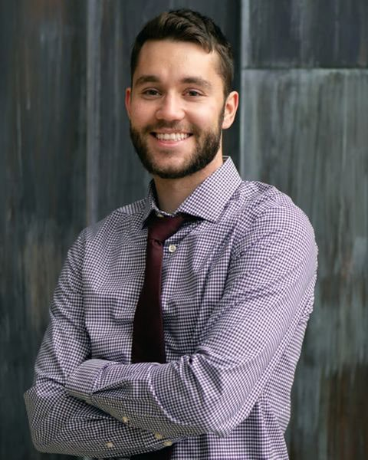
JAKE OBLAK

Athletic Director at a Boys and Girls Club

“[Philosophy] definitely gave me a fair amount of life experience rather than just reciting a book. I'm able to apply a lot of what I learned in philosophy and psychology to my job because I help kids build character and grow as people.”

2018 Graduate, Traditional Student Philosophy Major with a Psychology Minor, Business Administration Minor, and Coaching and Leadership Minor

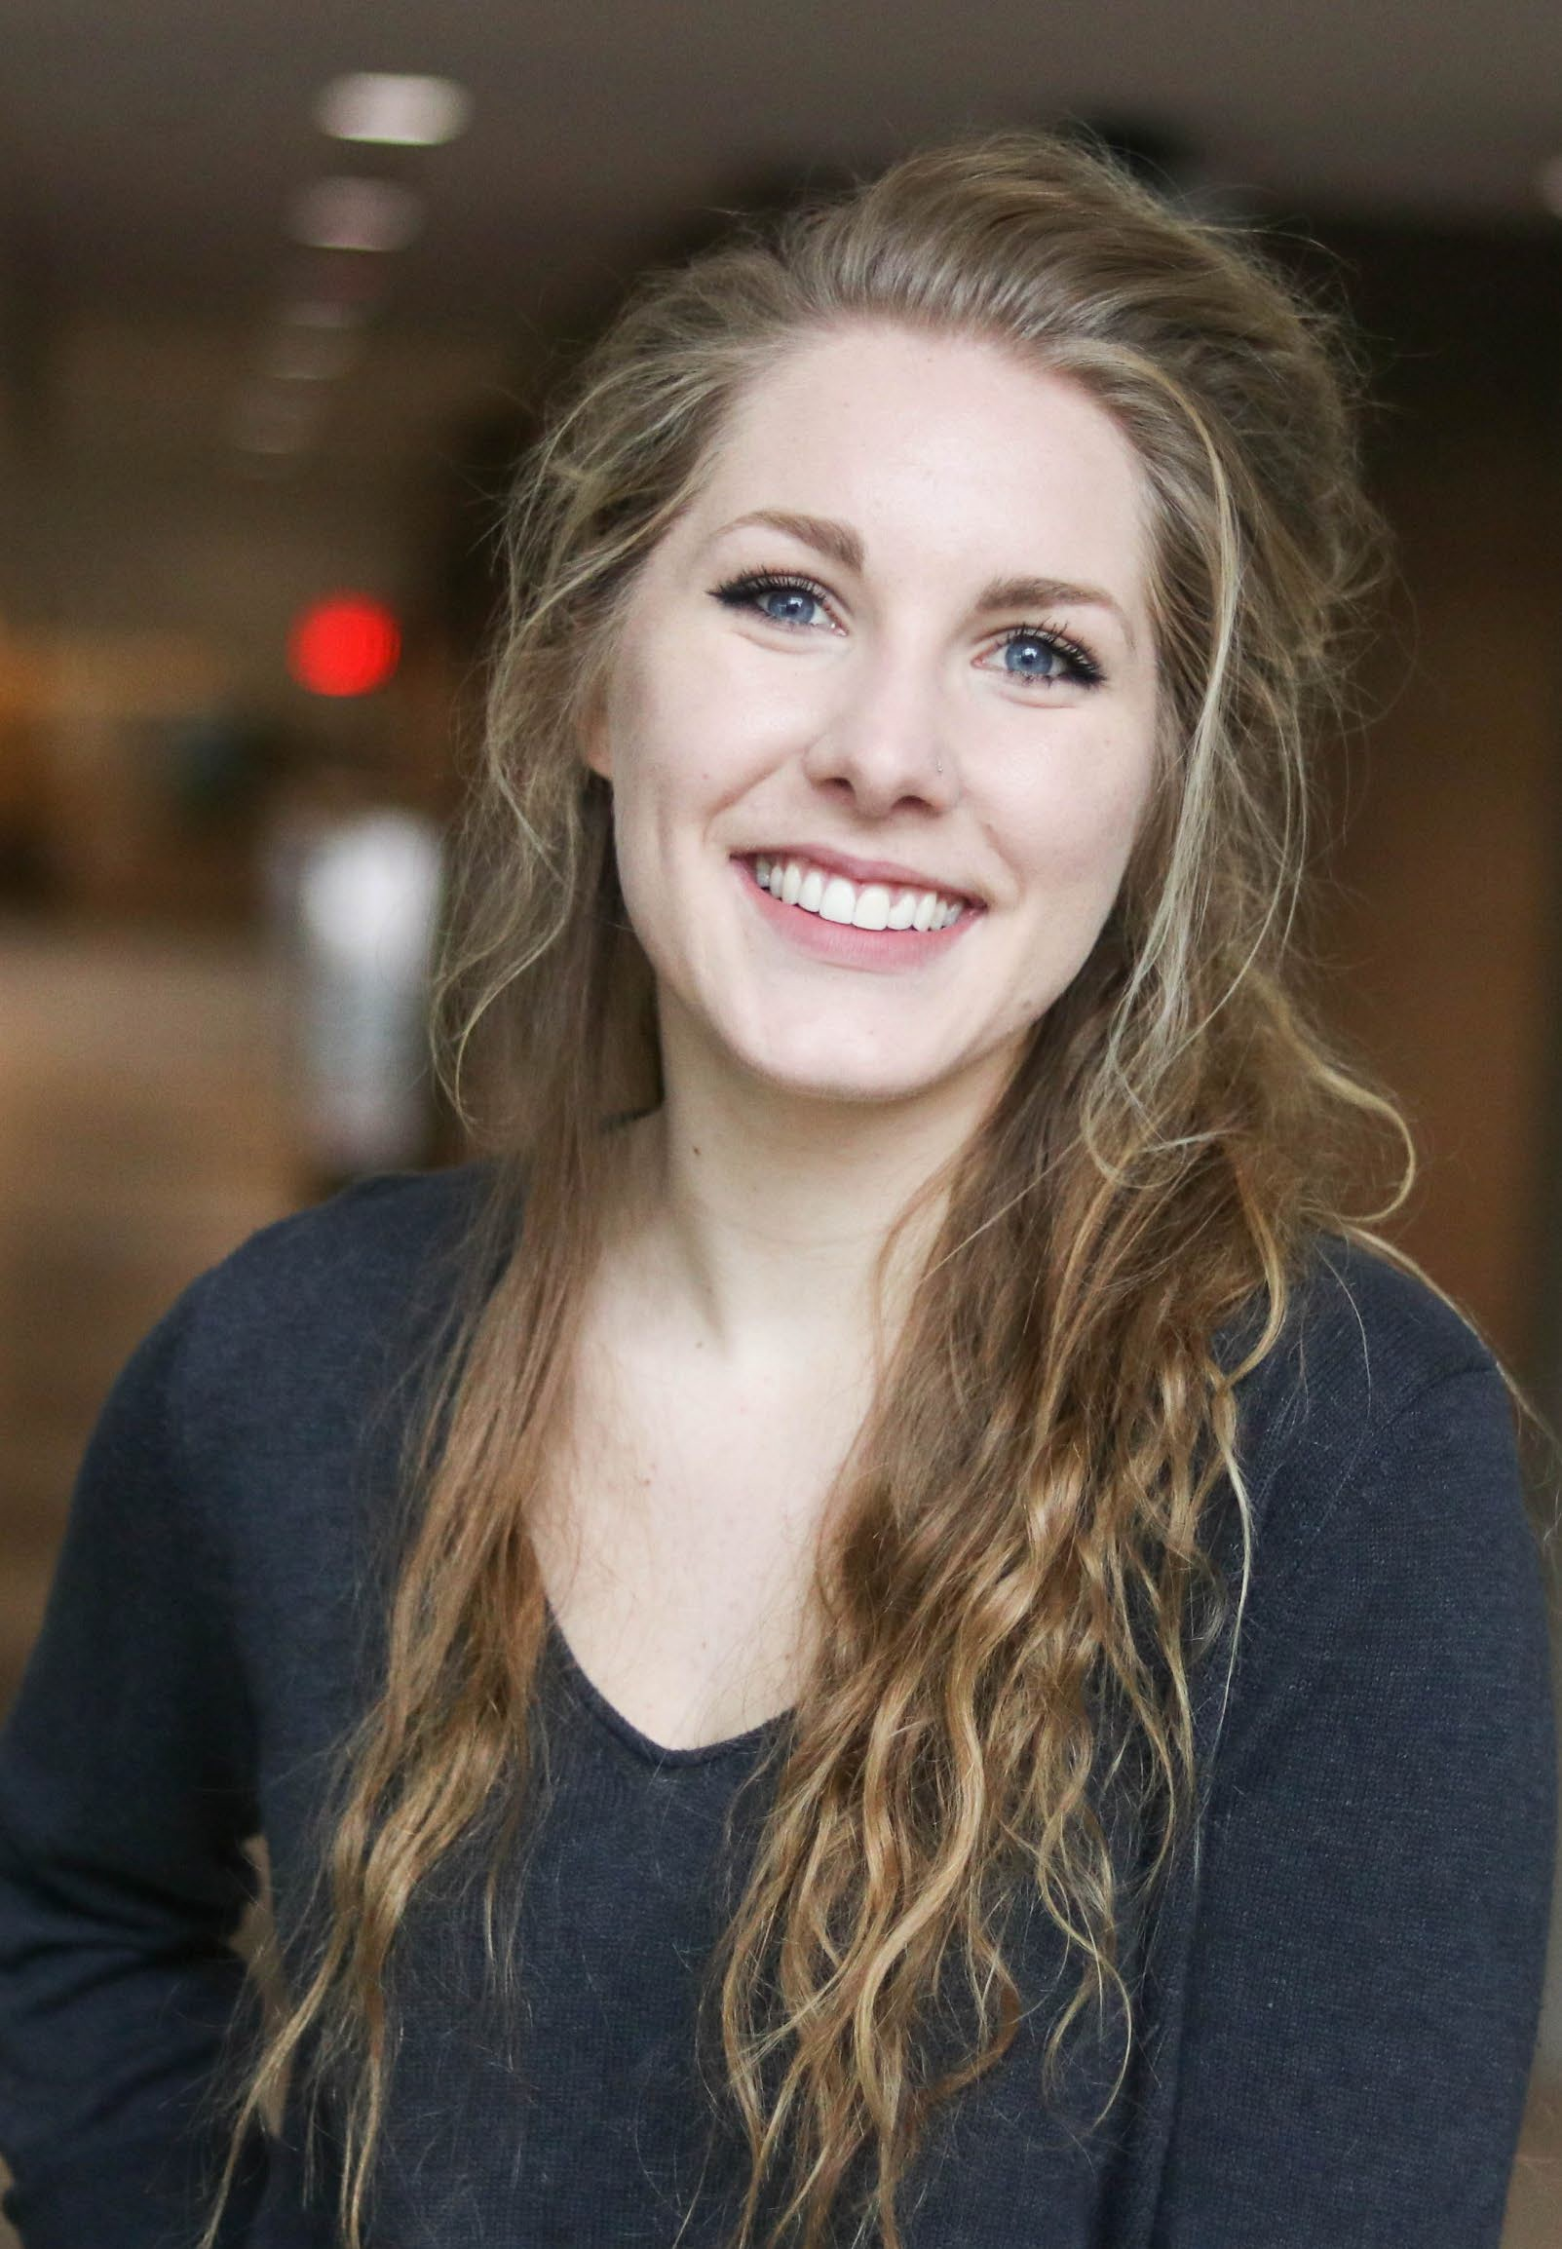
ELLA JANSON
Farmshed’s AmeriCorps Volunteer Coordinator and Server at Chef ’s Kitchen
“In looking at where I am now, and who I’ve become, I consider myself very fortunate. I spent the last 4 years looking critically at what I value, and why I value it. And, more importantly, I’ve developed a sense of what I believe a “just” world entails. With this knowledge, I am able to ground my actions in something very meaningful. Environmental Ethics was a huge part of my focus as an undergrad, and now, as I work at a nonprofit focused around sustainable agriculture, I find my teaching from UWSP as backing each of my decisions. I am able to live by what I value, all while truly understanding what it is I value.”

2019 Graduate, Traditional Student Philosophy with an Environmental Ethics Concentration and Drama, with a History Minor

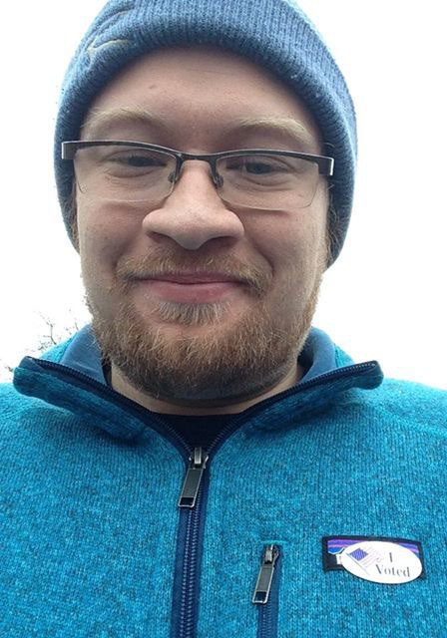
JUSTIN SEIS
Interim Supervisor for Fair Trade USA
“Taking philosophy as a student made everything else easier. It greatly improved my reading comprehension and writing, and made the other courses I took easier to navigate because of the strong foundation I built in my philosophy courses. Learning how to effectively construct an argument was useful as a student employee in the Office of Sustainability as it allowed me to make the case for the things I was advocating for more eloquently and gave me the creative problem solving skills to be able to tackle the inevitable hurdles that arose in my work trying to be a changemaker on campus.”

2018 Graduate, Non-Traditional Student
Philosophy with an Environmental Ethics Concentration and Sociology, with an Environmental Studies Minor

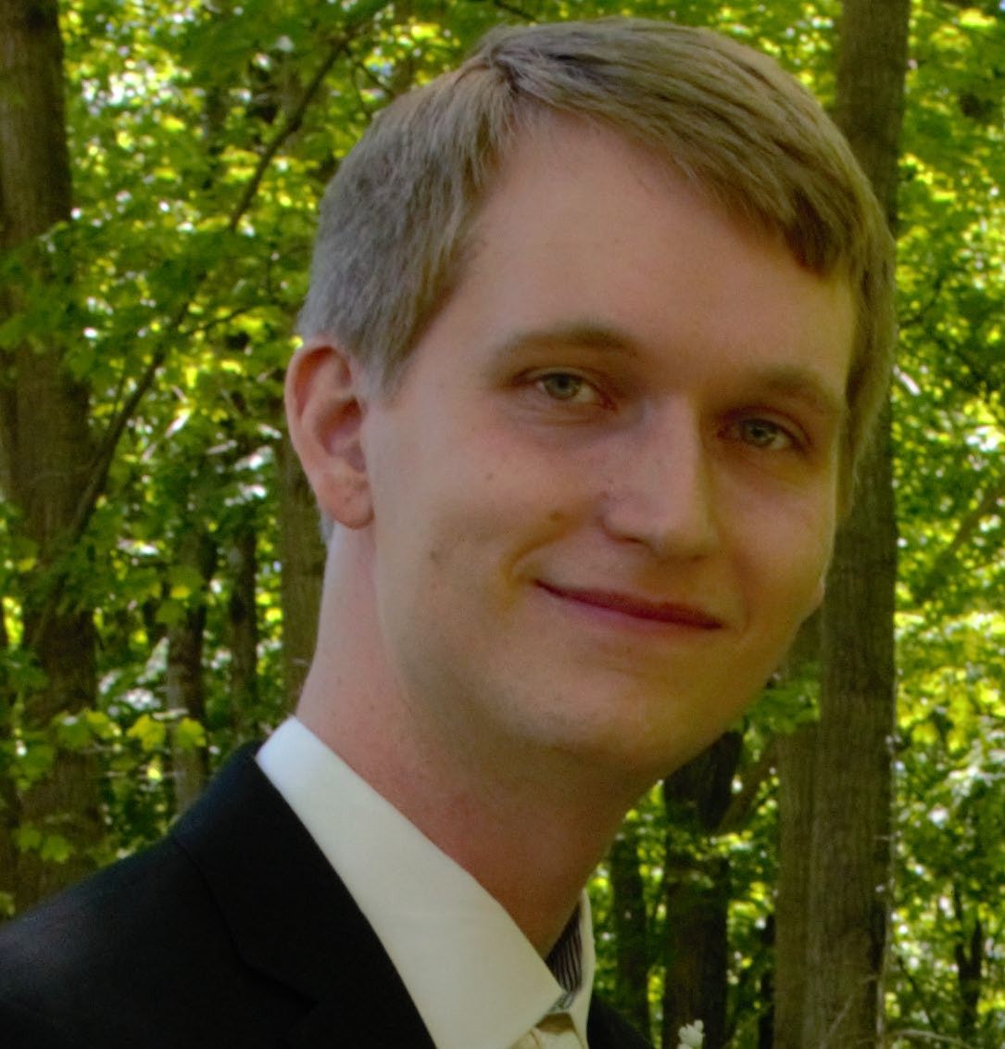
Isaiah George
Team Lead at Epic Systems, Madison WI

"Most of my job is to facilitate understanding between different groups of people. For example, I'm regularly coordinating between my company's software developers, customers, and our executive leadership to ensure we are solving the root cause of problems. My philosophy degree, and particularly the religious studies emphasis, taught me how to study, understand, and communicate the perspective of others."

2017 Graduate
Major in Philosophy, Bachelor of Science in Psychology
Emphasis in Religious Studies

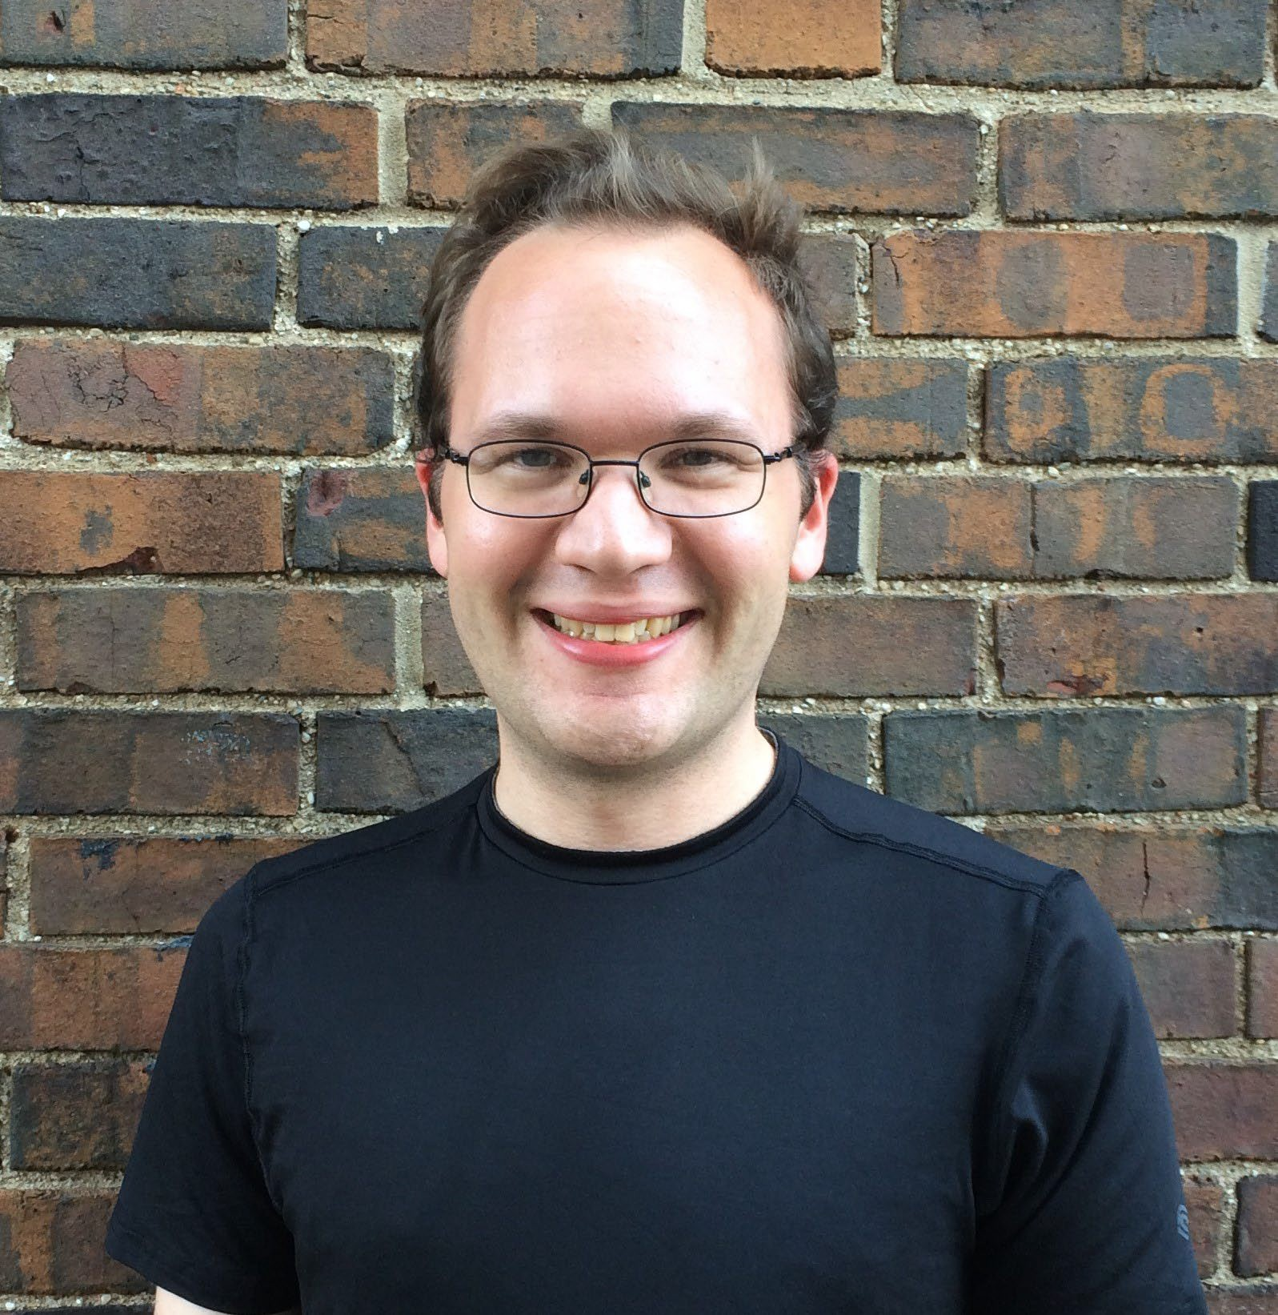
MICHAEL DOOER
Legal Assistant at a Law Firm and Freelance Pianist
“Specializing in environmental ethics particularly excited me. Since most of the developments in this specialty have occurred since the 20th Century, the coursework couldn’t have felt more current (or more relevant, considering the environmental challenges our generation is facing). Plus, Professor Diehm’s enthusiasm for the subject is so infectious. He really has a knack for breaking down and explaining complex philosophical concepts.”

2017 Graduate, Traditional Student Philosophy with an Environmental Ethics Concentration and Applied Music-Piano


Sarah Strauss
Psychotherapist

“My degree in religious studies has changed how I approach my work with clients, and how I approach relationships with people in general. My background with my studies in Philosophy and religion has grounded my current practice as a therapist.”

2017 Graduate
Philosophy Major with an Emphasis in Religious Studies

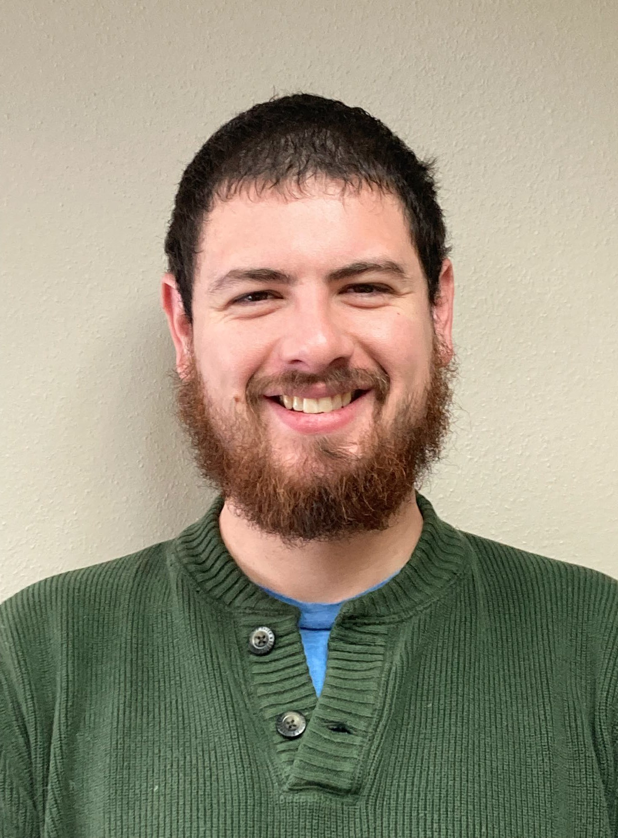
Robert Strauss
Job Coach for adults with disabilities at a Nonprofit

“It [Philosophy] helps you think about what's important. If you're doing Philosophy for the love of wisdom, it helps you figure out what you want to do. And that's pretty helpful in choosing what career path you want to go down."
2017 Graduate
Philosophy with an Emphasis in Religious Studies


KANA ROBERT EWING
Claims Adjuster for Sentry Insurance
“Whether it is ethics, or metaphysics, or epistemology, or whatever sub-field you may choose, a major component of philosophy is learning how to argue effectively. Learning how to take a claim, support it with evidence, and then turn around and show why your interpretation of the evidence should be accepted rather than other possible interpretations. So, if nothing else, even if you think the topics are too absurd and esoteric and impractical to be taken seriously, having a background in philosophy will almost definitely improve the quality of your work in your chosen field of study, because you will have a better understanding of how to effectively argue.”

2016 Graduate, Non-Traditional Student
Philosophy and Psychology


Dr. Tarryl Janik

PhD in Cultural Anthropology at UW-Milwaukee (2023) and an adjunct Anthropology instructor at the College of Lake County and Waubonsee Community College

"The philosophy and religious studies classes I took at UWSP prepared me not only for graduate school, but also for the work force. I still utilize everything that I learned as an undergraduate at UWSP and strive to pass on this knowledge to the next generation."

2015 Graduate, Non-Traditional Student
Major in Philosophy with an Emphasis in Religious Studies

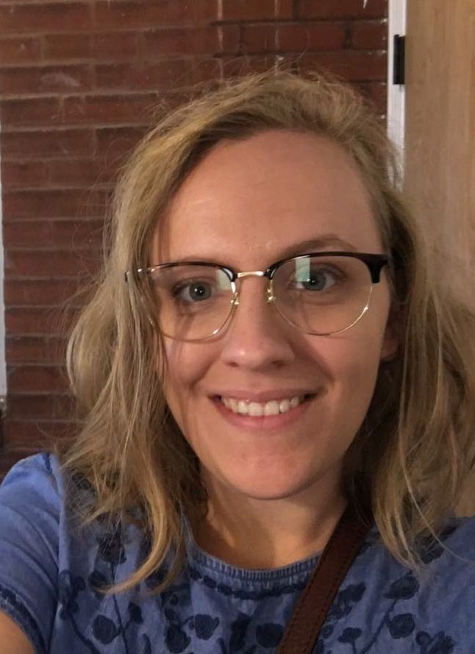
MEGAN WISE
E-Pledge Program Manager –
United Way of Dane County
“Being a major in Philosophy primes people so well for approaching life. It helps you clearly see your ultimate goal while still focusing on the intricate details, which makes you a great competitor when applying for jobs. Thanks to my Philosophy degree, I was always able to get interviews because my applications were always well written and persuaded the company that I could be a valuable asset to their team
2015 Graduate, Non-Traditional Student
Philosophy with Environmental Ethics Concentration

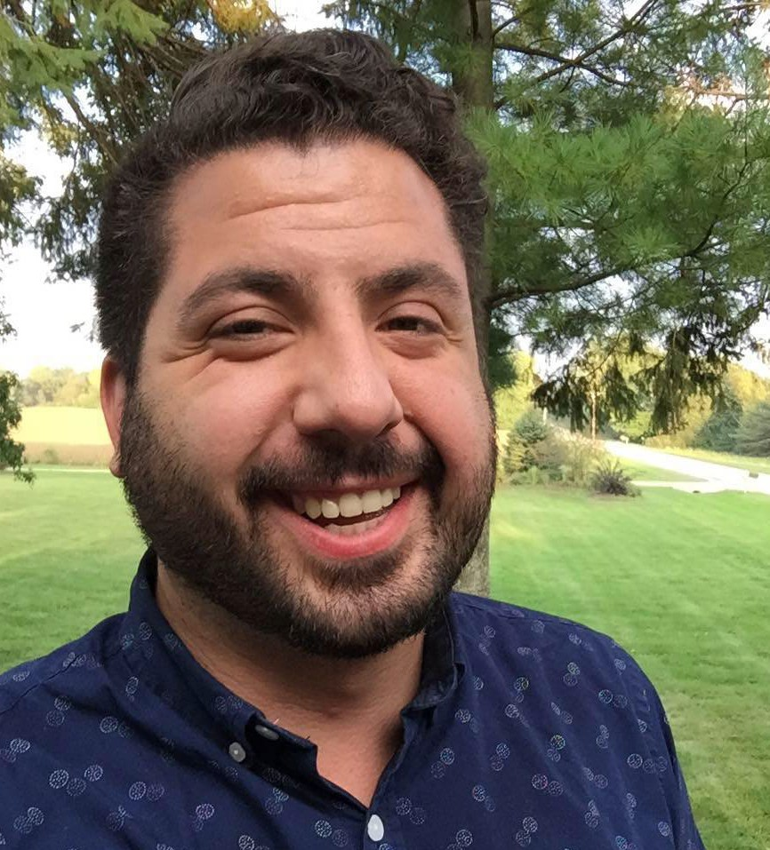
RYAN SCHWOBE
System Security Analyst – UW Hospitals & Clinics

“Learning Philosophy will only enhance what you are already doing because it removes you from normal conversations and encourages you to open up in new ways. There is always something to explore, and UWSP’s Philosophy Department was a safe space to pursue and embrace that collective growth, discussion, and civil discourse.

2015 Graduate, Traditional Transfer Student
Philosophy with Religious Studies Concentration

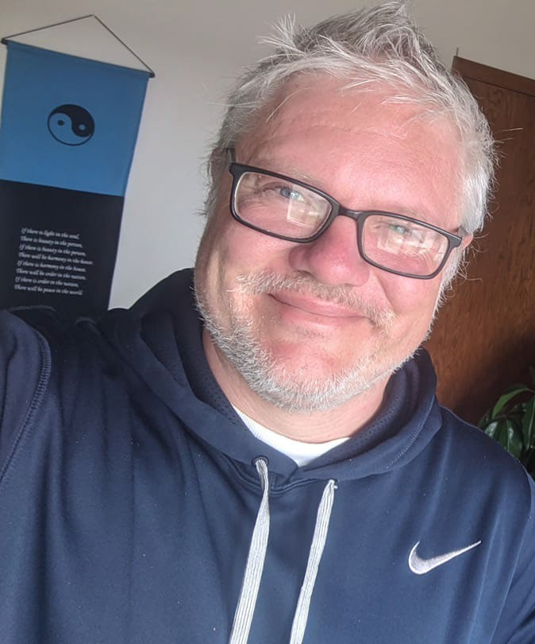
CORY RUSCH
Executive Director of Development – Central Wisconsin Children’s Museum

“My background in Philosophy has become a cornerstone of my success in the classroom. The idea of having a method and being able to talk about complex things in a simple ways has been the key to keeping students interested and engaged in their education.”

2013 Graduate, Non-Traditional Student
Philosophy and Broad Field Social Studies Teaching
History Minor

DYLAN HAIGHT
Client Services Analyst – Data Axel

“[A Philosophy degree] is so much more useful than it gets sold. Checking yourself and your own thoughts and biases is a soft skill that is incredibly essential to any kind of successful communication.”

2013 Graduate, Traditional Transfer Student Philosophy with a Religious Studies Concentration Psychology Minor

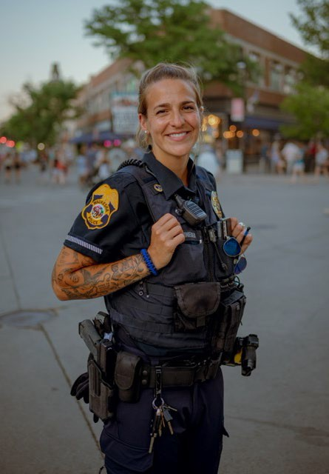
Sunny Schneider
Waukesha PD Neighborhood Engagement Unit Specialist

"I truly loved my time and appreciated all the opportunities at UWSP. It's a wonderful city and staff and it really did set me up for success."

2012 Graduate, Non-Traditional after 2 years in
U.S. Army, stationed in Germany and Iraq (outside Baghdad during Iraq War) and
2 years in National Guard
Major in History and a Minor in religious Studies
and Anthropology

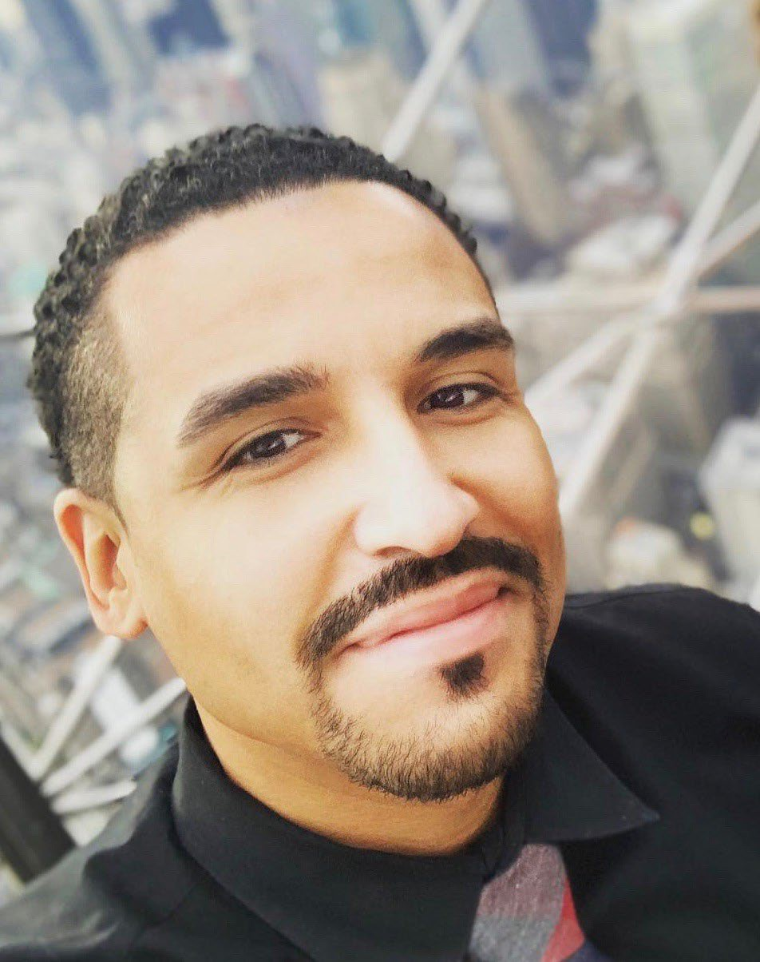
*DR. TONY FULLER
–
Assistant Professor of Neurosurgery Duke University Hospital

“There are few things that I can reflect on that is so translatable to literally anything. From a practicality standpoint, Philosophy can be translated into a lot of different fields and can be paired with anything. It isn’t often when you wished a four-hour class would go even longer, but that’s how much I loved my time in the Philosophy program at UWSP.

2011 Graduate, Traditional Student Philosophy and Biology Major Chemistry and Anthropology Minor

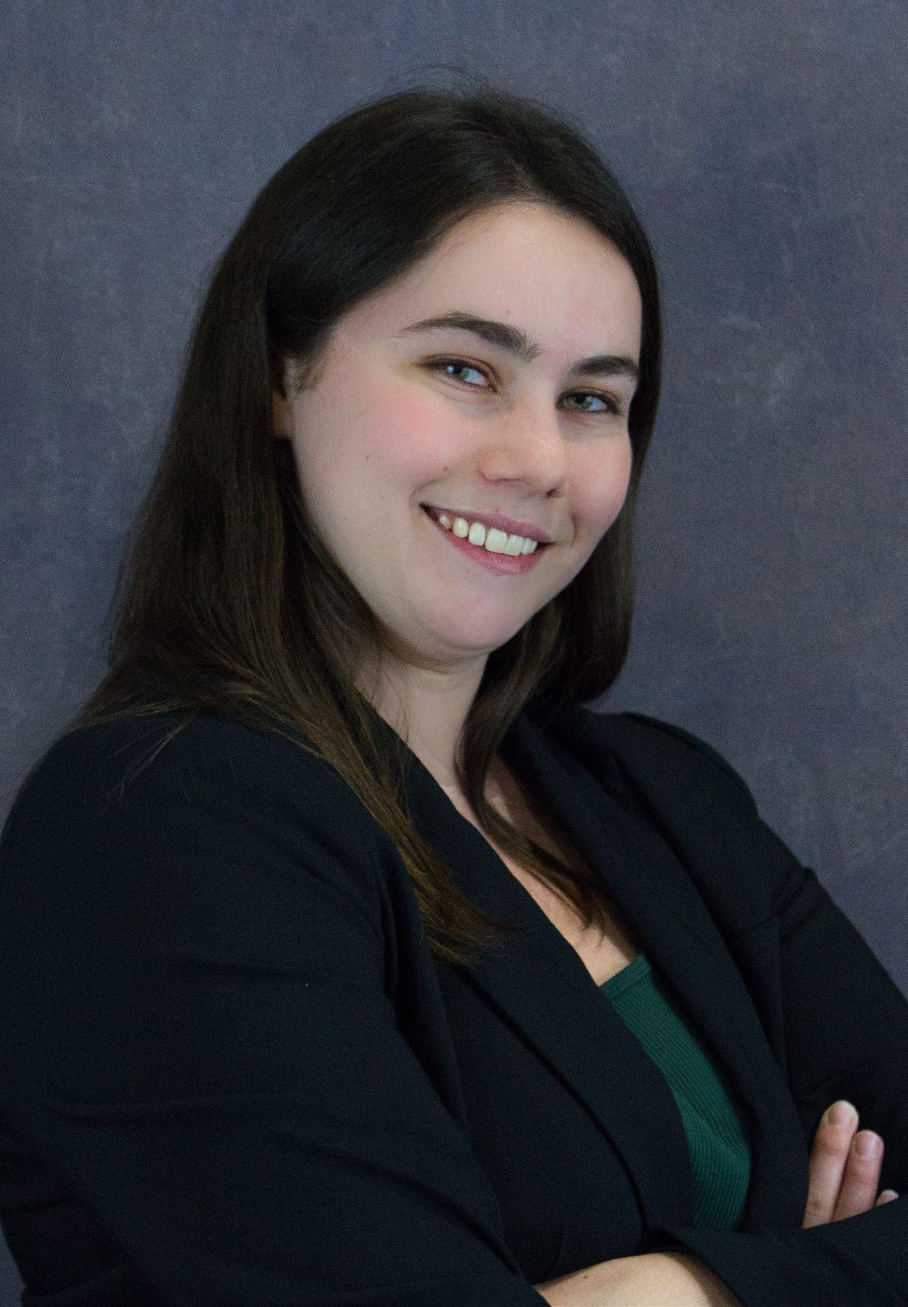
Robin School
Bank Manager Vice President

"The philosophy program taught me so many critical skills that have served me well in my career, including Logic, how to spot flaws and fallacies in an argument, critical thinking, and differing points of view in both religious and spiritual points of view.
Philosophy majors learn how to break a problem or statement down to its core, and truly analyze the structure and rationale behind it. A double major in Philosophy and Business taught me how to approach a problem or challenge logically and ethically and gave me the business background to then apply that solution in a profitable and strategic way."

2011 Graduate
Major in Philosophy with an Emphasis in Religious
Studies, Major in Business

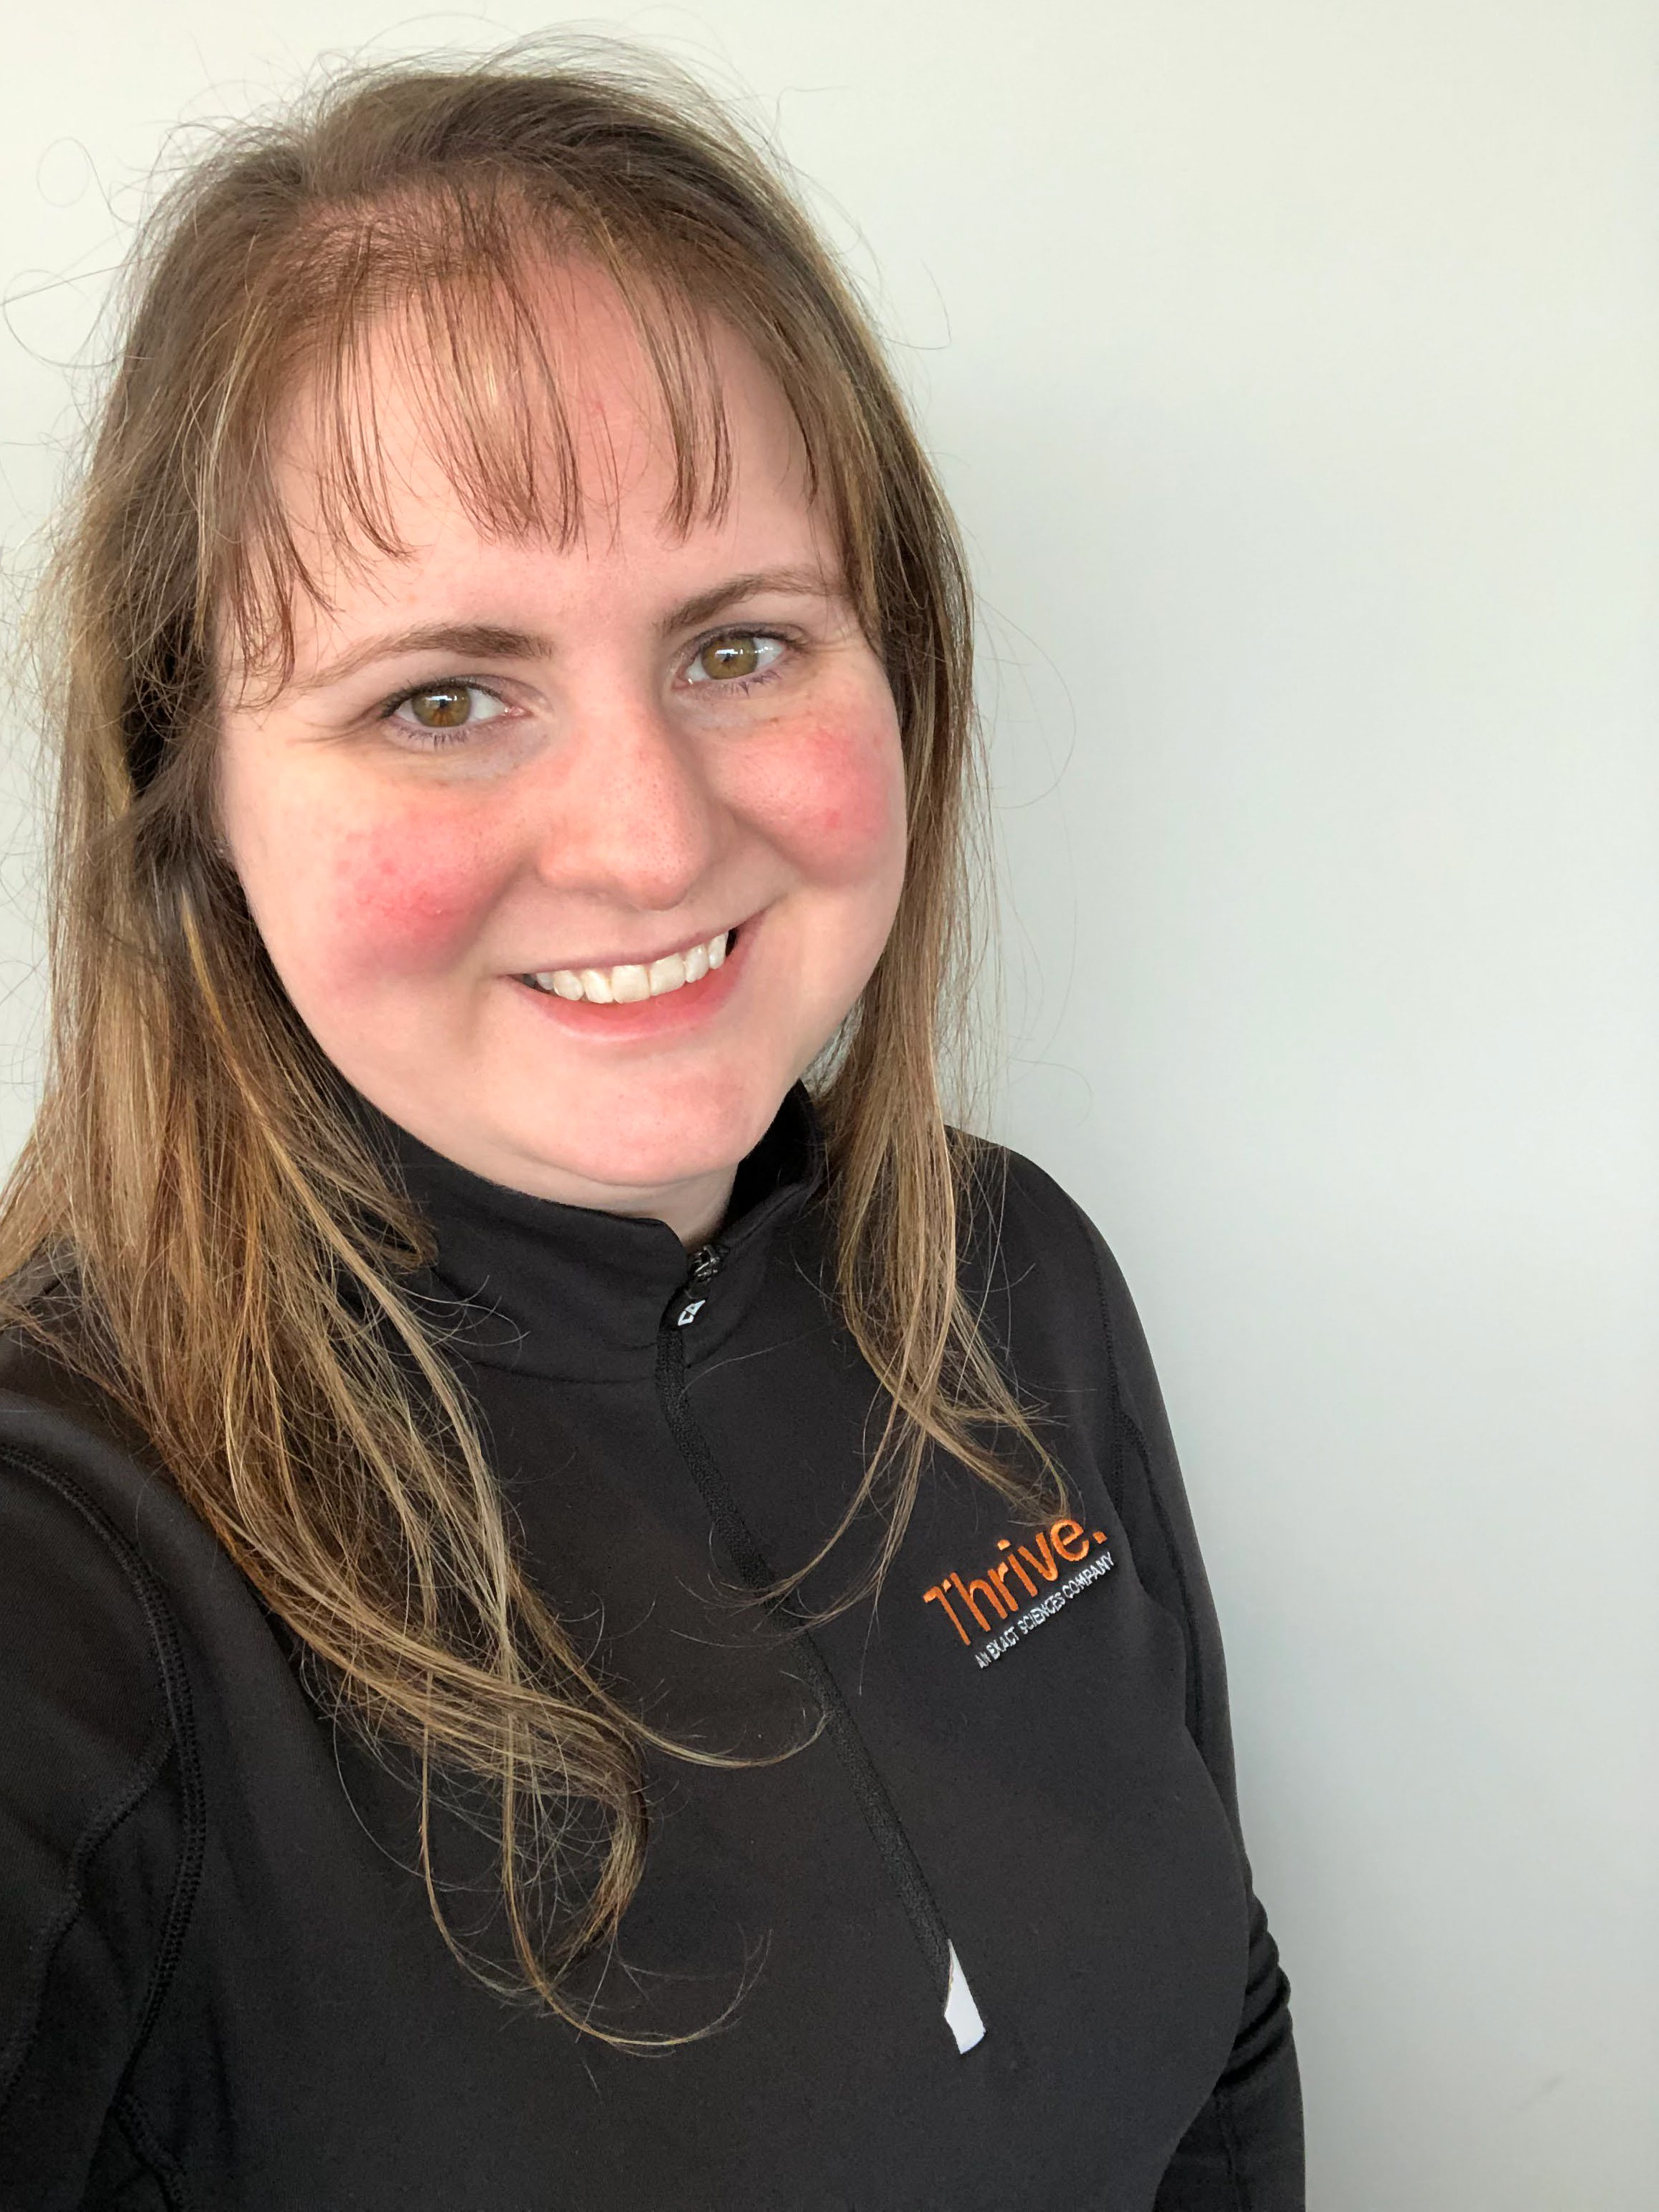
*SARAH NEWBY
Executive Administrative Partner for Integrations and Pipeline – Exact Sciences

“My Philosophy degree framed the proactive mentality that I carry with me now. Not only do the concepts that I learned help me navigate different situations and perspectives, but my professors instilled an attitude of energy and motivation within my studies which has given me a great foundation for the rest of my life.”

2010 Graduate, Traditional Student
Philosophy with Religious Studies Concentration

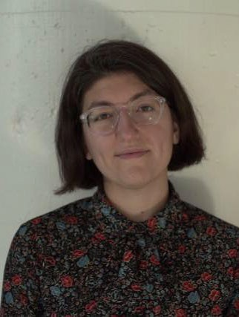
ELLIE JACKSON
Community Organizer & Event Planner – Colorful Connections
“I was on the verge of dropping out of college, but when I changed my major to Philosophy, I was actually motivated to finish my degree because I loved what I was learning. It gave me the words and tools I needed to express myself and communicate the ideas I have. It will never be a waste of a degree because I can apply it to literally everything.”

2009 Graduate, Traditional Student
Philosophy with Environmental Ethics Concentration Ethnobotany Minor

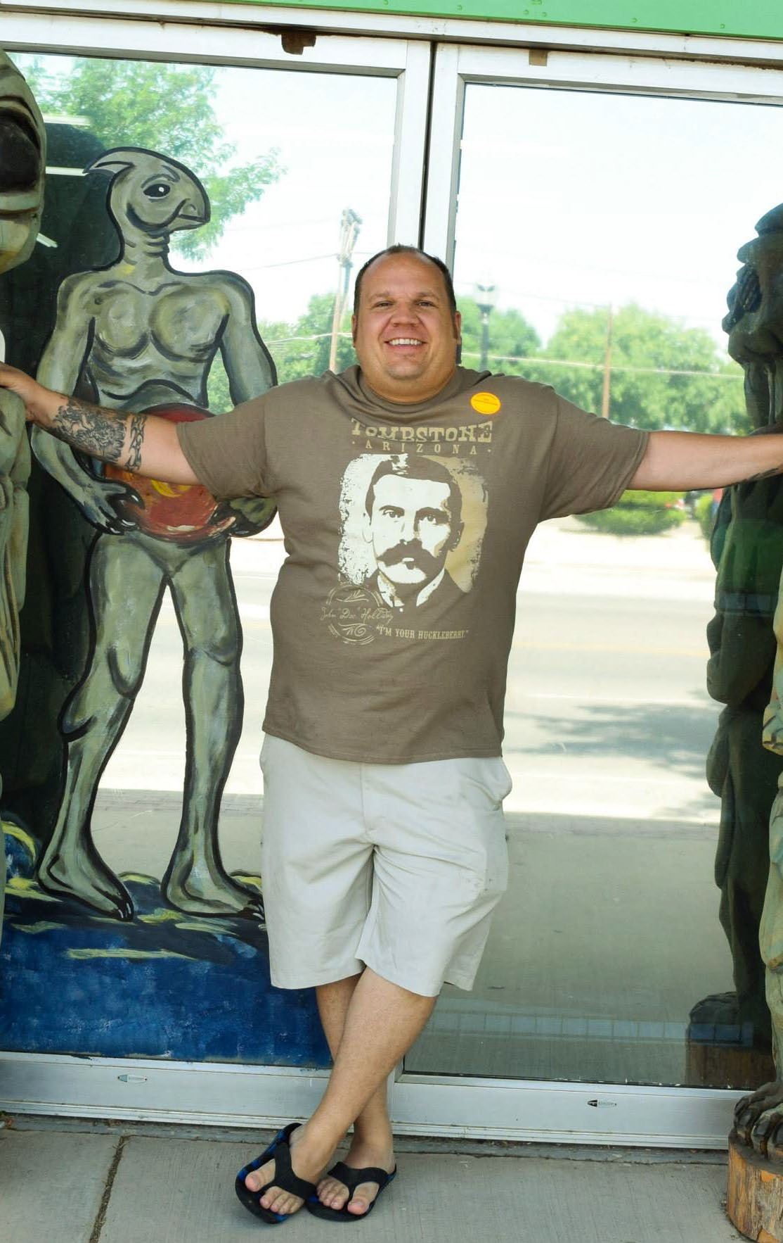
*JEREMIAH BOWDEN
Professor at Cornell College & Owner of HH Hinder Brewery

“I would have to say the biggest impact from my time at UWSP came from the care and guidance shown to me by Dr. Warren and Dr. Keefe who instilled in me the belief that each of us is able to make a difference in the lives of others.”

2008 Graduate, Non-Traditional Student
Philosophy: Religious Studies
PhD of Religion - Claremont Graduate University

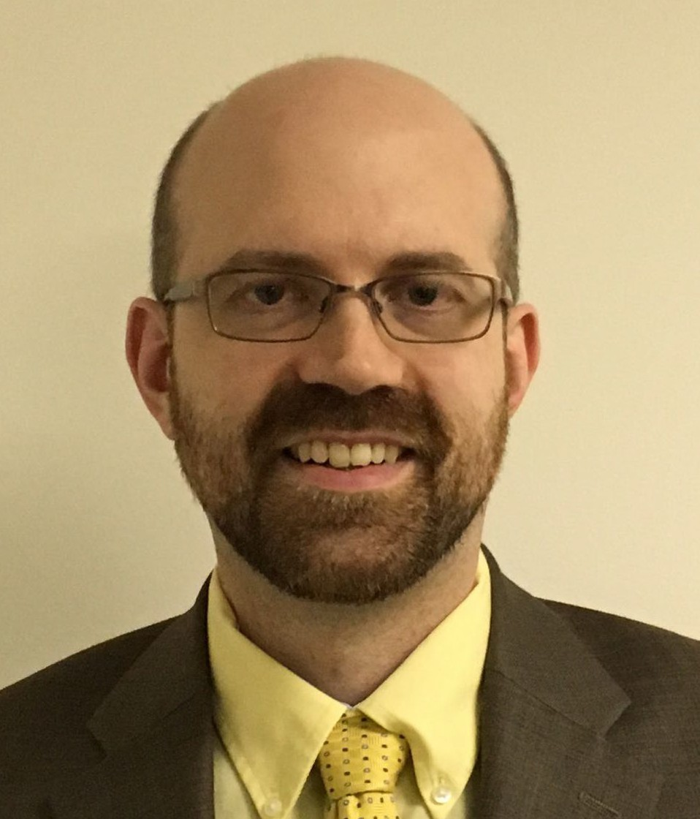
Hon. GALEN BAYNE-ALLISON
Judge for Lincoln County Circuit Court

“Philosophy allows you to develop a set of skills that is essential regardless of what career you want to pursue. Reading quickly with comprehension, identifying arguments and assertions being made, thinking critically about anything, putting aside preconceived notions, and taking on someone else’s understanding are all valuable and intellectual skills with unlimited applications.”
2006 Graduate, Non-Traditional Student
Philosophy

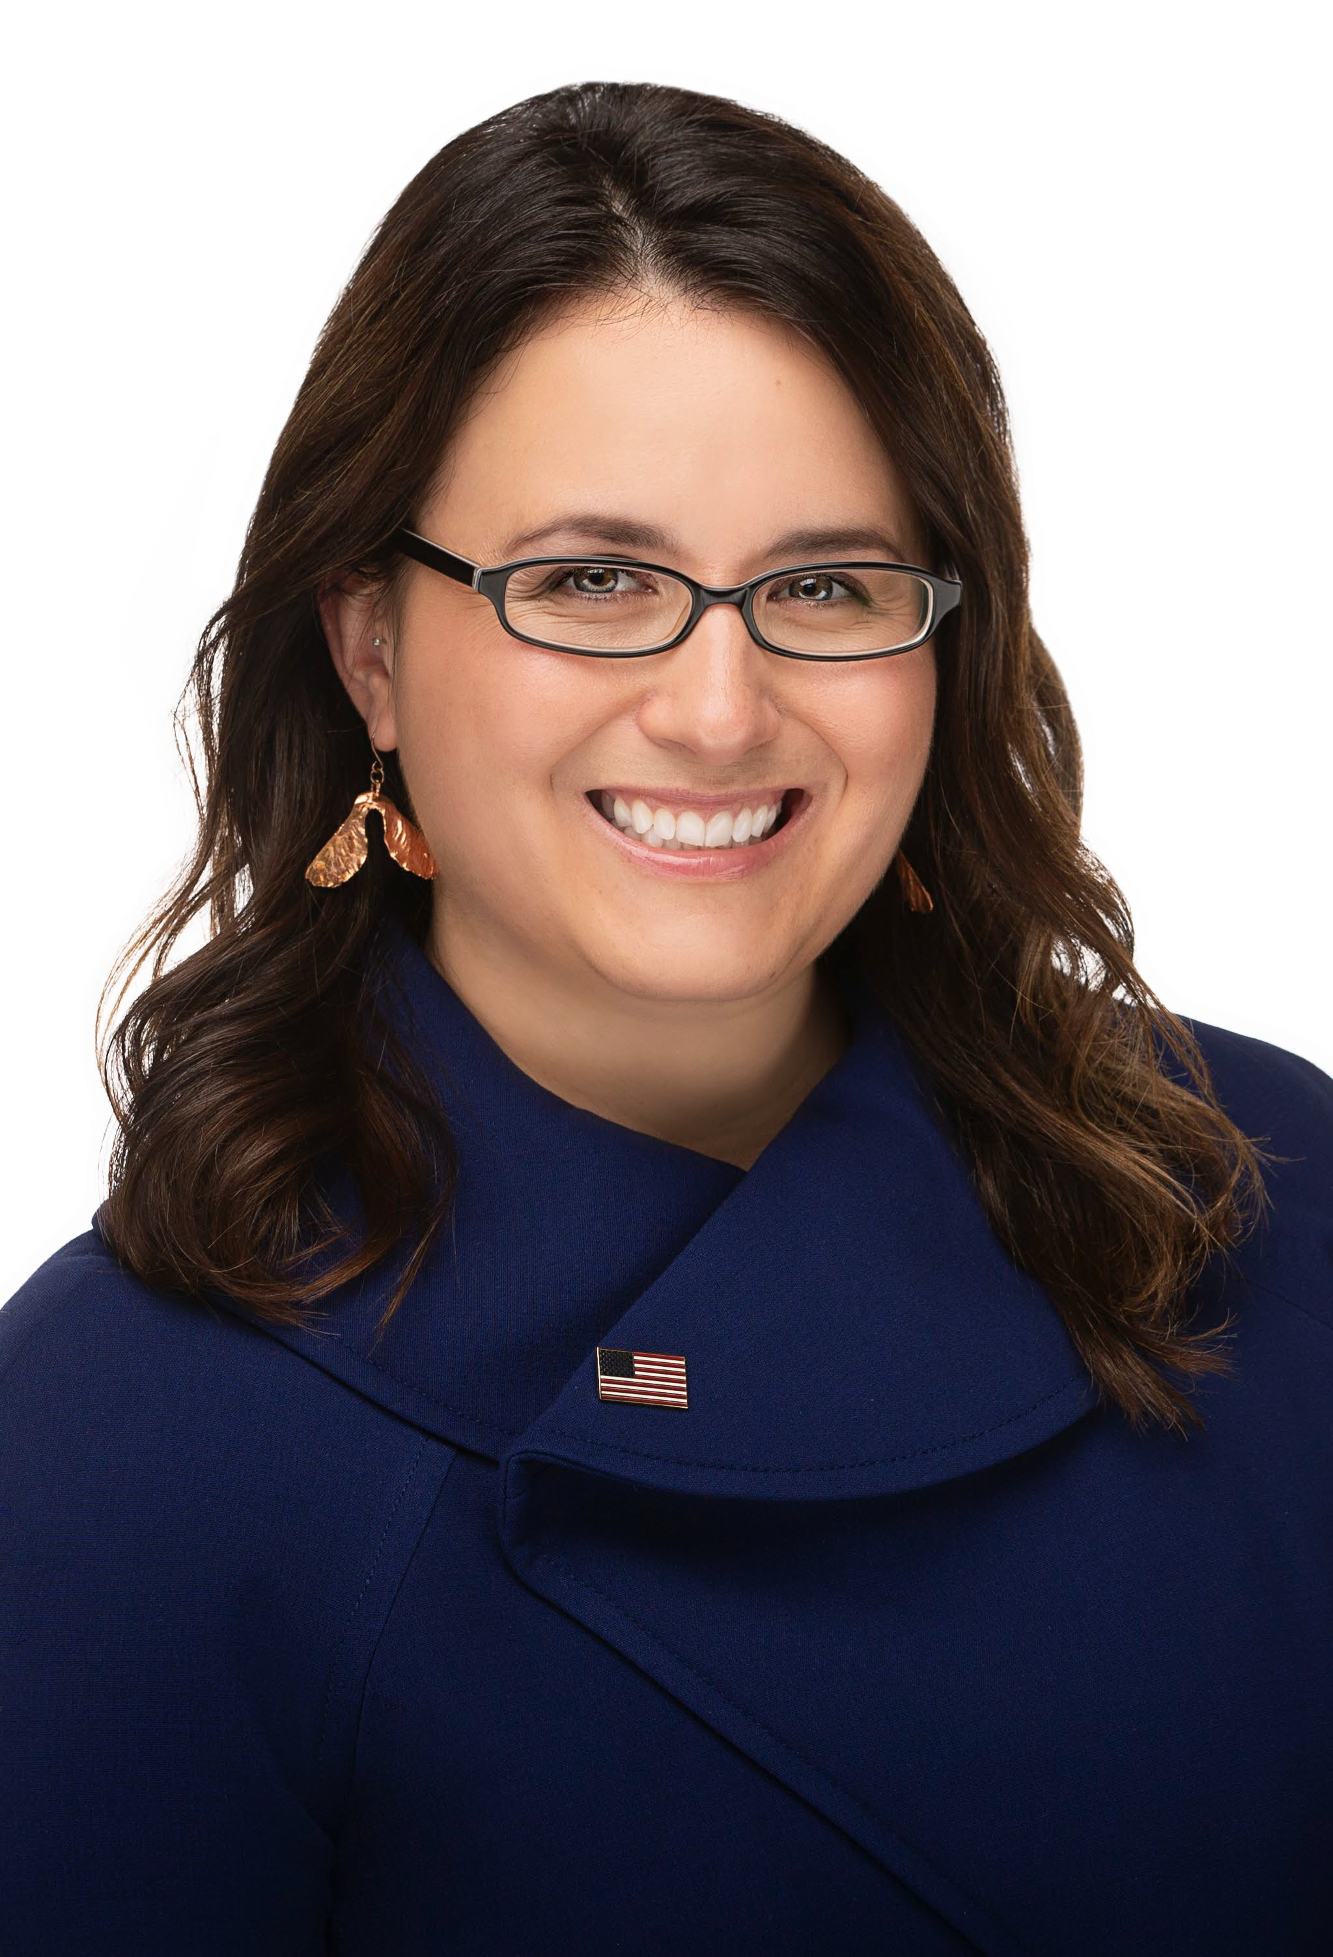
Katie Rosenberg
Mayor of Wausau
"Right now, we're living in a time when everybody has instant reactions to everything. We're on social media, so we're instantly reacting. We're kind of mean to each other, and Philosophy gives you that opportunity to slow down and really consider what you're thinking about, and what is the context that brought you to this place. And, that world view that there are other ways of thinking that are correct. So, I think that [Philosophy] has offered me an opportunity to have an open mind. That's really what you need in local government, especially right now our population is super diverse. We have a diversity of income levels, and we couldn't be more different sometimes. But, understanding that we're all coming at it and we're trying to do what's right in this world has been really helpful to have that background [in Philosophy], I would say."
2006 Graduate
Major in Philosophy with an Emphasis in Religious Studies

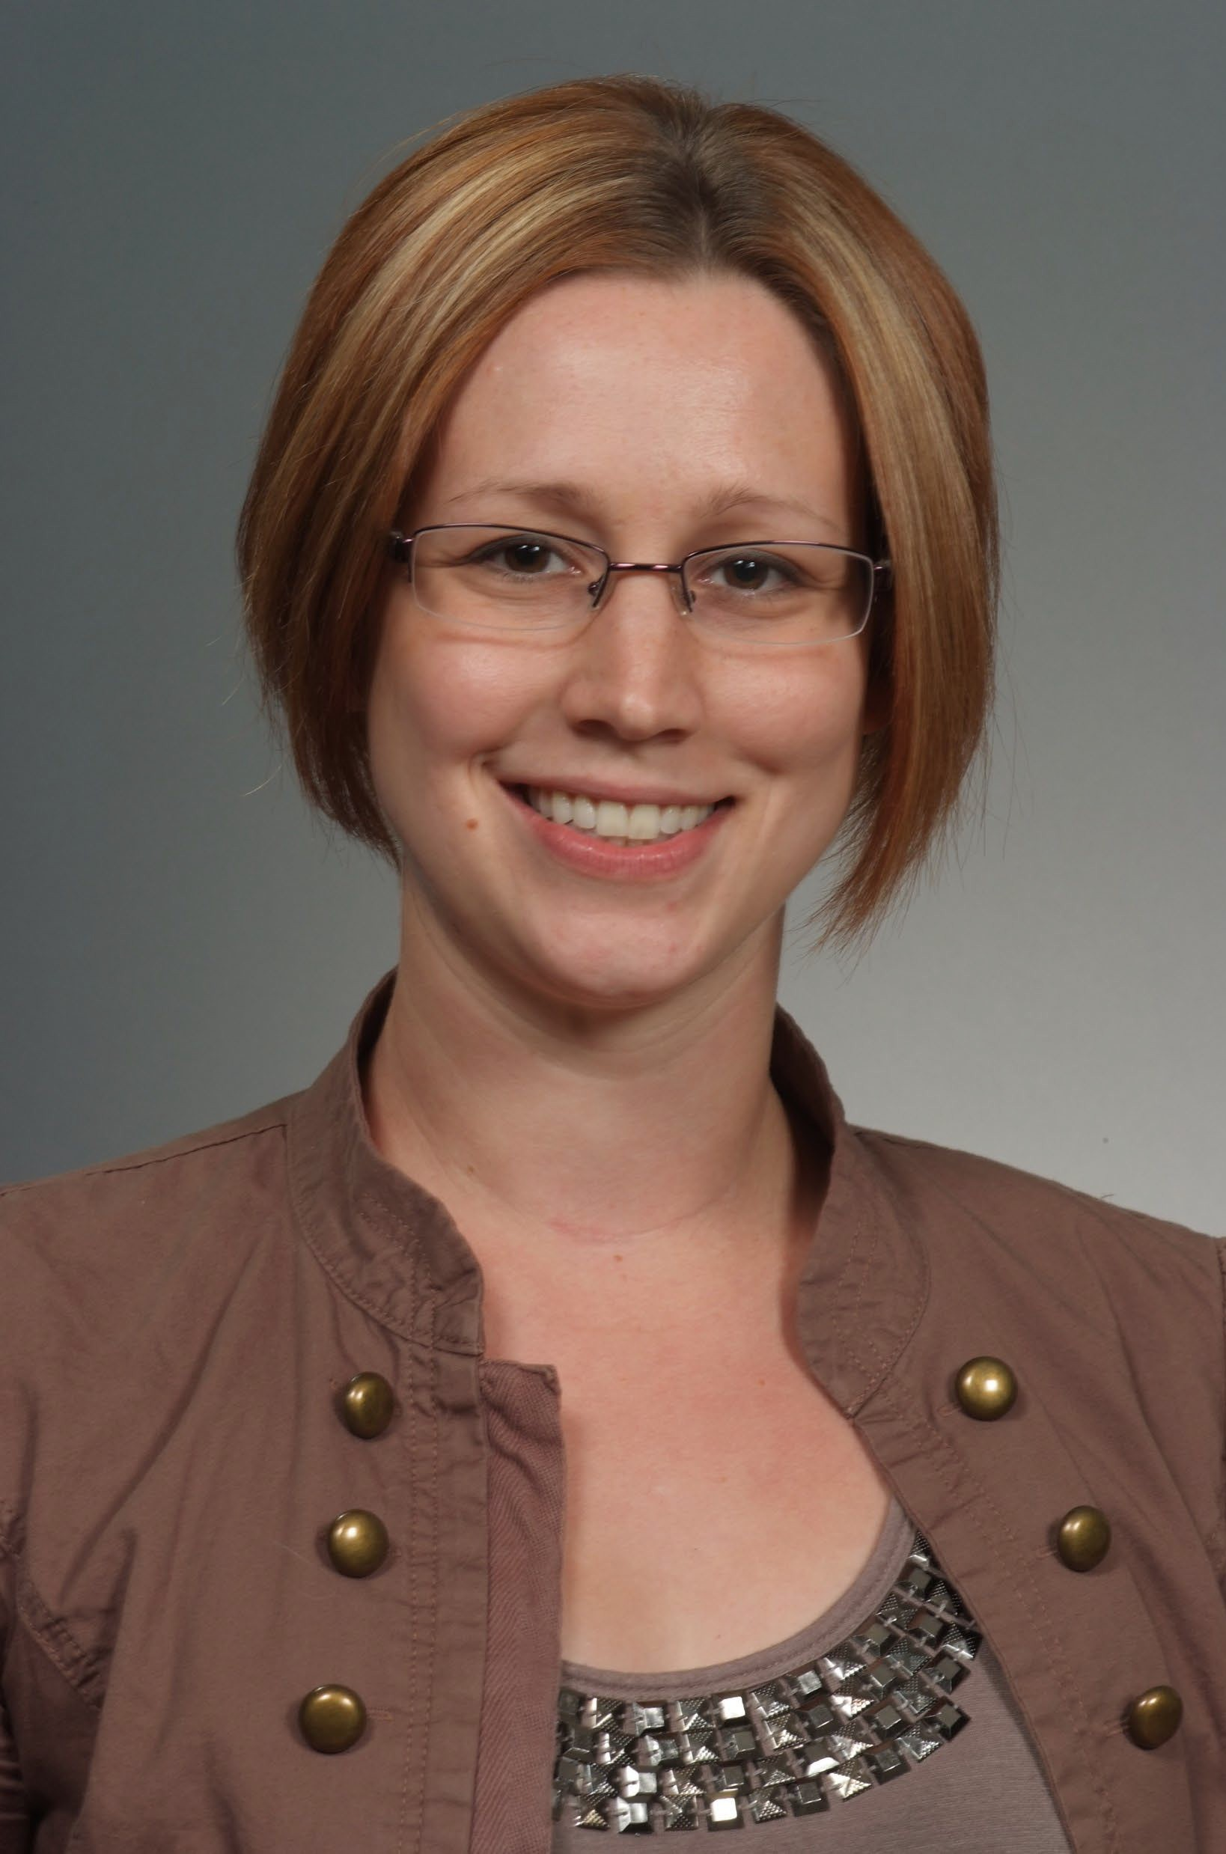
*DR. CHELSEA LOVEJOY
Associate Professor of Psychology – UW Stout

“The Philosophy minor as a whole experience really challenged me to speak up more, do more critical thinking, and have more critical conversations with others. It helped me open my mind to new perspectives and gave me the tools to see them as equally valuable.”

2006 Graduate, Traditional Student
Psychology Major with Philosophy Minor


*AMANDA MEIDL
Coordinator of Reading in the Disciplines & World Languages Tutoring - UWSP

“Philosophy challenges you in ways that other disciplines don’t, and at the same time it is something that is interwoven into every other discipline because it is ultimately the foundation of humanity.”

2005 Graduate, Non-Traditional Student
Philosophy Major with Religious Studies & Environmental Ethics Emphasis
Women’s Studies Minor

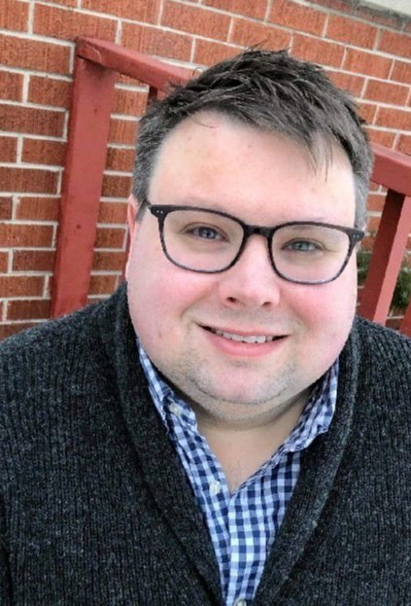
Brent Sirvio
Digital Content Creator for an Inbound Marketing Agency
"In one of my first days and first courses on campus, Dona Warren said, "Philosophy goes well with everything." I've found that to be entirely true.
Philosophy is so much more than arguing about what other people have been arguing about for centuries, it's about approach: thinking clearly and accurately, and then being able to articulate these ideas with clarity and rigor. That training, coupled with robust experience in the religious studies program, allowed me to develop strength of rhetoric balanced with understanding and empathy -- skills which have been essential in my professional life, particularly now in digital marketing as a writer, editor, strategist and mentor.
Philosophy does go well with everything, and I cannot more strongly endorse UWSP's philosophy program and its related concentrations, either as a dedicated field of study or a complement to any program the university offers."
2005 Graduate
Philosophy Major with an Emphasis in Religious Studies

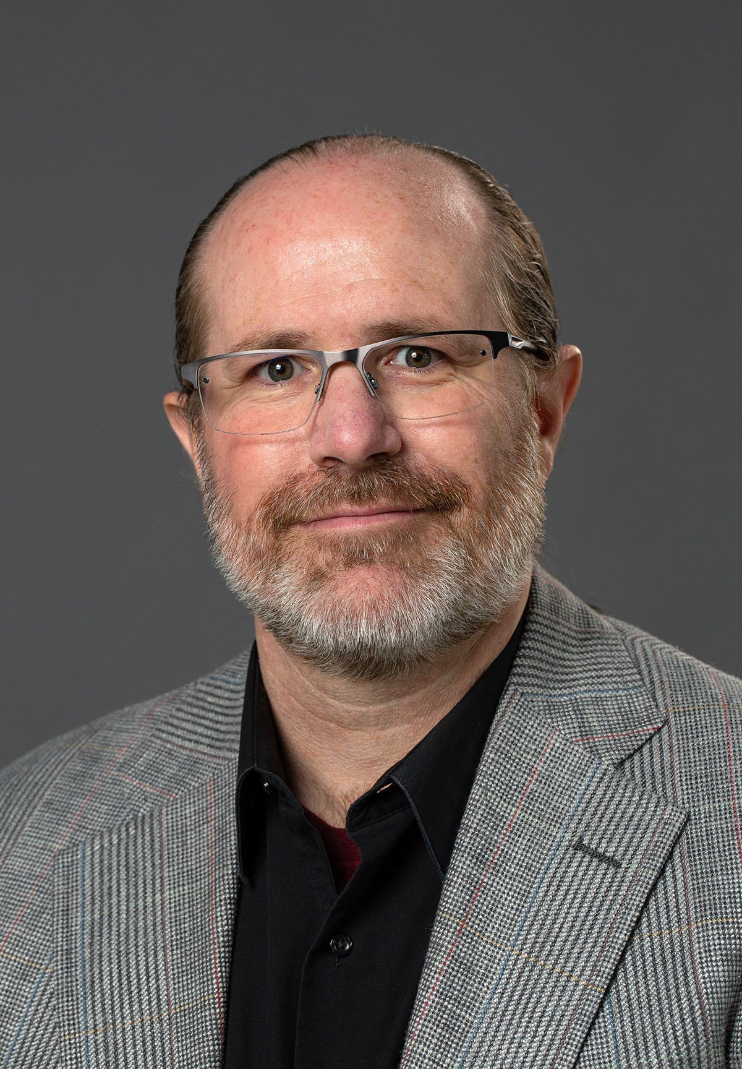
Dr. Ryan O'Leary
Lecturer in Religious Studies and Academic Success Associate with UWSP at Marshfield

"I am often inspired by the way Albert Camus expressed the connection between philosophy, idealism, and justice in his book, The Rebel, where he wrote these words: “In the light, the earth remains our first and our last love. Our comrades are breathing under the same sky as we; justice is a living thing.” My study of religion and philosophy has taught me to think more deeply, recognize that ideas cannot be separated from their history, and live more intentionally according to my ideals."

2003 Graduate, Non-Traditional Student
Double Major in Philosophy + Philosophy with an
Emphasis in Religious Studies

*CHRISTOPHER HARWOOD
Systems engineer for CDW IT Services Division

“The Philosophy Department at UWSP is really something special. The professors are clearly motivated to engage with the students to really nurture their academic interests, giving students the freedom to shift discussions and conversations as our focus and interests were changed and challenged.”

2003 Graduate, Traditional Student
Philosophy and English

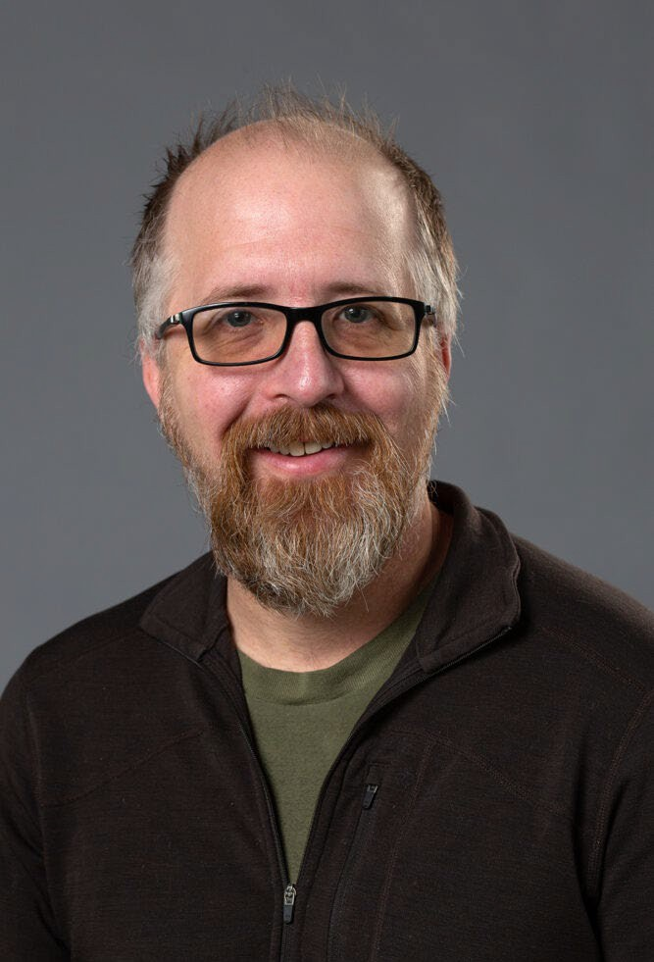
Dr. Jason Zinser
Associate Professor of Philosophy at UWSP

"Wandering into a philosophy class as an undergraduate clearly changed my life, setting me on a path to study and teach philosophy as a living. Exploring some of the “big questions” of the human condition through reading some of the greatest thinkers in history was (and remains) thrilling. While studying philosophy provides wonderful skills that are desired in the job market, it is accompanied with many private rewards as well."

1997 Graduate,
Philosophy and Psychology Major

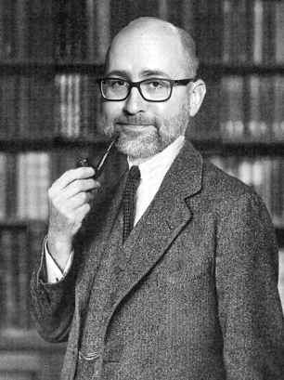
*DR. ANDREW BREI
Associate Professor of Philosophy at St. Mary’s University

“There are so many different ways, both tangible and intangible, to use your training [in Philosophy] to construct a good career and a good life.”

1996 Graduate, Traditional Student
Philosophy & German

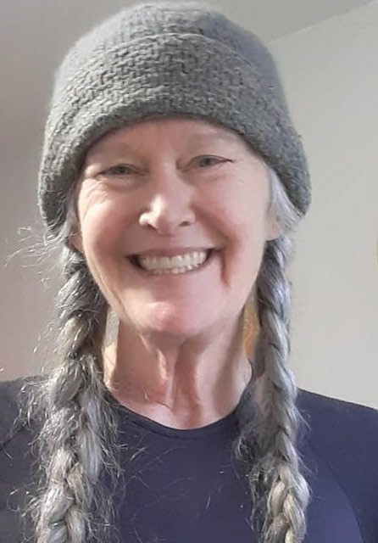
*MAUD HOLCOMB LAMARCHE
Computer Programmer for UW Extension Statewide Lakes Office & Entrepreneur

“Philosophy gave me a really well examined foundation for what I believe, what I think, and how I think. When I got into the ‘real world,’ I not only knew what my beliefs, morals, and ethics were, but that they were justly established in the literature and tools that I was given through my degree path.”

1994 Graduate, Traditional Student
Philosophy, Mathematics, and Logic

