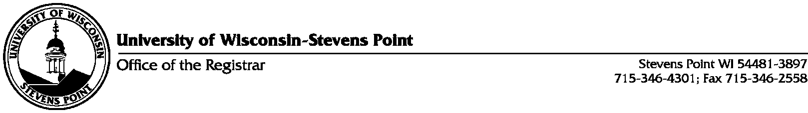

Change of Primary Name Form

This is a request to change your primary (legal) name in accesSPoint. If changing your last name, that name will be reflective in the last name of your preferred name as well.

Current name on file in Access Point Student ID Number: _______________________

____________________________________________________________________________
Last Name First Name Middle Initial

Please check all fields that apply and be prepared to show proper documentation, when returning this form to the Office of the Registrar (SSC 101).

- First Name Change Request Print New Name_________________________________
- Middle Initial Change Request Print New Middle Initial ________
- Last Name Change Request Print New Last Name______________________________

One of the following documents is required when changing your name.

- Marriage Certificate
- Adoption Papers
- Court Order
- Passport/Visa
- Driver's License
- Divorce Decree
- Social Security Card

Signature: _________________________________________________ Date: ____________

Office Use Only: Date Processed Initials

