
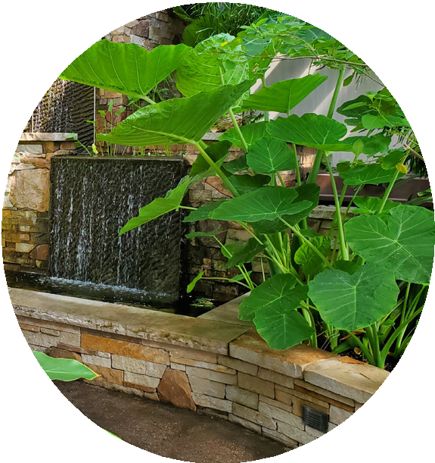
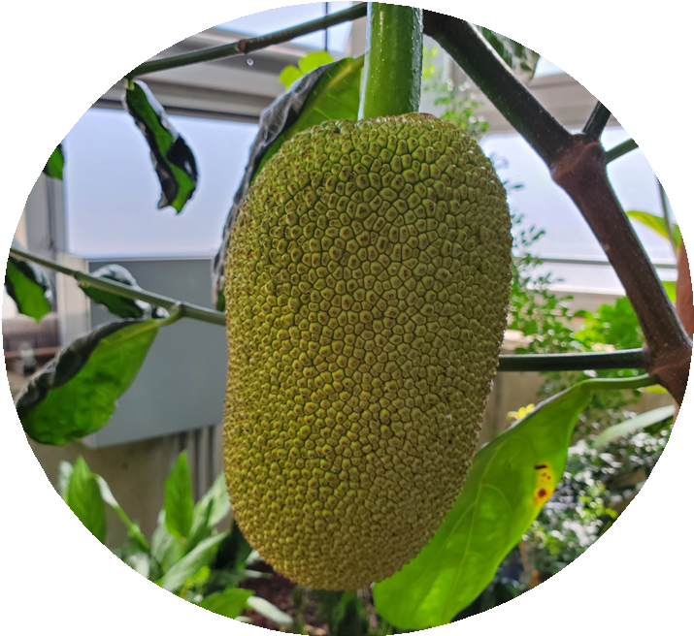

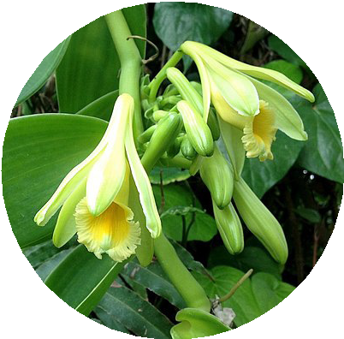

Donations
We accept online donations to support the Tropical Conservatory. Visit: https://give.uwsp.edu/give-now
Questions for us about Conservatory use?
Call 715-346-2159

Hours
The space is open daily to campus and the community from 8 a.m. to 6 p.m. (Plant care and maintenance 8-10 am)

Group Visits
Larger groups should allow 2-weeks’ notice
to schedule by calling our main office. School groups can coordinate with the UWSP Planetarium.
As an educational area, the Conservatory is a shared use space and photography usage must accommodate faculty or student work in progress.

Accessibility
The Tropical Conservatory is accessible by walker or
wheelchair, but the floor is rough/narrow and could be wet.

Parking
Parking is available on Stanley Street, with a kiosk for payment.

