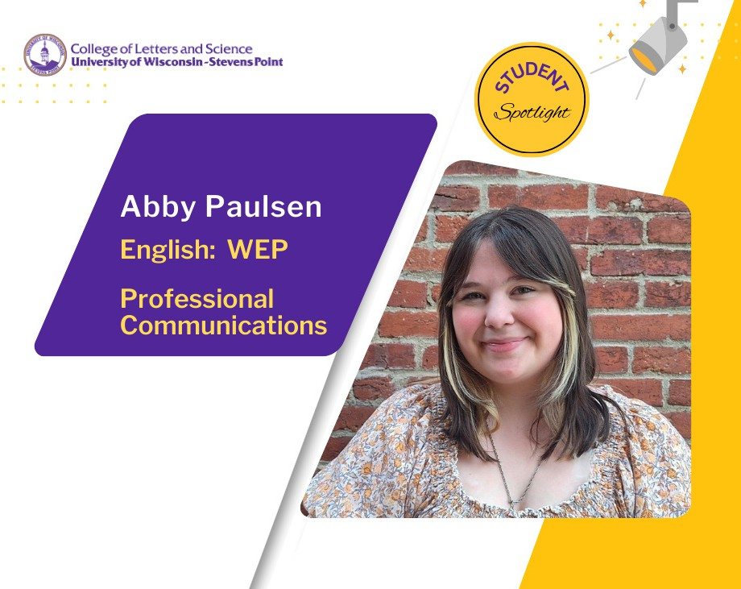

Senior Abby Paulsen has had the opportunity to design everything from chap books to books of poetry, and short story collections through her course experiences. She has a deeper appreciation of early American novels and has grown more fond of poetry. In her spare time, she puts her thoughts into “junk journals.”

The writing process is tangible now that Paulsen has been involved in the student-led Cornerstone Press. She began through
classes such as Book Design and then worked for the university press as an intern. Paulsen has moved through the ranks, now a member of the production team working closely with Cornerstone Press Director and Publisher Ross Tangedal, associate professor of English.
“His courses have opened my eyes to what publishing can actually be like. We work closely with our authors,” she said. “I get to see all the questionnaires that come through from authors, the vibe they are going for.”

In those collaborations between students and Cornerstone Press authors, Paulsen has helped to design 12 book covers over the last year.

“The authors get a lot of say,” she said.

Those project management skills gained in course work spill over into her interests in civic engagement. As a founding member of the Progressive Action Organization in 2023, Paulsen is giving voice in various ways to causes she cares deeply about. With up to 100 members, PAO hosts vigils, clothing drives and marches to spread awareness of social justice issues.

This month the students are making zines, self-published booklets that convey ideas about civic rights in creative ways.

“Using your voice is important to me,” she said.

Paulsen has made strong connections by getting involved in student media organizations such as 90FM student radio for their annual trivia competition. She has also been working in digital content and SEO research for Berkshire Hathaway Travel Protection as their marketing intern.

She will graduate in May with majors in English: Writing, Editing, and Publishing and in Professional Communications. Post graduation, she hopes to pursue her passions related to content writing, editorial, graphic design, public relations, and social media marketing.

