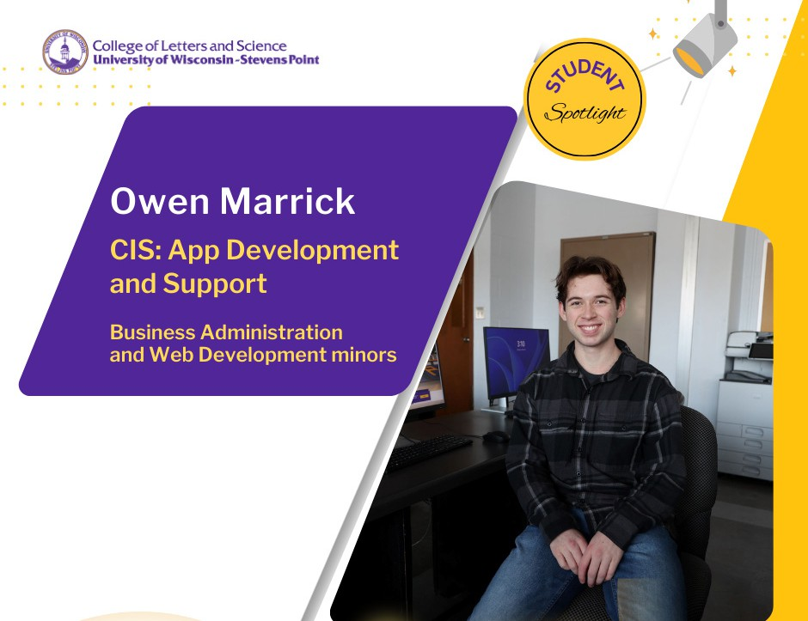

The UW-Stevens Point campus tour solidified his college decision. Although he was initiallly undecided on a major, he knew that he wanted to find a path to graduate
in under four years. Owen Marrick enrolled

with a semester’s worth of course credits.
The Green Bay native is studying Computer Information Systems: App Development and Support. He will earn minors in Business
Administration and Web Development. Marrick said he is excited to be a part of the advances in the computing field.

Marrick completed a crucial programming
course─CIS 120─as a first-year student. That knowledge base gave him the drive to apply for the Sentry co-op position as a sophomore. The software development program is part-time during the academic year and full-time over summer. Associates work on real-world projects and develop their professional and technical skills. Marrick will be working closely with a small cohort of about a dozen in the co-op.

He said another huge motivator for applying for the Sentry position was taking the Computing Major Seminar, a 1-credit course that prepares students in career research, organizing job application materials, and networking with local employers. Then, his adviser, Department of Computing and New Media Technologies Chair, Tim Krause stepped in to support his success.

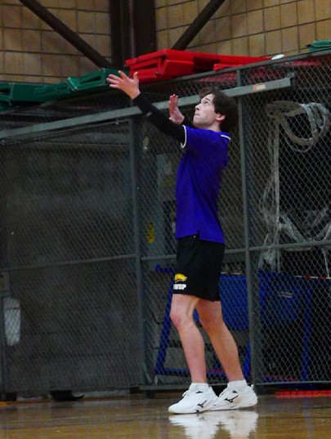
“He talked me through the Sentry internship; and I even did interview preparation with him,” Marrick said.
Every other weekend, Marrick travels with the UWSP Men’s Club Volleyball team for tournaments across the state of Wisconsin. He joined the club last winter and they practice four times weekly. It’s an outlet he enjoys between his course load and the new internship. The key, he said, is not to get behind and to emphasize having solid planning strategies.
“With my time management side, I’m always really good at getting organized and able to avoid problems before they come up,” he said.

Marrick is making connections now that will shape his plan to work as a computer systems professional in the future.



