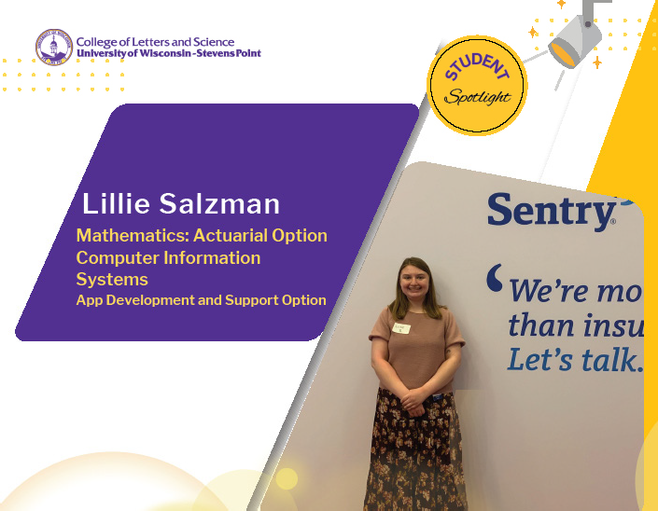

Even her hobbies showcase Lillie Salzman’s analytical side. She enjoys the structure and patterns and mathematical mindset she uses in crochet.

The Wausau senior will earn degrees this spring in Mathematics: Actuarial Option and in Computer
Information Systems: Application Development and Support. She had settled on the actuarial emphasis and then deeper into her program requirements, decided to widen her focus by adding studies in computer science.

Salzman enrolled at UW-Stevens Point main campus after taking courses at the Wausau campus for her

first year. Small class sizes and supportive faculty
were key factors in her decision to continue at UWSP. Along the way, she said professors have always been responsive and willing to collaborate and engage with students to explain concepts. She said she loved working on sorting algorithms in the course taught by Cindy McCabe, professor of mathematics.

After passing her first actuarial exam, Salzman applied and got accepted to a full-time summer internship in Sentry’s pricing department. She began her internship in May and works partially remote. In just two months on the job, she said she is already contributing work that supports her co-workers.

“I had to give a report for a teammate who was on leave. I felt like what I did for it was useful,” Salzman said. “I’ve learned I like analyzing data in this role.”

Her team members at Sentry have been encouraging. She found the internship opportunity through a professional event on campus and was drawn to Sentry’s reputation and positive work environment. She has been able to learn about work involved in a variety of departments.

Salzman advises future interns to be open to various roles, including data and business analysis. The on-the-
job experience has been rewarding and encourages her to keep exploring the field.

Her dedication to high achievement has yielded her results. Since 2021, Salzman has achieved a 4.0 GPA on every College of Letters and Science Dean’s List. This spring, she was honored with the COLS Continuing Distinguished Student Award in Mathematics!
“I am excited to find a role where I can use both my majors,” Salzman said.

