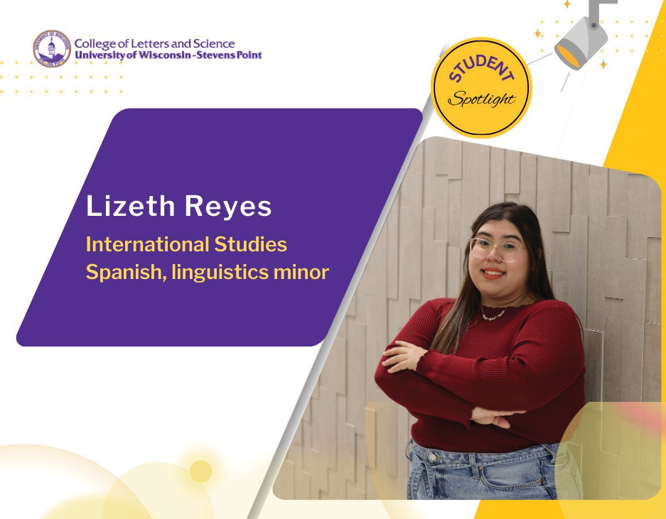
Lizeth Reyes said she has always put herself out of her comfort zone.

“I think it’s the best way to learn!”

The Milwaukee native is a first-generation college student who has had to navigate her own path.
She said she has faced insecurity in the past. Reyes enrolled for her first year at the University of Utah to experience living in an entirely new community. Then after her studies moved online because of COVID-19, she transferred to UW-
Stevens Point in 2021 with a declared major of international studies. She is also earning minors in Spanish and linguistics.

The smaller campus size at UWSP has helped her create more meaningful connections. Not knowing what the next steps might look like, Reyes said she has been so grateful to her adviser and faculty in School of Humanities and Global Studies, professors James Berry and Valerie Barske in particular who have guided her path and exposed her to applied experiences to put her passions into practice.

Her professors have encouraged Reyes’ desire to make positive cultural impacts. After spending a semester abroad in Valladolid, Spain, she is thrilled to be able to follow her ambitions by working to serve others in
a language role following her May graduation. Reyes has accepted a graduate placement at University of Glasgow in Scotland to earn her master’s degree in Translation Studies. She will be enrolled this September for the one-year program.

Even as a young child, Reyes often translated from Spanish to English for her family members.

She is deeply engaged in campus life as president of the Spanish Club, secretary of the History Club, and the education chair of the Hmong and Southeast Asian American Club. Their spring fundraiser tasked her with making 1,000 egg rolls! What some see as a challenge, Reyes sees as a strength. She said she is driven by her desire to understand global cultures deeper, through her lens.
“Getting hands on experience in translation that has been my career goal for as long as I can remember,”
Reyes said.

“You really get to broaden your knowledge and ideas by exploring global issues. The program will be a challenge, but that challenge is what should drive me and not set me back.”

