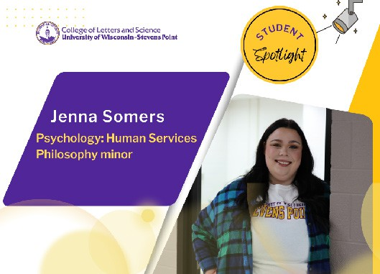

For the past two years, Jenna Somers has been helping students with peer coaching in the Tutoring Learning Center. Somers decided to enroll in college a bit later than her peers, after working and getting
married. She transferred from UW-Stevens Point at Wausau to the main campus at UWSP following her sophomore year.

Somers has a natural curiosity and a strong desire to help others from all walks of life.
The Iola, Wis. native is a senior majoring in Psychology: Human Services and earning a minor in philosophy. Her adviser, Dr. Jeana Council, helped her to gain applied experiences through placements in two separate summer internships.

As an intern for the Nekoosa School District, Somers observed the work of a school counselor. Her previous work in the UWSP Department of Psychology lab, recording counseling sessions, helped her to exercise some of the counseling skills she observed as an intern, working with youth. From routine questions to the best ways to handle more emotional needs, Somers learned there was not a typical day.
“I also really liked getting to first-hand experience of how jobs in the mental health field
operate on a day-to-day basis,” she said.

Somers enjoys the work of coaching students through study strategies and helping them to develop good academic habits. She said everyone can be successful when they are open to new experiences, show up, and do the work!
“I recognize things in people that they can’t see in themselves,” she said.

She recently started part-time work as a paraprofessional supporting students in the Iola School District. When she has free time, Somers enjoys hiking with her dog, listening to podcasts, and spending time with her husband.

