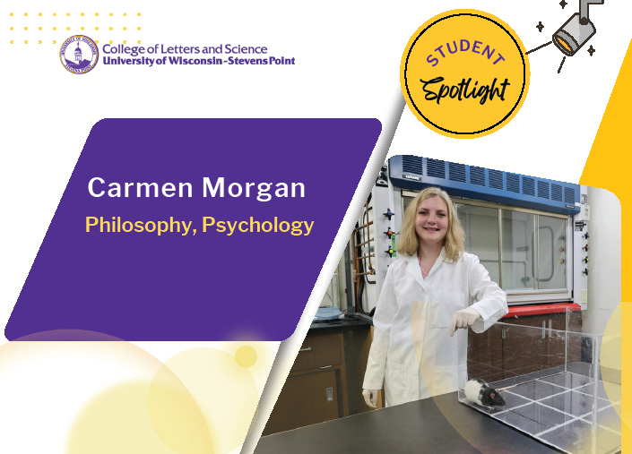

Senior Carmen Morgan studied at colleges in Alaska and Texas but said she didn’t feel like she was “at home” until she transferred to UW-Stevens Point.
Morgan is a double major in psychology and philosophy, as well as the lead peer adviser for the Academic and Career Advising Center (ACAC). She assists students with the campus systems they will use to schedule courses or navigate a waitlist.

“We try to make sure students feel supported,” she said.

It’s the type of connection she hopes to build on for her professional life. Morgan will apply to graduate school following graduation to work in some capacity with counseling adults.

She is also passionate about staying involved in research. She joined an ongoing study with Dr. Heather Molenda-Figueira, psychology, and peers last year to understand the impact of Bisphenol-S (BPS) on brain development and reproduction behavior in rats. It’s been a fluid process, with the need for creative thinking as unexpected issues happen in the research process.
“It’s changed my outlook now that I have been doing research for almost a year now,” said Morgan.

Morgan is thrilled to present her capstone project on social dynamics at the Undergraduate Research Symposium under the supervision of associate philosophy professor Jason Zinser.

Before her senior year, Morgan traveled abroad to study with a group of fellow students in the European Union, a course with psychology professor Justin Rueb, which earned credits toward her student capstone work.

“I’ve always been interested in other cultures and I wanted to see other ways of life,” Morgan said. “You get a valuable perspective on your own culture being immersed in another country’s culture, it was really insightful to study abroad.”

Including her contributions to the ACAC, Philosophy Club and Psychology Club during the academic year, Morgan keeps a hectic schedule. She said she carves out time to relieve stress and prevent burnout from demanding semesters practicing yoga at home. Her advice is, “Schedule time for yourself!”



