Sophomore Sophie McArthur will get the chance to put her German speaking language skills into practice during the spring semester while enrolled in the UWSP study abroad program in Marburg, Germany. It might have seemed like a complicated, overwhelming move in the past. McArthur said the close connections she has
developed with her professors and their encouragement have given her confidence to succeed no matter where her studies take her.
She will take four courses in a mix of English and German instruction. After the program, she will likely earn enough credits for a major in German. She is also enrolled in the Pre-Engineering Associate Degree program.

Sophie McArthur
Pre-Engineering German

D
Spotlight
E
N
T
S
T
U


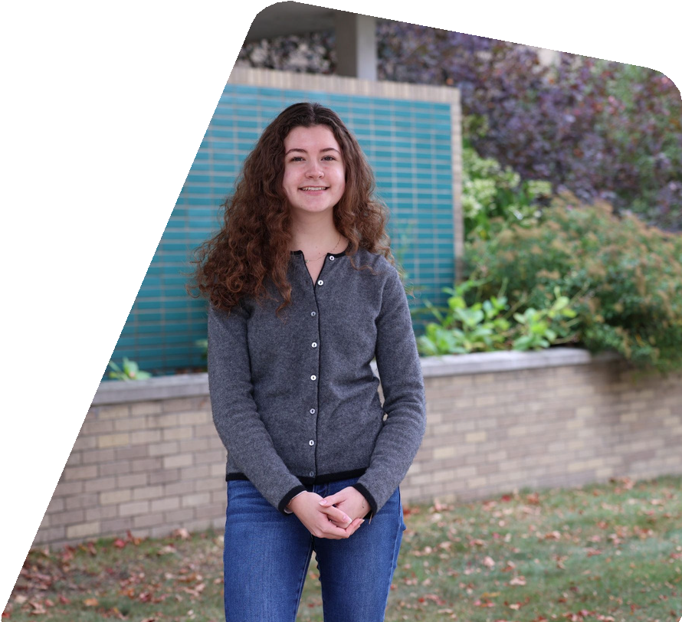





“I hope to become more fluent, and work on my conversational German,” she said.

As a first-year student, she said she got involved with German Club, meeting new friends easily. The program will build on her first travel to Germany with fellow high school students and give her a deeper appreciation for her family heritage. They traveled to several German cities— Dresden, Munich, Berlin—after her high school graduation.

Another member of her family, her uncle Chris who taught in the physical therapy program at UWSP, was instrumental in her major choice of mechanical engineering. In the program, students transfer to one of three campuses to complete the B.S. in Mechanical Engineering. McArthur plans to complete her degree at UW-Milwaukee.

She has always been intrigued by problem solving, working on analytical thinking. She helps other students solve problems as a part-time staff member in the Office of the Registrar where she answers needs on the phone and assists with office duties.

Other students should know that faculty are always willing to talk about courses and internship opportunities. Getting information about study abroad was an open, easy process of getting her questions answered, she said. McArthur said professors in the German program, Dr. Barske and Dr. Leek, have provided her guidance and taken an interest in her future.
“They have been very helpful and feel strongly about connecting you to the world after graduation,” she said.

She recommends that students take advantage of office hours and other ways to get to know their professors.
It’s made all the difference for her.

