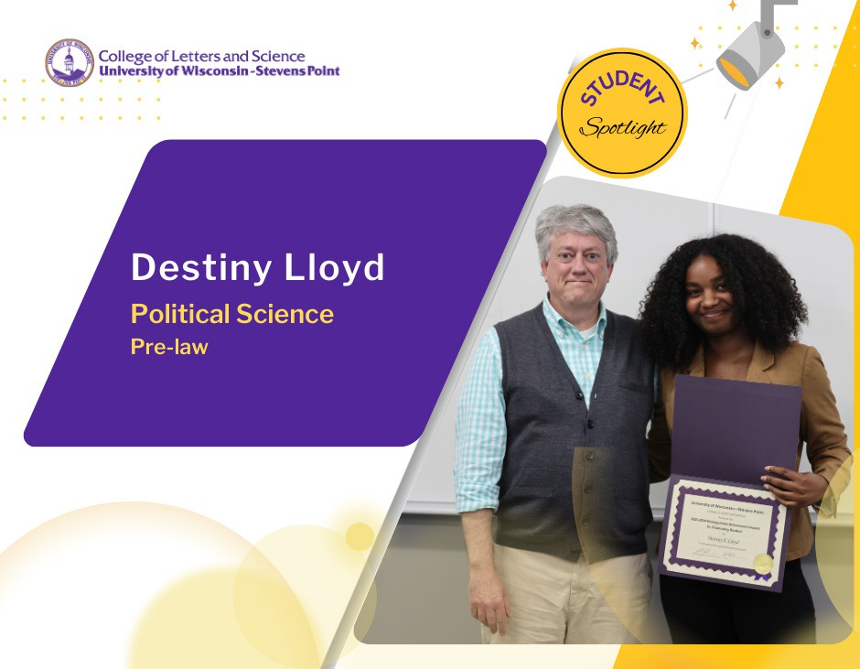

Destiny Lloyd made the most of her time in the Department of Political Science at UW-Stevens Point. The political science major, pre-law minor immersed herself in knowledge of the legal system in course work and gained experience working
with professionals in the court system during her internship at Justice Point.
It was in her role interning with the local drug treatment court where she started to build connections. She attended group counseling sessions and honed her advocacy skills. Lloyd assisted with a number of cases and analyzed data on recidivism rates to gain an understanding of how the restorative justice policy was performing for helping to keep people from re-entering the criminal justice system.

“It was very versatile. I had different options regarding the kind of work I wanted to do, such as working with clients, as a group, and even individually. Justice Point runs some great programs and it’s important for other students and our community to see the differences they make in the lives of others,” said Lloyd.

As the oldest of three siblings, Lloyd said she has always been disciplined. Because she constantly aims to improve her understanding of the legal system, she joined organizations that helped nurture her career path. She served in the Student Government Association at UWSP as a senator and chair.

Last year, Lloyd was driven to help relaunch the Student Legal Society. The student organization involves about 15 current members. They invited attorneys and judges to speak about their career paths and toured law schools around Wisconsin. She served as club president, helping to nurture other students with information about law school exams and presentations on restorative justice as well as race and the criminal justice system.
“I really love what I’m studying, that gives me the drive,” said Lloyd.

Her goal is to make an impact for disadvantaged communities, for people who find themselves without the means to
defend themselves and their rights.

“I was seeing patterns of injustice and it makes me want to make a change in that area,” she said. “Advocating for people legally felt I could make an impact that way.”

Ahead of her graduation in May, Lloyd was accepted to attend The George Washington University Law School as 1 of 10 Open Doors Scholars. She was previously named a Noel Compass Scholar and served as vice president of the program this year.

“I am extremely excited and still a little shocked about it!” she said.

Lloyd said the guidance received from her adviser Scott West, and her professors in political science, Dorothy DeBoer and John Blakeman, have really made a difference in supporting her success at UWSP!

