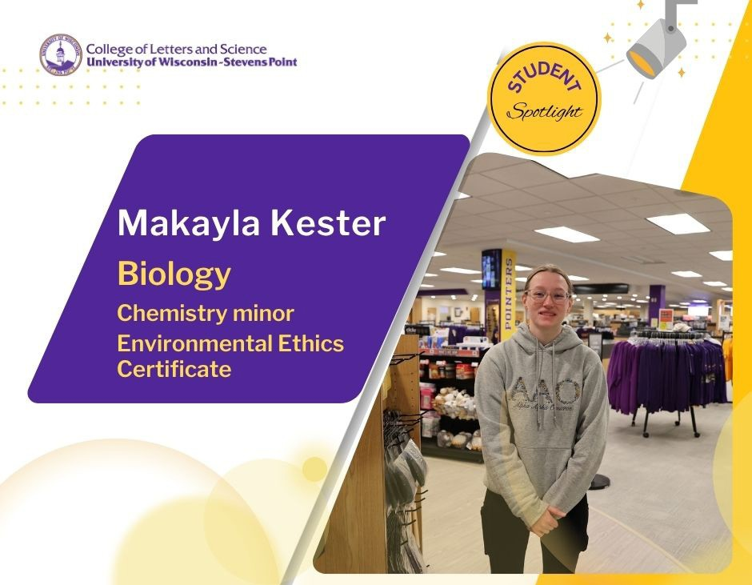

Senior Makayla Kester said her biology major has allowed her to explore all the sub fields of biology. She was undecided on a major until shortly before she enrolled at UW-Stevens Point.

Her older sister, Amanda, will earn degrees in Music Education and Music Performance this year. Makayla said her decision to attend UWSP was prompted by her sister’s enrollment. Her mom is also a Pointer alum. The university’s reputation and the size of the campus were drivers for Makayla.
She grew up in nearby Wisconsin Rapids.

Makayla was honored this spring with the College of Letters and Science Continuing Student Distinguished Achievement Award. As she works
toward her degree in biology, she will earn a minor in chemistry and the Environmental Ethics Certificate.

In her final semesters at UWSP, the honors student will spend even more time conducting research. She started in course-based undergraduate research with Ann Impullitti, biology, as a part of the Tiny Earth curriculum. She expects to spend up to 10 hours a week in the lab this fall, conducting microbiology research with soils.

She loved the hands-on learning focus of the course. The Tiny Earth course taught by Dr. Impullitti included a diverse group of students from outside of biology and biochemistry. Makayla attended a symposium in Madison last spring presenting their findings with others from across the state at the Tiny Earth symposium. Another impactful course for her was taking organic chemistry with Professor Robin Tanke, chemistry. Students should know that faculty at UWSP are helpful and accommodating with support such as office hours to help students.
“I just like discovering new things. It would be so cool to discover an antibiotic,” she said.

Not only has she been hands-on in research, Makayla has led a wide variety of work at the University Bookstore. Working there since her first year at UWSP, she regularly helps with store inventory, training, and customer service. Wherever she is needed.

As for student organizations? There are over 180 clubs on campus offering a range of social and professional experiences for students. Makayla is a member of the Biochemistry Club and a music enthusiasts fraternity called Alpha Alpha Omicron. The club members, including her sister, Amanda, help out as ushers for UWSP performances. She is a past volunteer with UWSP Pointer Pals.

