E
N
T
S
T
U


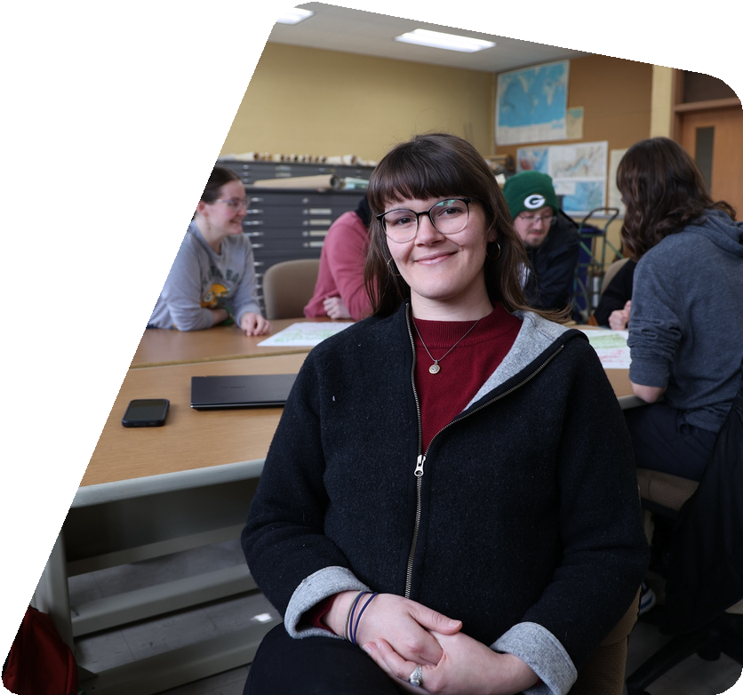





Hendry will graduate from UW-Stevens Point with a degree in geospatial sciences in the spring of 2025. She knows the field offers opportunities for work with engineering firms,
D
Spotlight
Sabrina Hendry
Geospatial Sciences
The ideal job for junior geospatial sciences major Sabrina Hendry would allow her a good balance between working in the field and time in the office organizing data into useful mapping tools.
“I’ve always liked geography and maps can tell a story about an area. It leads you to think about what’s happening there,” she said.
government entities, or a wide range of companies in need of land use analysis. It’s exciting to think she could even work for herself, Hendry said.

Two years ago, Hendry was living with a relative in Madison and studying civil engineering at a technical college. It was the right opportunity to continue her education after several years working in the agricultural industry near her home in upstate New York. Hendry discovered she could transfer her credits and earn her bachelor’s degree within two more years.

Inspired by her new knowledge using CAD programming and working with Geographic Information Systems (GIS), Hendry landed on the geospatial sciences degree program at UWSP. She said the campus reminded her of home. She was impressed by the university emphasis on sustainability and said she was motivated by the breadth of courses in the major.

Among her favorite classes in the program have been those working with technology in her remote sensing and GIS courses.
“I have a very artistic and an analytical side of myself and with a geospatial sciences major I’m really able to use a lot of the analytical and the artistic parts of my thinking,” she said.

As a transfer student, Hendry said she has felt welcomed at UWSP and made very good friends. Connecting with faculty has been important to her success.

“Taking advantage and really getting to know your professors is key. They want to teach and help you learn,” she said.

Last semester, Hendry was named president of the Geo Club, a group of geospatial science majors and some students with natural resources backgrounds. The organization gives her leadership skills and the chance to learn from professionals in the field. Hendry said she stays up to date on campus events and enjoys the diversi-ty of live music available on and off campus.

When she isn’t studying, she enjoys riding horses and downhill skiing.

