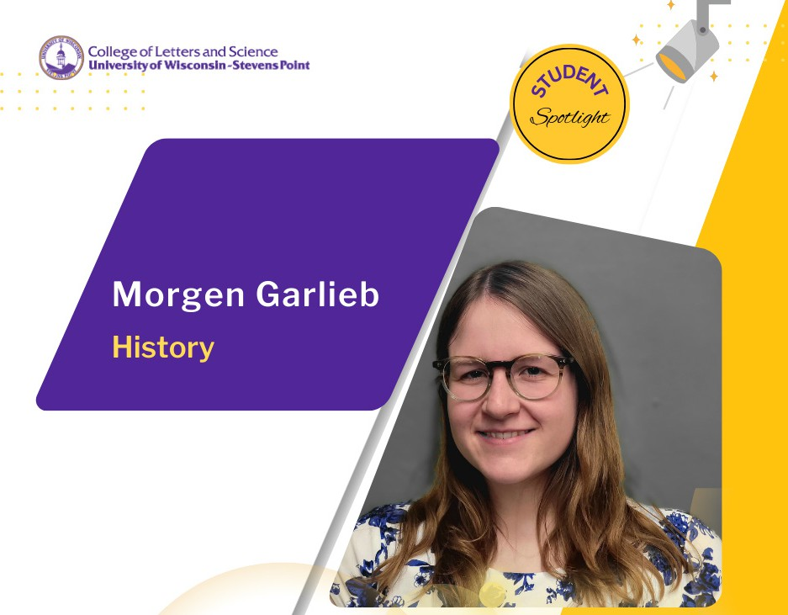

Very few of junior Morgen Garlieb’s courses are lecture-based. The history major said her course work is focused around community understanding and most of her classes foster group discussion about various topics in history.

Last semester, her Museum Exhibits- HIST 390 course showcased weeks of their collaborative work with a public exhibition called Roads to Point.
Garlieb helped her group acquire the physical objects related to modes of transportation over the decades. They landed on a design for the layout of the exhibit and wrote detail-oriented object labels to tell the story behind each exhibit item.

She is passionate about public history. Garlieb said she was drawn to the major after taking a general education history class. She enrolled initially undecided on a path at UWSP. Her hometown friend from Kiel, in northeastern Wisconsin, was pursuing a natural resources major.

As a first-year student, Garlieb said she was nervous that professors would be unapproachable. The complete opposite has been true. Garlieb said she frequently attends faculty office hours. It was during a visit with assistant professor of history Cory Haala where she learned another student was working on reactivating a museum-centered club. Environmental education and interpretation major Dani Allen spearheaded the club’s formation last fall. Haala and museum outreach specialist Brigid Ferkett signed on as advisers and Allen and Garlieb became the first officers for Museum Studies and Enthusiasts or MuSE.

What Garlieb enjoys is the opportunity to get engaged in events and unique projects. MuSE has drawn the interest of dozens of students already. They are working on creative materials for two spring events and will staff booths for the upcoming Dino Night at the Olson Museum of Natural History, in the Science Building next month. It’s a way to build awareness for students and the community about the array of natural science collections accessible on campus.

Her interest in MuSE is to welcome others in to collaborate on tangible and impactful projects, to improve exhibits and help shape the future of the museum.
“I hope it brings awareness of all the ways you can develop museum skills. Hopefully it can attract others,
even non-majors. We would love for people to find a community,” she said.

History students at UWSP are exposed to community collaboration often applying their learning in their public history seminar. Garlieb was part of a group that helped the Portage County Historical Society curate historical features for visitors of Heritage Park. She was thrilled to work on something that will serve others long after she graduates.

“I am trying to pursue a career in museum and historical society work, and the classes I’ve had the opportunity to take at UWSP give me a great window into what that work will look like.”

