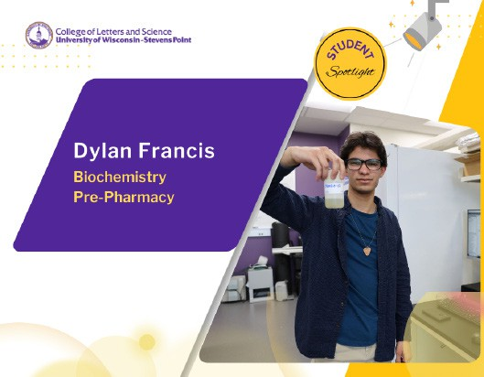

Biochemistry major Dylan Francis enrolled at UWSP wanting to further explore his interests in science. Although he was open to majors in data analytics, chemistry, or wildlife, as he explored the options over his first year Francis said he knew he wanted
to be involved in science that could help people.
Over the past year, Francis has worked closely with professor and Department of Chemistry and Biochemistry Chair Dave Snyder in research measuring nitrogen in agricultural run-off. Their work tests an alternative approach to sampling that produces less toxic waste, called Total Nitrogen (TN) analysis. Snyder said the
project grew out of a senior capstone project in his CHEM 446 course.
Francis and his research partner, Madison Culli, measured samples collected as part of the Great Lakes Restoration Initiative’s Edge-of-Field Monitoring project. They presented their results in the College of Letters and Science Undergraduate Research Symposium.
The experience working in a lab setting has further inspired Francis to pursue work with his biochemistry
major in pharmacy research.
“I’m interested in advances that we can make,” said Francis.

The skills gained in his undergraduate research will be invaluable as he pursues the next step in his career journey, graduate school.
The honors program student said he realized he was taking on an unofficial support role for other students in classes, so he gravitated toward helping to tutor others in the Tutoring Learning Center (TLC) each week. Francis remembers his first semester, finding it hard to understand how to properly study.
He encourages students to reach out to faculty via email or office hours to establish relationships and benefit from their support.

“The professors here are definitely approachable,” he said.
Working in the TLC during drop-in hours, you often get approached about a host of spontaneous questions, he said.
“It’s a nice challenge and kind of prepares you for graduate school tests,” he said.

Beyond his course work and research on campus, Francis is a member of the UWSP Biochemistry Club and has played club soccer. Another avenue he enjoys, dating back to the third grade, is practicing guitar. A great stress reliever, he said? Playing Metallica’s “Master of Puppets.”

