Early on in his college career, he took a comparative religion course at the UW-Stevens Point Wausau campus and realized he cared deeply about its core concepts. Senior Philosophy: Religious Studies major Matthew Dzwonkowski says he has worked with committed professors in his studies who have made themselves available for questions.

He said his adviser Dr. Alice Keefe, professor of religious studies, represents a variety of perspectives in her teaching and has an uncanny ability to know where to seek out the answers to field student questions.

“She can open a book and point to a quote she can incorporate. And she’s never afraid to listen to student ideas,’ he said.

Matthew Dzwonkowski
Philosophy: Religious Studies

D
Spotlight
E
N
T
S
T
U


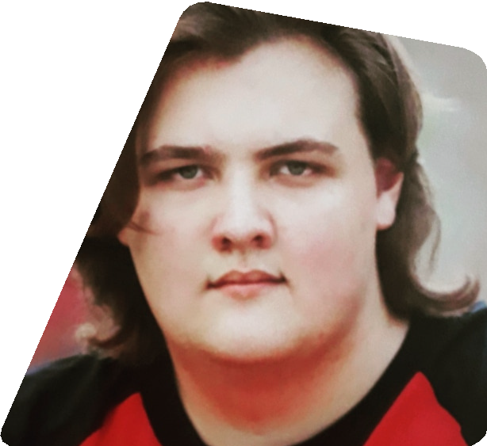




Dzwonkowski commutes from his home in Marathon City, Wis. He transferred to UWSP his sophomore year from UW-La Crosse where he began taking Russian courses with Natalia Roberts, a professor in the UW Collaborative Language Program (CLP). With early exposure to a second language, he grew up learning French from his mother; Dzwonkowski said he strives to be a polyglot so he can forge deeper connections with people.

He has been interested in world cultures since growing up listening to his extended family speaking in Czech at family functions. On his father’s side, it was German, Polish and Russian.

“Hearing those stories, I wanted to maintain those traditions,” he said.

Dzwonkowski describes his language studies as his hobby. A hobby he has diligently pursued, earning the Working Fluency Global Seal of Biliteracy in Russian.
“Take every opportunity as you can to get any certification that you can earn. It can only help you to succeed,” said Dzwonkowski.

Not only stepping up to help as a teaching assistant in French, Dzwonkowski has further helped to organize cultural events for the Department of World Languages. Working again with Professor Roberts, he coordinated an event to celebrate the Slavic holiday of Maslenitsa, marking the start of spring in Russia. Last winter, language students and community members gathered to try the customary blini—Russian pancakes —with toppings and teas, and to learn about the social customs of the week-long festival.

When he graduates next fall, Dzwonkowski will be seeking a role that helps him to build connections with others.

“Talking to someone on their own terms, in their language, is truly a magical thing,” he said.
