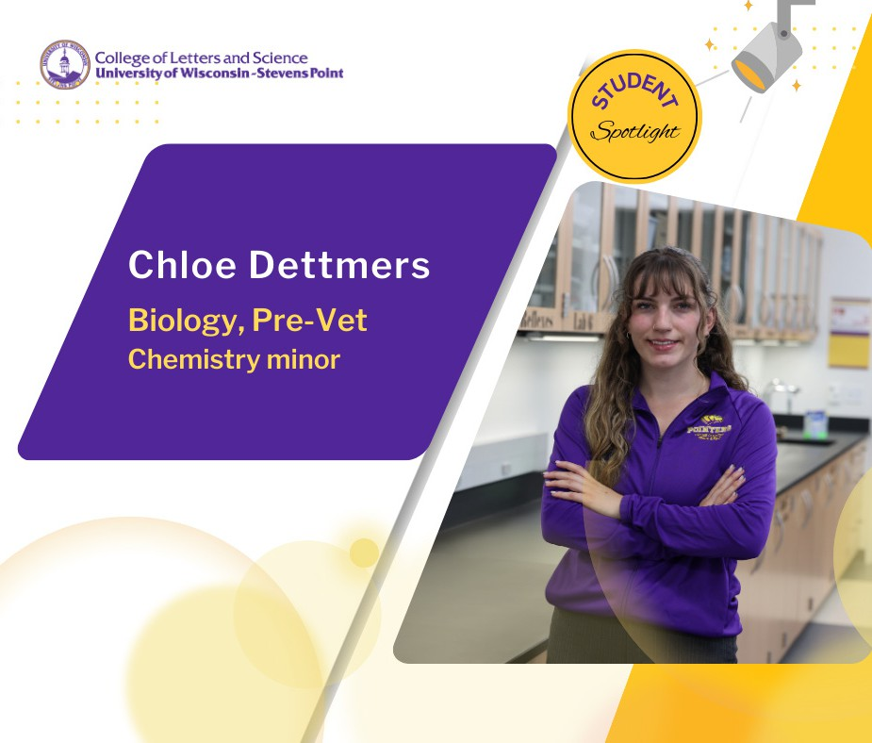

This year, Chloe Dettmers will lead the Pre-Veterinary Medicine Society as student president.
Dettmers is a biology major with pre-veterinary emphasis and earning a minor in chemistry. She said she has always been drawn to understanding animals. Her grandfather, a retired veterinarian, often shared stories about his work and those stories motivated her interest. When Dettmers toured campus and learned about the wealth of animal research she could be involved in working with UW-Stevens Point faculty, she was sold.

The program gave her experiences to get hands-on starting in her first year. She has worked alongside biology associate professor Sarah Jane Alger for the past three years in primate research studying behavior.

“I’ve been working toward this my whole life,” she said.

The summer before her senior year, Dettmers had the chance to work in a mentorship with a central Wisconsin veterinary clinic. She has even conducted field research with lizards at the Grand Canyon National Park! The opportunities are out there, she said, especially by connecting with professors in office hours and telling them about your areas of interest.

Dettmers has enjoyed getting to know her faculty, especially professors Robin Tanke and Jennifer Bray.
“Dr. Bray took an interest in my life outside of the course,” Dettmers shared. “She radiated positivity and knew about me and that made a difference.”

She will once again compete as a sprinter on the UWSP Track & Field team. Dettmers said she has built a strong community of friends from across campus, starting with making friends in her residence hall. The McFarland, Wis. native said she began to connect with study buddies in similar courses from across the biology major.

“You definitely bond because it’s challenging,” Dettmers said.

This fall her courses will delve into interrelationships of plants and animals, along with labs and lectures in physiology, exploring microbial ecology and genetics. Her favorite study break? Spending time taking in the serenity of the Tropical Conservatory inside the Chemistry Biology Building. Even if it’s just a five-minute reprieve between lectures, being in nature keeps her engaged.

“I take advantage of the nature that Stevens Point has around it,” said Dettmers. “It helps center me and helps keep me focused.”

When she graduates in May, she hopes to secure an internship and attend graduate school in veterinary science.

