Jackson Carter, a senior psychology undergraduate, is doing everything he can to achieve his goals after he graduates from UW-Stevens Point. He has immersed himself
in neuroscience studies. Working on multiple projects this past summer, Carter supported faculty-mentored research in biology and psychology.
“I like the unknown. There is so much that we
don’t know that even if it’s a sliver more, I really like exploring the behavioral and the cellular
part of the science,” he said.

Always interested in psychology, Carter said he learned that he enjoyed the neuroscience discipline after taking a number of courses during his first two years. He will earn minors in Substance Use and Addiction Studies and Neuroscience and Behavior.

Jackson Carter
Psychology
Neuroscience and Behavior minor Substance Use and Addiction Studies minor

D
Spotlight
E
N
T
S
T
U


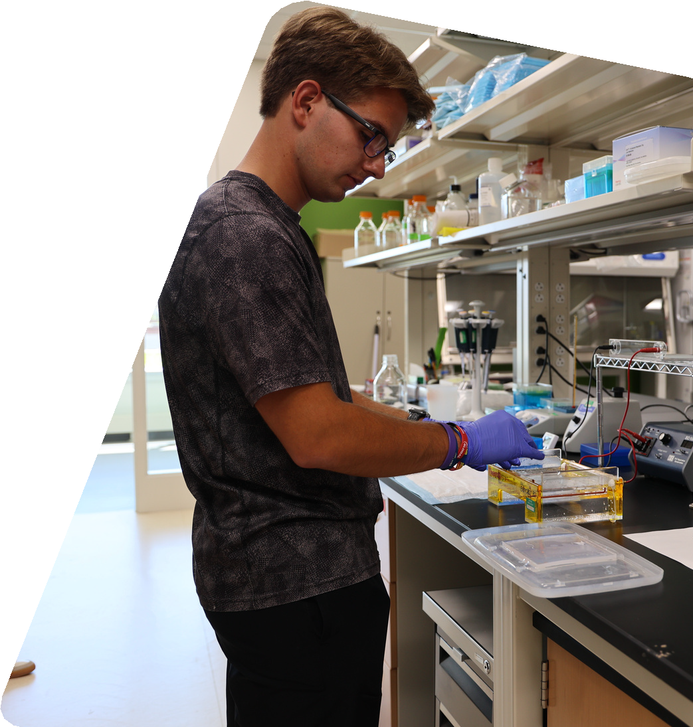





Despite commuting to the main campus from home in the Wausau area, Carter said professors have been accessible for office hours and he has remained connected to friends and study groups. This fall, he will serve as treasurer for the Neuroscience Club and as secretary for the Psychology Club.

His research experience in 2025 included presenting a poster on superstitious belief for the College of Letters and Science Undergraduate Research Symposium. He expanded on his research interest, collaborating with biology and psychology faculty over the summer break.

“You get to know everyone. You start bouncing ideas off of each other,” Carter said.

He assisted in genotyping mice in Dr. Jennifer Bray’s biology lab. He examined the pituitary gland in an electron microscopy project with professors Karin Bodensteiner, Sol Sepsenwol, and Bray. And he grew his skills in supporting the Department of Psychology animal lab under Dr. Heather Molenda-Figueira.
“Just being able to say I am working on projects that are furthering the understanding of neuroscience is so cool and exciting to me and I hope I can continue this into graduate school and my career,” he said.

Now more comfortable in his technical skills as a research assistant, he has his focus on a career in a neuroscience laboratory. The next challenge and resume builder for Carter will bring hundreds of scientists, educators and students to UW-Stevens Point on October 25. He will get the chance to present with fellow student MacKenzie Hardy on the ultra-structural differences in the pituitary gland of CCL2 transgenic mice and C57 control mice.

Getting to put his work in front of subject experts at the Upper Midwest Chapter of the Society for Neuroscience Conference, hosted for the first time at UWSP, is an opportunity to share his growing expertise—an achievement that reflects both his hard work and the mentorships that guide him.

