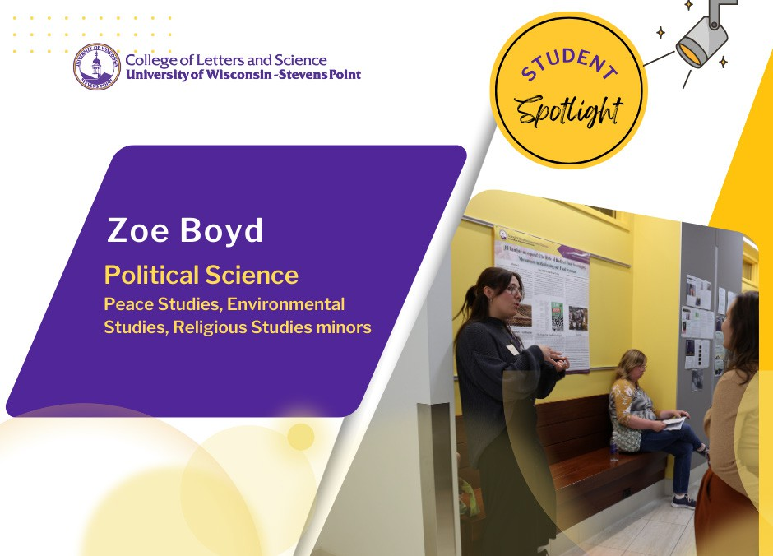

Junior political science major Zoe Boyd grew up in suburban Chicago and heard about UW-Stevens Point while attending a college fair.
Without the benefit of knowing anyone on campus, Boyd decided she would find places to connect and belong.
Boyd interned with the Campus Vote Project and then helped create the campus Pointers Vote Coalition to work
on voter engagement and registration
efforts. Because she had always enjoyed performance, she joined the A Cappella musical student group. Then, through her political science professor and adviser, Dr. Jennifer Collins, Boyd secured a position to serve refugees in the Ethiopian Community Development Council. She attended cultural orientation meetings and helped spread awareness of volunteer opportunities for the new nonprofit.
“You just have to see what feels right for you. Ask yourself, ‘what do I want to get out of my time here,’ in balancing your class work, jobs, other time demands,” Boyd said.
In her upper-level courses, Boyd said she values the time she has spent connecting with faculty such as conducting research on food sovereignty movements in Latin America.
She presented on the topic in last year’s College of Letters and Science Undergraduate Research Symposium.
Boyd has consistently tried to connect with other students in her classes for peer support. What she would tell an incoming student is how crucial it is to stay on top of course assignments and engage in class discussions. In her experience, faculty are invested in your success and willing to work with you to help students manage their coursework.
“Every time I’ve reached out, they are more than happy to help out,” said Boyd. “Showing up to class is half the battle!”

When she graduates next year Zoe Boyd has plans to find employment in the non-profit sector, perhaps working in local government. She will also earn minors in peace studies, environmental studies, and religious studies.
“I can do things important to me while also making a career out of it.”

