Groundwater Model Project
A Project of the UW-Stevens Point Student Chapter of AWRA
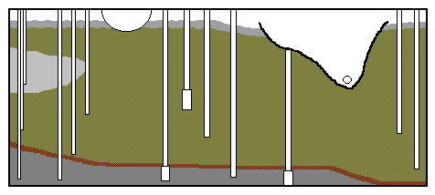
Groundwater Model Project
TNR room 243
College of Natural Resources
UW-Stevens Point
Stevens Point, WI 54481
Phone: 715-346-4613
gwmproj@uwsp.edu

Groundwater Model Order Form

Name:

Billing Address:

Shipping Address:

Phone:
Email:
Date Ordered:
Payment Type:
(Credit Card (3% fee of total amount), Wire Transfer, or Check only)

Quantity | Description | Price Each
 | Groundwater Flow Model | $1077.83
 | Carrying Case | $255.00
 | Rain Simulator | $275.00
 | Repair/Refill Model | $500.00
 | Shipping and Handling | TBD
 | Wire transfer charge | $20.00
*Additional Handling fee added for  customers outside of Wisconsin |  | $50.00

How you heard about us:

*Wisconsin residents/organizations will be charged sales tax of 5.5%. If you are a tax-exempt organization, please provide your Tax Exemption Number with your order.

