YSI Dissolved Oxygen Meter (ProODO and ProSolo)
Hints Companion to Instrument User Manual
Jim Klosiewski, Sandy Wickman, Al Wirt – February 2020

Basic Operation
- It is important that you read the manual that came with your meter. This document is not meant to replace the information found in the manual.
- Some dissolved oxygen meters are maintained by a volunteer “Meter Minder”. We encourage all Meter Minders to password protect the meter that they are responsible for so the settings cannot be changed from one user to another.
- If you are signing out a meter, it has already been calibrated by the “Meter Minder”. You do not need to calibrate it. The instruments hold calibration very well so even if you will be sampling a couple of days later, accuracy is retained.
- All lake groups and individuals that own their own meter and enter data into the SWIMS database must calibrate their meter each time the instrument is used.
  - You will be calibrating your meter using the % saturation method only. It is not necessary to calibrate in both % and mg/L/ppm. Calibrating in % saturation will simultaneously calibrate mg/L/ppm.
- While conducting a lake profile do not let the probe hit the lake bottom. The sensor cap can be damaged by dragging it on the lake bottom.

Calibration Procedures Refer to the owner’s manual for complete calibration instructions.
- Be sure the meter sensor/s are clean before calibration.

- Calibrate your meter indoors. Allow 15 minutes so the meter can acclimate to room temperature.

- If your meter measures conductivity, it must be calibrated before dissolved oxygen. The meter uses temperature, barometric pressure and conductivity to derive D.O.

- Barometric pressure should be checked and calibrated if necessary, before you calibrate D.O.

- If your sensor does not include conductivity, the Salinity correction value should be set to zero. Press the Cal key, select conductivity, then select salinity. Make sure the calibration value is 0.0. If not, change it to 0.0, wait for it to stabilize, and accept calibration.

- If your meter displays an “Out of Range” message during calibration, you will be prompted to accept or reject the calibration. Never accept it.
  - Verify the barometer reading and inspect the sensor cap. Try calibration again. If you receive the error message again, you should replace the ODO sensor cap.
  - If you get this message when calibrating conductivity, clean the vent holes with the small brush that comes with the meter and a small amount of dish detergent. Try calibration again.

Barometric Pressure
Barometric pressure reported on online weather sites, TV weather reports and airports has been corrected to sea level and, needs to be un-corrected to the true barometric pressure using the following guidance.

Retrieve barometric pressure for your area from an online weather site or another source.
  - Find your closest corresponding local altitude on the following “Un-correcting Barometric Pressure Based on Altitude” chart and apply one of the two correction factors from the table.
  - Example: Rhinelander is approximately 1550 feet in altitude
  - If online BP is 29.96 inches at the time of calibration un-correct it by subtracting 1.6 inches (29.96 – 1.6 = 28.36 inches)
  - 28.36 inches is the value your meter should be displaying.
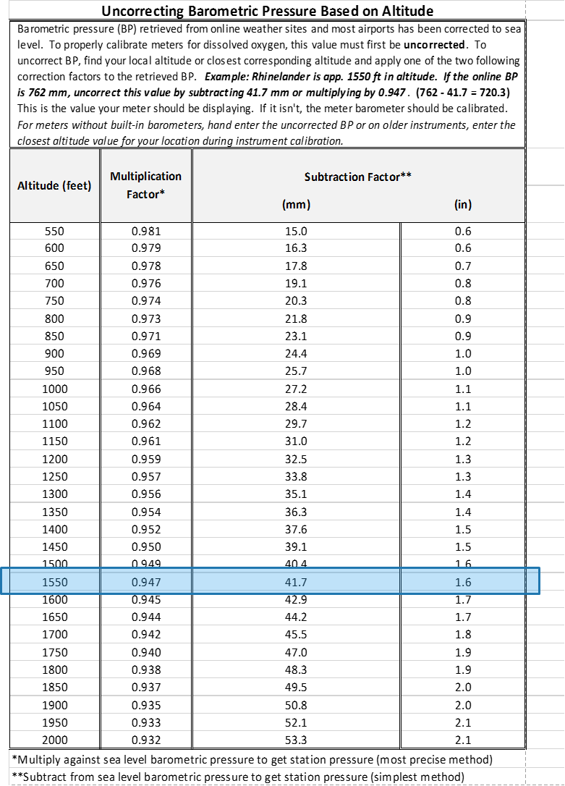
  - Calibrate the barometer if it is off by more than 0.1 inches.

- Press the Cal key, then select Barometer.
- Select Calibration value then enter the correct “true” barometric pressure.
- Select Accept Calibration. “Calibration successful!” will be displayed in the message area.
- For meters without built-in barometers, hand enter the un-corrected BP.

Conductivity
- Use a conductivity standard of 1000 µS for freshwater environments for greatest stability, (order from YSI or other vendors). Standards have an expiration date. Do not use expired standards.

- Fill the graduated cylinder (that is included with the purchase of the ODO/CT cable assembly) with enough conductivity standard so that top vent holes are submerged. Gently agitate so air bubbles are removed from vent holes.

- Press the Cal key, select Conductivity, then select Specific Conductance.

- Select Calibration value then enter the calibration value of the standard used. Note the measurement units the instrument is reporting and calibrating and be sure to enter in the correct calibration value for the units being used. For example, 10,000 μS = 10 mS. Make sure that the units are correct and match the units displayed on the handheld.

- Observe the actual measurement readings for stability (white line on graph shows no significant change for 40 seconds), then select Accept Calibration. “Calibration successful!” will be displayed in the message area.

- Pour out conductivity standard and rinse sensor and graduated cylinder with tap water.
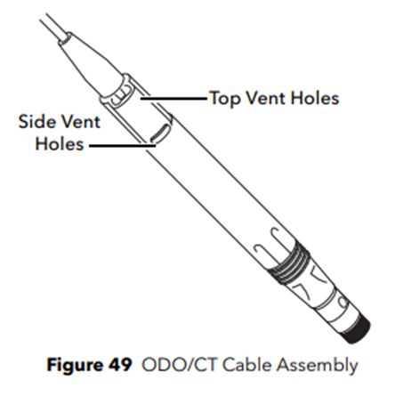

Dissolved Oxygen
- Check to make sure that there are no water droplets on the sensor cap or temperature sensor.

- Place a small amount of clean water or a wet sponge into the calibration sleeve.

- Attach the probe guard and carefully slide into the calibration sleeve.

- Press the Cal key, then select ODO. Select DO%.

- Observe the actual measurement readings for stability (white line on graph shows no significant change for 40 seconds), then select Accept Calibration. “Calibration successful!” will be displayed in the message area.

- If you are not a Meter Minder select View Calibration Record to show the stored sensor calibrations. Use these values for your calibration log.

Taking Measurements
- Push and hold the green power button (lower right of key pad) to turn the unit on.
- Remove the calibration/storage sleeve from the sensor guard.

You may receive a Calibration prompt (this is a function that can be turned on or off). Those meters with a Meter Minder have already calibrated the meter. Press Esc.

- Place the probe in the water at the appropriate depth you will be sampling. An accurate reading can be obtained by gently agitating the sensor bulkhead using a short up and down motion of about a couple of inches per second. When the reading stabilizes, write down the values. Some fluctuation is normal.

The readings should be:
Temperature in °F
mmHg
D.O. %
D.O. mg/L
Spc Cond uS/cm (if you have an ODO/CT sensor that reads conductivity)

- Continue to the next depth and repeat.
- When you finish your lake profile, press the green power key to turn the device off. Place the sleeve on the sensor guard after making sure that the yellow sponge is in the bottom of the sleeve and that it is wet.

Maintenance
https://www.ysi.com/customer-support/software-firmware-downloads - Fill out the form and get instant access to the latest software and firmware releases.

Sensor and Cable Assembly
- After each sampling outing rinse the sensor and housing off with tap water to prevent the spread of AIS. Do not use chemicals to disinfect the unit – this can damage the sensor. If you need to clean the sensor, use a warmwater dish detergent solution and a soft cloth. Any other cleaners will damage the sensor.
- If you have an ODO/CT sensor clean out the top and side vent holes with the small brush supplied with the meter.

Short-term Storage
- Up to one month - keep the sensor cap membrane moist during short-term storage by wetting the sponge inside the sensor guard cover/calibration sleeve.
Long-term storage
- For periods longer than a month - use the sensor cap that covered the sensor in shipment. Wet the sponge and attach the cover to the reading end of the sensor. Replace the sponge when it becomes dirty.
Temperature
- You should verify that the temperature sensor is reading accurately once a year. It can be compared to a Certified thermometer (your CLMN Coordinator should have access to one).
- The temperature sensor cannot be calibrated. If the temp sensor falls out of spec listed in the manual, contact YSI for help.

ODO Sensor Cap
Visually inspect the sensor cap every time the instrument is used, checking for scratches or light leaking through the painted surface when the instrument is on. Optical DO sensor caps are warranted for either 12 or 24 months depending on the model but, as the ODO sensor cap ages, deterioration of the dye layer can reduce measurement stability and response time.

Replacing the Sensor Cap
ProODO Sensor Cap kit Item #626320
ProDO Sensor Cap kit Item #626320

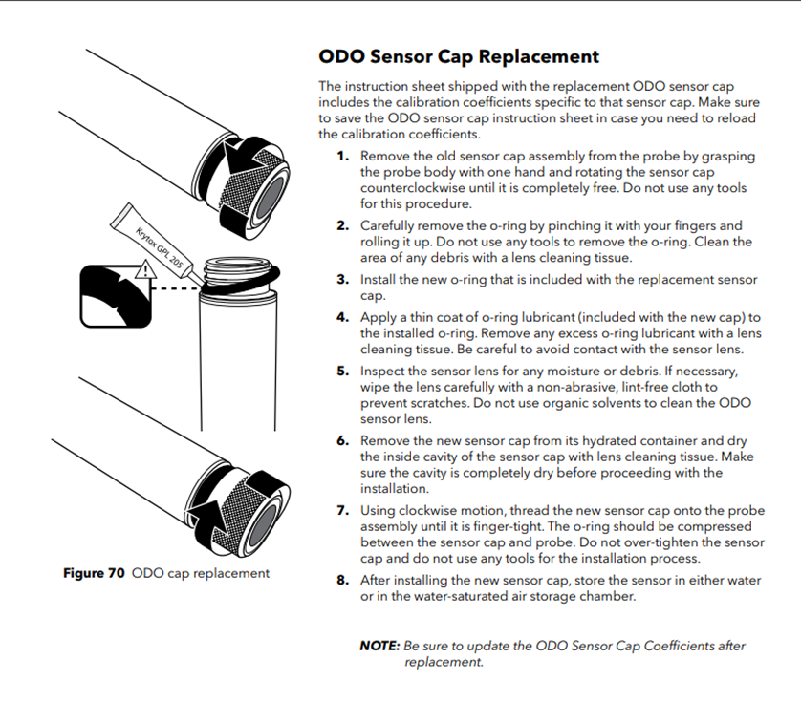

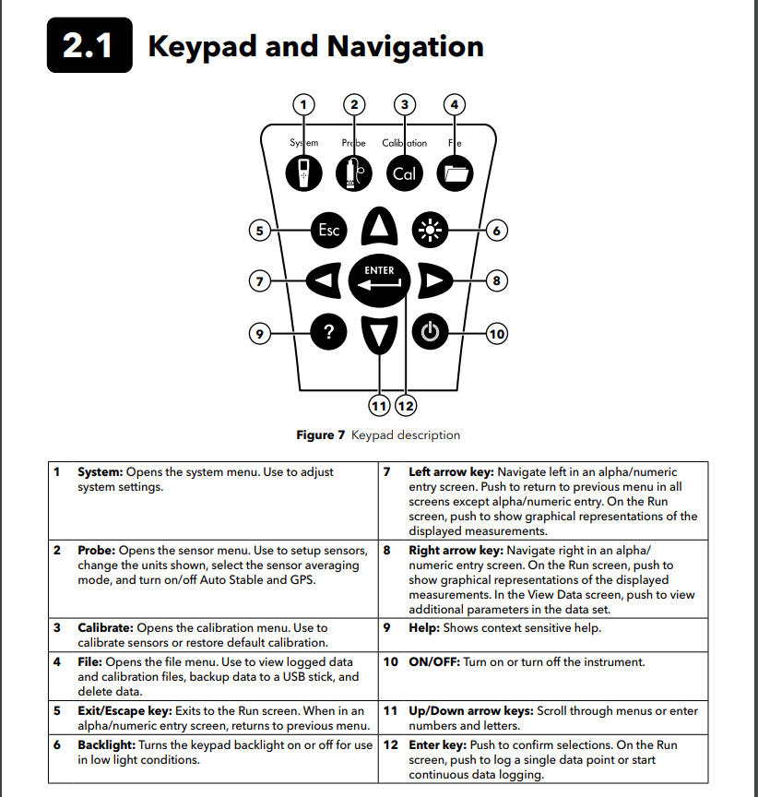

References

ProDigital User Manual Professional Series Digital Handheld Meters
User Manual Item# 626973-01Ref Revision F

ProODO User Manual
Item #626279 Rev C Drawing # A626279 March 2009

