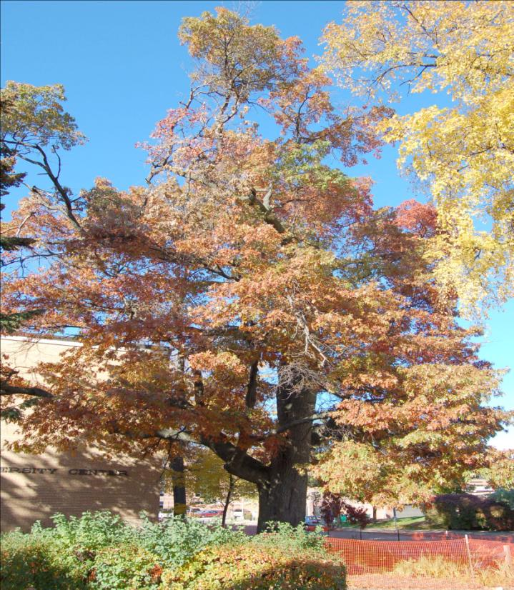

CAMPUS TREE CARE PLAN

University of Wisconsin – Stevens Point

December 2010

Prepared by: David Lein¹, Richard Hauer², and Les Werner²

Undergraduate Urban Forestry Research Assistant and Associate Professors of Urban Forestry

Special Thanks to the Forestry 333 (Urban Forest Management) Spring Class 2010

Table of Contents
- Purpose 1

- Standard One: Campus Tree Advisory Committee 1
  - Committee Role 1
  - Committee Members 1-2

- Standard Two: Campus Tree Care Plan 2
  - Responsible Authority 2
  - Goals & Targets 2
  - Planting Process 3-4
    - Tree Selection 3
    - Recommended/Prohibited Species 3
    - Planting 4
    - Establishment Period 4
  - Maintenance & Landscaping 4-6
    - Tree Risk Assessment 4
    - Removals 4
    - Pruning 5-6
    - Tree Health Care 6
    - Catastrophic Events 6
  - Protection & Preservation 6
  - Tree Damage Assessment 7
  - Prohibited Practices 7
  - Communication Strategy 7

- Standard Three: Campus Tree Program with Dedicated Annual Expenditures 8

- Standard Four: Arbor Day Observance 8

- Standard Five: Service Learning Project 9
  - College Days for Kids 9
  - Earth Day Tree Plantings 9
  - Student Society of Arboriculture 9
  - Planting Week 9
  - Lecture Series - Educating the Community in the Value of Trees 9

- Conclusion 10

- Appendix 11-15
  - Definitions of commonly used terms in the Campus Tree Care Plan 11
  - Wisconsin Department of Natural Resources - Terrestrial Restricted Species List 12
  - Wisconsin Department of Natural Resources –Tree Planting Guidelines 13
  - Prescription or Dosage Based Watering 14
  - Protection & Preservation Process 15

Purpose

The University of Wisconsin – Stevens Point (UWSP) Campus Tree Care Plan was developed to foster a healthy and sustained tree population. This valued urban resource is vital to educate students as well as the public about quality tree care and sound urban forest management techniques. The campus tree care plan delineates the creation of policies, procedures, and practices advocating for a healthy and sustained urban forest. This plan follows the Arbor Day Foundation’s Tree Campus USA program which helps establish and maintain healthy community forests on campuses. The five standards of the Tree Campus USA program are used to develop goals and objectives to help UWSP fulfill its urban forest mission. The UWSP’s underlining mission in the creation of this plan is to maintain a safe and diverse urban tree population that is sustainable and a visual and ecological foundation that is an integral part of the campus infrastructure.

Standard One: Campus Tree Advisory Committee

A tree advisory group, board, or committee serves to provide direction and oversight for an urban tree population. They ideally represent the interest of the human population that the urban forest serves. This section depicts the role and committee members.

Committee Role: The purpose of the Campus Tree Advisory Committee (CTAC) is to guide and monitor this comprehensive tree care plan. The CTAC will have a minimum of one meeting a year to review tree projects, determine if tree care policies and goals are being met, propose solutions to campus tree issues, and to support the Arbor Day observances as well as service learning projects. The CTAC will be present at the Arbor Day observances and service learning projects as time allows.

Committee Members: The CTAC will comprise a representative collection of members that understand urban forest management principles and constraining factors of trees and other campus infrastructure. The members may change over time to better meet the mission set forward in this plan. These members are found in Table 1.

Table 1. Members of the UWSP Tree Advisory Committee.

UWSP Grounds Supervisor
UWSP Grounds Student Intern
UWSP Student Society of Arboriculture Officer/Member
UWSP Urban Forestry Professor
Community Professional (e.g., Stevens Point City Forester or Professional Arborist)
UWSP Student at Large (Proposed)
UWSP Representative to the Chancellor (Proposed)

Committee members shall serve an annual term coinciding with the academic year. There is no term limit for committee. The Grounds Department Supervisor will preside over the meeting in the absence of the committee chair. The committee chair will be selected by the committee members by vote.
Standard Two: Campus Tree Care Plan

The tree care plan presented below provides a means to maintain a campus tree population consistent with the mission of this plan. This is a set of guidelines to help manage the urban forest. They are not the end all for practices that may be needed to maintain the urban forest. The CTAC should regularly review and update this plan as needed so the best informed decision based on current scientific analysis is made. These guidelines may be modified if there is a scientifically based alternate tree care practice that is superior. The following tree care policies and practices should not be overlooked since history has shown that poor tree care practices and the lack of planning has the potential for unnecessary risks to public safety and a greater cost to maintain or treat trees. Common terms used throughout this plan are described in Appendix A.

Responsible Authority: The UWSP’s Campus Tree Advisory Committee, Grounds Department, Student Society of Arboriculture (SSA), and students in urban forestry courses are entrusted with the authority to implement the campus tree care plan. When arboricultural work exceeds the capacity of those listed above to complete work safely and/or effectively, appropriately trained, qualified, and sufficiently insured contractors shall be used.

- Goals & Targets

The UWSP was selected by the State of Wisconsin to become more sustainable through university actions in energy use, purchasing of supplies, and other actions. Reducing the campus reliance on non-renewable energy sources is one action. The campus urban forest can contribute to this goal from the strategic placement of trees to reduce energy consumption and develop a more energy efficient campus. While observing these expectations and adhering to UWSP’s mission there are three proposed goals that will help achieve these targets and provide state of the art education opportunities for students.

Our first goal is to keep current the campus tree inventory we completed in 2010. The inventory data was analyzed with the i-Tree v3.0 program. One plan is for the SSA to keep this inventory current by having a SSA officer submit updates as trees are planted and removed.

Our second goal is to maintain the current spatial data layer using GPS/GIS. These maps will help us identify suitable tree planting sites and existing tree locations. With this information we will be able to assess our current canopy coverage and identify areas where the campus is able to maintain a canopy coverage that is appropriate for the campus. This layer can also be used in identifying where trees may be strategically planted to help reduce energy demands.

A third goal is to maintain the existing tree population and plant replacement trees for removed trees and to meet canopy goals. Safety is a priority and unsafe trees should be made safe or removed. Maintenance of the existing tree populations should be given priority over tree planting when budgets are limited. Tree planting is an important part of creating a visually and ecologically robust campus and an important part with the outdoor classroom for several college courses on campus.

- Planting Process

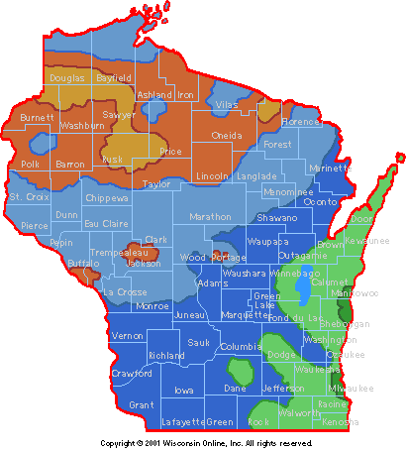
Tree Selection: The CTAC will approve appropriate woody plants (trees, shrubs, and vines) to be planted on campus. Ample consideration shall be given to the outdoor classroom and teaching needs of courses on campus. For example, identification courses such as urban trees and shrubs, vascular plant taxonomy, and dendrology all benefit from a diverse urban tree and shrub population. Plant selections should also be based on site characteristics (e.g., soil characteristics, microclimate, drainage, water availability, orientation, available sunlight, proximity to infrastructure, etc.), maintenance requirements, and desired landscape design goals which include maintaining tree species diversity and determining the overall functionality of the mature tree form.

As much as possible, species diversity will follow a 30-20-10 rule. This means that the entire tree population will have less than 30 percent of individuals from a scientific family, 20 percent of individuals from a single genus, and 10 percent from a single species. When possible, unique species that can be established and marginally hardy plants to campus will be planted for educational purposes.
Figure 1. Hardiness zone map of Wisconsin.

Recommended/Prohibited Species: The CTAC will develop and update as needed a recommended and prohibited tree species list. The recommended tree species can either be a native or non-native species and should fit within the tree selection guidelines described in the above section. Prohibited species include any species listed on the Wisconsin Department of Natural Resources terrestrial restricted species list (Appendix B). Prohibited species may be planted on campus for educational purposes only as long as the species is sufficiently controlled. Trees that require excessive maintenance or significant pest problems should be minimized.

Planting: Tree planting specifications shall follow best management practices as prescribed by the International Society of Arboriculture, American Standards for Nursery Stock, and the Wisconsin Department of Natural Resources (Appendix C). In general, these steps should be taken to:
- Locate the root collar of the tree and create a planting site hole that is no deeper than the root depth and ideally three times the diameter of the tree’s root ball.
- Remove any tags, tree wrap, plastic root ball containers, and/or the bottom half of the wire basket prior to placing in the planting hole.
- Plant with the tree’s root collar at grade or one to two inches above the original grade of the site if root system is likely.
- Remove any remaining twine, burlap, and wire basket from the root ball.
- Remove any soil accumulations from the top of the root ball to expose the root collar if buried and remove any encircling roots or stem girdling roots.
- Adjust the tree from different sides so that it is sitting straight (vertical).
- Back fill the hole to the original soil grade, water to eliminate any air pockets, and ensure that the root collar is not buried.
- Stake as needed using a wide band for one growing season.
- Apply a three to four inches of mulch on top of the planting site leaving an area of bare soil one to two inches from the root collar.
- Follow-up with watering as needed until established.

Establishment Period: Water the tree sufficiently with one to two gallons of water per diameter inch of the stem (Appendix D). In general, daily watering is needed after planting for several weeks. Watering frequency decreases to several times per week for the next several months and eventually to weekly watering until established. Only fertilize newly planted trees when a soil test requires it or based on landscape goals. Minimize any canopy pruning during the establishment period unless to prune broken or damaged branches. If pruning is to be done follow the proper pruning procedures below.

- Maintenance & Landscaping

Tree Risk Assessment: Tree risk assessments should be performed as resources allow. Trees bordering high-use areas will receive more frequent inspection. Less frequent inspection will occur with trees in areas that have less frequent human activity. It is recommended that trees be inspected following significant weather loading events. The Grounds Department can decide whether or not to remove a high risk tree. Although CTAC may provide guidance in cases that warrant a final authority for decision making. Tree risk assessments will be scientifically based and use guidelines in the USDA Urban Tree Risk Management system (NA-TP-03-03) or any other approach that the CTAC deems sufficient.

Removals: Trees that are designated as hazardous to human or property and the hazard cannot be corrected will be removed. Only qualified personnel should remove trees. Once the tree and stump have been removed, the backfilled hole may be replanted as long as the replacement tree fits within the tree selection criteria as described in the previous section.

Pruning: The urban forest on campus will generally follow goal orientated pruning techniques that are based on a tree’s age. The best time to prune will be determined by tree species, age, location, and the potential threat of pests. Trees within the vicinity of high-use areas such as walkways and roadways should be inspected for safety and clearance issues as resources allow. Recommended clearance heights of branches and foliage are eight feet above walkways and a minimum of 14 to 16 feet above roadways. All pruning activities must follow ANSI safety standards and the ISA’s Best Management Practices - Tree Pruning Guide. Pruning of campus trees will be coordinated through the Grounds Department, arboriculture classes, and the SSA.

While pruning campus trees there are some important pruning recommendations that should be highlighted. Pruning should avoid damaging the branch collar (Figure 2). Branches should be removed prior to the branch reaching a diameter greater than two inches to reduce wound size. All pruning will be done on a priority basis whereas safety takes precedence followed by establishing proper tree structure and lastly aesthetics.

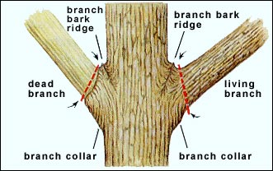
- Young Trees: It is recommended that young established trees up to seven years old go through a training and structural pruning technique on an annual basis or as needed. The goal of the training technique is to establish and maintain a dominant central terminal leader and the lowest permanent scaffold limbs. The goal of structural pruning is to establish a branch architecture that reduces the chance of future branch failure. Structural pruning should maintain a live crown ratio of 60%, establish appropriate spacing between scaffold limbs, and remove any branches before they grow to reach half the diameter of where it is attached to the trunk. It is recommended that no more than 25% of the live crown of young trees shall be removed.
Figure 2. Pruning locations and terminology.

- Juvenile Trees: Trees seven to twenty years of age should continue to receive structural pruning every three to five years. Similar to the young tree structural pruning technique a live crown ratio of 60% should be maintained, establish and maintain appropriate spacing between scaffold limbs, remove any branch before it grows to reach half the diameter of where it is attached to the trunk, and remove any temporary branch before it reaches two inches in diameter.

- Mature Trees: Trees twenty years of age and older will use cleaning, thinning, raising, and reduction pruning techniques. These pruning techniques are used to improve tree structure and to the reduce the risk of injury to humans and property damage. The goal of cleaning is to remove dead, dying, diseased, sub-ordinate, and weakly attached branches. The goal of thinning is to reduce the number of scaffold branches to increase light/wind penetration, all while retaining the natural crown shape. The goal of raising is to remove lower branches and provide more clearance and to maintain at least a live crown ratio of 60%. The goal of reduction pruning is to remove a part of a branch back to a lateral branch in an effort to slow the branch’s growth or redirect growth. It is recommended that no pruning will remove more than ten percent of a mature tree’s live crown to minimize the wound surface area (wound diameter should not exceed one third of the trunk’s diameter at that location).

Tree Health Care: Tree health care actions will be approved on an individual tree/incident basis. To help maintain the vitality of campus trees it is recommended that tree care personnel preform an ocular assessment of whether or not there is a pest infestation, nutrient deficiency, water stress, or any other unusual condition while preforming tree maintenance. When a tree health issue is identified, appropriate treatment options will be made based on funding, priority, and likelihood of success.

Catastrophic Events: A catastrophic event in the urban forest can be described as anything that suddenly inflicts major tree damage or death in a defined area without notice. Such events often include a major weather event or pest infestation. A preplanned response and recovery plan will be developed as resources allow.

A response portion of the plan typically develops a priority list of what areas need to be cleared of all safety hazards first. That list usually identifies high-use areas as the top priority and decreases priority as usage decreases. The recovery portion may establish protocols on how a landscape restoration project will be accomplished through priority based pruning and planting.
In the event that this plan is implemented an incident manager may want to provide an evaluation of what happened, what the plan addressed correctly, and what areas of the plan needs improvement.

Protection & Preservation: All trees should be considered for retention or transplanting in construction areas. Tree protection zones will be created prior to construction and a critical root zone established. Construction activities shall not occur in the critical root zone unless specifically authorized. It is recommended that all trees that are identified as needing protection within the designated work area have a Council of Tree and Landscape Appraisers (CTLA) value calculated prior to the start of the project and after the project is complete. When damage to a protected tree is identified the visiting project manager may be penalized based on the criteria described in the tree damage assessment section and as agreed to within a construction contract. Appendix E presents a proposed protection and preservation process.

Prohibited Practices: Vandalism or any tree care not authorized by the Grounds Department on campus is prohibited. This includes tree carving, attaching advertisements with the use of nails and staples, and removing parts of the tree or any other action that decreases the tree’s vitality. Any tree, shrub, or vine that is planted without the guidance/approval of the Grounds Department is prohibited. Minor removal of tree parts for educational purposes is authorized.

Communication Strategy: The University of Wisconsin - Stevens Point Campus Tree Care Plan will be publicly displayed on the UWSP’s website on the Grounds Department page. All related campus tree programs can be advertised to the student body by the campus e-mail distribution system, the official university website, and the weekly informational emailing to natural resource students and faculty.

To effectively communicate the proper policies, procedures, and practices outlined in the campus tree care plan it is suggested that all potential contractors be notified during a project bidding process to ensure full cooperation. UWSP may give a paper copy of the relevant campus tree care plan sections for a contractor to reference which helps eliminate any miscommunication prior to any work is to be initiated. UWSP may also want to provide a reference to the campus tree care plan for the student body in the student handbook, which is a handbook outlining all acceptable behavior.
Standard Three: Campus Tree Program with Dedicated Annual Expenditures

Currently an annual tree care budget of $52,100 is spent with managing the UWSP urban forest. The annual budget divided by an approximate 9,200 full-time students equates to $5.66 spent per student. This budget does not account for the value of present tree care equipment or the volunteer labor from the SSA, arboriculture classes, and service learning projects.

Table 2. Current annual tree care expenditures at UWSP.

Expense Area¹ | Cost ($)
Annual Planting | 8,000
Annual Pruning | 2,000
Annual Tree and Stump Removal/Disposal | 3,000
Annual Pest and Disease Control | 100
Annual Establishment/Irrigation | 3,000
Annual Repair/Infrastructure Damage | 12,000
Annual Litter/Storm Clean-up | 4,000
Expenditure for Program Administration | 10,000
Other Annual Expenditures | 10,000

¹From Forestry 333 Stratum Exercise: Parameter Input Data (2010)

Standard Four: Arbor Day Observance

An Arbor Day observance will be held on UWSP annually on the last Friday of April which is in accordance to the State of Wisconsin’s law. Each Arbor Day celebration will be used as an opportunity to educate the campus community about the benefits of having trees in our community. The Arbor Day observance will be held on campus with a public invitation to the surrounding community. On Arbor Day UWSP may want to host guest lectures about the importance of having trees in our community, or have a ceremonial tree planting on campus with a short memorial portraying the importance of Arbor Day.

It is required by Tree Campus USA to record evidence of the annual Arbor Day observance. This evidence may be recorded in a log book that includes the date, time, location, and individuals participating in the event. Additional evidence that can easily be recorded is any media stories/advertisements by the student newspaper, city newspaper, county newspaper, and local news radio and television stations, or pictures and video recordings of the Arbor Day observance.

Standard Five: Service Learning Project

UWSP inspires to share the importance that our campus’s tree resource has with students, staff and community through service learning projects. Service learning is also important to the general education of students and is a current area being integrated into the general degree requirements for students at UWSP. Student organizations on campus including the SSA and Society of American Foresters have annual tree plantings that can easily be used to educate people on benefits trees provide. Below is a list of the service learning projects (pre-existing and proposed) that can be implemented at UWSP.

College Days for Kids (Pre-existing): College Days for Kids is a program designed for high - ability sixth graders. Participating schools bring these sixth graders to UWSP for a couple days to experience enrichment classes taught by university faculty and academic staff. The objective of this program is to expose the sixth graders to all of the potential degrees offered at UWSP in hopes to spark an interest. These students are exposed to the forestry programs by giving them hands-on activities and tree identification.

Arbor Day and Earth Day Tree Plantings (Pre-existing): UWSP has observed both Arbor Day and Earth Day by planting trees on campus. This event typically had an attendance composed of student and community volunteers, and campus officials. Volunteers are split into small groups and are typically assigned one SSA student to educate them on how to plant a tree correctly. Arbor Day and Earth Day tree plantings have been historically covered by many local media sources such as the Stevens Point Journal and by the campus newspaper.

Student Society of Arboriculture (Pre-existing): Campus pruning creates an opportunity for interested students to gain knowledge and experience in the field of arboriculture. Campus pruning consists of a head-pruning officer who takes other students around campus and gives them hands-on experience in the basics of pruning trees. The SSA has Experience Days that are another way to provide students with the chance to gain valuable work experience off campus. Another service is “Climbing for Kids” this program teaches children about careers as an arborist through climbing demonstrations.

Planting Week (Proposed): A proposed “UWSP Tree Care and Planting Week” (UWSP-TCPW) project may serve as an outreach opportunity to portray the spirit of the Tree Campus USA designation for the university. The UWSP-TCPW will also serve as an opportunity to engage the campus population, local public, and schools within the communities to learn how to plant trees, shrubs, and other vegetation on campus grounds, along with performing various arboricultural demonstrations on campus trees, shrubs, and other vegetation. The UWSP-TCPW will be a great opportunity for the campus population to work and educate community members and school children alike.

Lecture Series - Educating the Community in the Value of Trees (Proposed): Students may be selected to host a free informal lecture on campus about the values of neighborhood trees. The goal is that community members walk away with a greater understanding, as well as a renewed appreciation of the urban forest environment while student lecturers gain valuable experience in public speaking.
Conclusion

The University of Wisconsin - Stevens Point Campus Tree Care Plan was created to develop an initial set of proper policies, procedures, and practices advocating for a healthy and sustained urban forest. This plan followed the five standards that the Arbor Day Foundation’s Tree Campus USA initiative to promote healthy community forests on campuses. It is expect that this plan will be revisited on a periodic basis to see if current approaches work, if areas important to urban forest management are missing, and to modify this plan as needed. This plan does not cover every possible aspect important to managing the urban forest. Rather, it provides an important basis to move a written and orderly process forward.

Appendix A – Definitions of commonly used terms in the Campus Tree Care Plan.

Definitions: Below is a list of terms used in urban forestry that are presented here to aid in clarity and understanding of this document.

Branch Collar – The area where tree stem tissues and branch tissues overlap connecting the branch to the stem.
Canopy Cover – The extent of the outer layer of leaves over the ground below. It is the proportion of land that the canopy covers compared to the total land area.
CTLA – Acronym for Council of Tree and Landscape Appraisers, which is a tree appraisal that estimates the replacement cost of a tree with another tree of the same species, condition, and size.
DBH – Acronym for diameter at breast height which is the standard place of measurement, 4.5 feet, for a tree’s stem diameter.
Hardiness Zone – A geographically defined area in which plant life is capable of growing. The United States is divided into 11 hardiness zones based on a plant’s ability to withstand the minimum temperatures of that zone.
Internodal Pruning – Cuts made between branch unions or buds which may lead to branch dieback.
Native Species – A naturally occurring species of plant/tree that is indigenous to an area or region.
Pruning – The removal of any portion of a tree through the use of a cutting tool.
Root Ball – The collection of soil and roots of a tree that has been packaged to aid in transportation of the tree.
Topping – Internodal pruning at the top portion of a tree canopy.
Temporary branch – Any branch below the lowest permanent scaffold limb or any branch that is targeted to be removed in the future.

For more definitions see the “Techno Tree Biology Dictionary & Tree Care Information” website at: http://www.treedictionary.com/. This website has been provided by Keslick and Son Modern Arboriculture, Associates © 2009.

Appendix B – Wisconsin Department of Natural Resources - Terrestrial Restricted Species List

Classification¹ | Common Name | Scientific Name
P/R | Amur honeysuckle | Lonicera maackii
 | Amur maple (CV) | Acer ginnala
R | Autumn olive | Elaeagnus umbellata
R | Bells honeysuckle | Lonicera x bella
 | buckthorn | Rhamnus spp.
 | Burning bush (CV) | Euonymus alata
NR | Callery pear | Pyrus calleryana
 | Chinese elm | Ulmus parvifolia
R | Common buckthorn | Rhamnus cathartica
 | English ivy | Hedera helix
 | European barberry | Berberis vulgaris
 | European mountain ash | Sorbus acuparia
R | Glossy buckthorn (CV) | Frangula alnus
 | honeysuckle | Lonicera spp.
 | Japanese barberry (CV) | Berberis thunbergii
P | Japanese honeysuckle | Lonicera japonica
R | Morrow's honeysuckle | Lonicera morrowii
R | Multiflora rose | Rosa multiflora
 | Norway maple (CV) | Acer platanoides
R | Oriental bittersweet | Celastrus orbiculatus
P | Princess tree | Paulownia tomentosa
R | Russian olive | Elaeagnus angustifolia
P | Sawtooth oak | Quercus acutissima
NR | Scotch pine | Pinus sylvestris
 | Siberian elm | Ulmus pumila
R | Tartarian honeysuckle | Lonicera tatarica
R | Tree-of-heaven | Ailanthus altissima
 | Wayfaring tree | Viburnum lantana
 | White mulberry | Morus alba
 | White poplar | Populus alba
P | Wineberry | Rubus phoenicolasius

¹Chapter NR 40 Classification Key: P=Prohibited; R=Restricted; C=Caution; NR=Non-restricted

For an updated list of the current invasive species please visit this website and click on - A Field Guide to Terrestrial Invasive Plants in Wisconsin
http://dnr.wi.gov/invasives/

Appendix C – Wisconsin Department of Natural Resources –Tree Planting Guidelines.

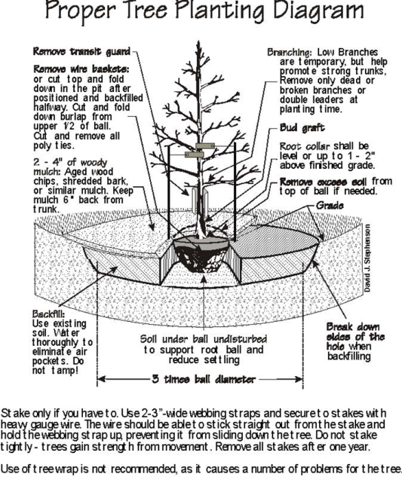

Appendix D – Prescription or Dosage Based Watering

Labor to water trees is sometimes given as a reason or excuse used for not adequately watering newly planted trees. If the water requirements of newly transplanted trees cannot be met, planting smaller trees is recommended. For example, 1- and 2-inch caliper trees have less root loss and recover faster than trees 2 to 3 inches in stem caliper. Mulching trees to a 2- to 3-inch depth is recommended as it helps to reduce evaporation and conserve precious water. Incorporating the labor cost of watering trees within the tree planting budget should insure adequate watering occurs and trees establish successfully. If tree planting is part of the contract process, consider including watering as an additional component in the bid. Your community forestry program will be far better off if trees are adequately watered rather than continually replanting and not realizing the benefits that mature and established trees provide.

Irrigation Guidelines for Quickly Establishing Trees (Well- drained sites during the growing season in the Midwest)

- Less than 2-inch caliper planting stock: Water daily for 1 week; every other day for 1 to 2 months; weekly until established

- 2- to 4-inch caliper planting stock: Water daily for 1 to 2 weeks; every other day for 2 months; weekly until established

- 4-inch caliper planting stock: Water daily for 2 weeks; every other day for 3 months; weekly until established

Notes: Modified from Gilman, E.F. 1997. Trees for Urban and Suburban Landscapes. Delmar Publishers. 662 pp.
- Delete daily irrigation when planting in fall or early spring. Little irrigation is needed when planting in winter.
- Reduce frequency in cool, cloudy, wet weather if soil is poorly drained (soil drains less than 3/4 inches per hour). Eliminate daily irrigation in poorly drained soil. Following a rainfall wait until all free moisture drains out of the soil.
- Establishment takes 12 months per-inch-trunk caliper.
- Minimum frequency for survival could be once each week.
- Irrigation can cease once trees drop deciduous foliage in the fall.
- At each irrigation, apply 1 to 2 gallons for each inch of trunk diameter to the root ball.

Adapted from: Hauer, R.J. 2000. Tree Establishment: Water you going to do! Minnesota Shade Tree Advocate. 3(3):5-7

Appendix E – Protection & Preservation Process

Selection of trees to retain shall occur before construction occurs. The first step in this approach is to create or obtain a site map of the area that is designated for construction or renovation, including the buildings and their locations, the construction area(s), and the tree locations. While using this site map, identify all the trees whose root systems are likely to be impacted by the construction processes and all the trees whose branches may be damaged by construction equipment. These trees will then be considered to be potentially impacted. Once all of the potentially impacted trees are identified, they will then need to be prioritized or ranked. The potentially impacted trees will need to be ranked from high priority for preservation to low priority for preservation, and also ranked as not salvageable if necessary. High priority trees are those trees that are of medium to large size ranging from greater than 10-inches in diameter at breast height (DBH) to larger than 24-inches in DBH. High priority trees are also trees of desirable species that have good form and structure, are in good health, and have adequate room to continue growing. High priority trees should receive a high preservation and protection priority. In addition, large valuable trees should receive preservation consideration with construction alternatives allowing that the desired features and costs of the proposed buildings are maintained. Trees with a low priority for preservation are generally smaller trees with less than 10-inches in DBH. Trees that have a low priority ranking can also be those which have a relatively low landscape value, poor form and structure, species of relatively low landscape or educational value, and/or insufficient space for future growth. Trees that are deemed not salvageable from a construction or renovation area are those with characteristics such as undesirable species, very poor health, have a very low landscape or educational values, heavily diseased, heavily damaged, and have little chance of recovering their desirable form, structure, and function.

Protection of retained trees shall occur during construction activities. Once the areas containing high and low priority rankings for preserving trees are identified, these areas need to be zoned for protection. These tree protection zones need to be sheltered by tree protection fencing. The tree protection fencing must be installed around all groups of trees or individual trees designated as high or low priority rankings for preservation. The fencing must be installed at a distance from each tree or groups of trees of at least 1.25-feet per inch of trunk diameter, or 6-feet away, whichever distance is greater. The fencing must also be installed before any equipment arrives on the construction or renovation site. The area within the tree protection fencing zone must be mulched to a depth of 4-inches. The fencing must be maintained for the entire duration of the construction or renovation project and may be removed at the end of the project, provided that official permission has been granted by the committee. No activity shall occur within the tree protection fencing zone other than laying mulch. The project manager shall be held liable and will be penalized if events other than mulching occur within the tree protection fencing zone. (Please refer to the Tree Damage Assessment section for more information) The tree protection fencing must be 11.5-gauge, galvanized, chain-link fencing with a minimum of 1.625-inch outside diameter, tubular steel posts and top rails and a minimum height of 4-feet. Surface mounted fence panels may be used if approved by the Committee. Surface mounted fence panels must also be adequately braced to resist wind loading.

