What is Anthropology?

A
nthropology is the study of humanity from a holistic, comparative and cross-cultural perspective. Anthropologists strive to better understand and explain human prehistory and the origin of our species as well as the diverse cultures, communicative practices, adaptive strategies, and livelihoods of contemporary peoples. Anthropology is an interdisciplinary study that draws and builds upon knowledge from the social and biological sciences as well as the humanities and physical sciences. A central concern of anthropologists is the application of knowledge to the solution of human problems.

The practical value of anthropology goes beyond broadening our understanding of the human species and how we have changed biologically and culturally. For any person seeking to understand and deal with diverse groups of people in our own society, or distinct cultures around the world, for travel, business or scientific pursuits, a background in anthropology is very valuable. A key component of anthropology is learning to know and respect other cultures. Anthropology makes an important contribution toward the modern goals of peaceful relations between nations and ethnic groups. Racial slurs and put-downs, ethnic jibes, and religious prejudice are more than just impolite and discourteous - they cannot be justified by anthropologists, who have learned to understand the history and dynamics of human cultures.

Anthropology is an excellent minor that complements any number of other university programs. The recently redesigned anthropology minor at UWSP allows students to use courses in other disciplines to fulfill a portion of the requirements for the minor.
Anthropology Courses
Spring 2015

ANTH 101 General Anthropology
3 cr. (GDR: NW, SS; GEP: GA, SS)
Sec 1 T R 11:00-12:15 Choi, I.
Introduction to anthropology that includes human evolution and biological diversity, human cultural and linguistic diversity, and archaeology.

ANTH 102 Introduction to Archaeology
3 cr. (GEP: SS; GDR: SS1)
Sec 1 R 14:00-16:30 Kelly, G.
Introduction to the anthropological subfield of archaeology, which studies human cultures through the recovery, documentation, analysis, and interpretation of material remains and environmental data.

ANTH 105 Biological Anthropology
3 cr. (GEP: SS; GDR: SS1)
Sec 1 M W 9:35-10:50 Choi, I.
Sec 2 M W 11:00-12:15 Choi, I.
This course explores the mechanisms of human and non-human primate biological evolution, human genetic diversity, and the fossil record of human ancestors. In addition students will study human biology and its effects on behavior. Studies include the mechanisms of human and non-human primate biological evolution, genetic inheritance, human adaptability and variation, as well as the intersections of forensic anthropology and bioarchaeology including the fossil record of human ancestors.

ANTH 110 Cultural Anthropology
3 cr. (GEP: SS; GA GDR: SS, NW)
Sec 1 T R 9:35-10:50 Jennings, T.
Sec 2 M W 12:35-13:50 Jennings, T.
This course introduces students to the basic concepts, debates, and methods of cultural anthropology. Culture frames the way people perceive, understand, experience, relate to, and respond to the social and physical worlds around them. Cultural anthropology invites us to think critically about practices and beliefs that we assume to be normal, logical, or inevitably right in our everyday lives.

ANTH 311 Human Evolution
3 cr. (Writing Emphasis)
Sec 1 T R 9:35-10:50 Choi, I.
This course investigates human biology and its effects on behavior. Studies include evolutionary theories, human and non-human primate biological evolution, genetic inheritance, human adaptability and variation, as well as the intersection of forensic anthropology and bioarchaeology. Prereq. ANTH 105 or biology.

ANTH 325 Culture and Language
3 cr. (SS1)
Sec 1 T R 11:00-12:15 Jennings, T.
Linguistic anthropology is an interdisciplinary field dedicated to the study of language in its social and cultural context. This course examines how language both reflects and shapes thought, worldview, culture, identity, and power. You will learn how to apply the concepts we study to your everyday experiences with language and reflect critically on those experiences.

ANTH 380 Medical Anthropology
3 cr. (GEP: SS; GA GDR: SS1; NW)
Sec 1 M W 11:00-12:15 Jennings, T.
Anthropological approaches to the knowledge and understanding of health and disease from a comparative and cross-cultural perspective.

Interdisciplinary Studies (IS)
Minoring in anthropology fulfills the Integration Level of the General Education Program (GEP) embedded in each major.
Minoring in Anthropology

To complete a minor in anthropology you will need 18 credits including:

- Two Courses (6 credits):
ANTH 105 (Biological Anthropology) and
ANTH 110 (Cultural Anthropology)

One Course (3 credits):
ANTH 311 (Human Evolution) or
ANTH 325 (Culture and Language)

- Two Courses (6 credits) from the Anthropology curriculum 300 or above.

3. One elective (3 credits) Any ANTH course not included in above core; ART 270, 370, 380, 382; BIOL 101, 210, 305, 322, 311; BUS 339; CIS 300; EDUC 205, 305; ENGL 284, 374, 382, 348/548, 354/544; FREN 381/681; GERM 481/681; HMNG 101, 102; SPAN 481, 483; GEOG 113, 120, 300, 340/540, 496/696; HIST 101, 102, 216, 217, 232, 233, 248, 280, 310/510, 314, 342, 382/582, 389, 392, 393; INTL 381; IA 150, 160, 310; MUS 220, 307/507; NRES 150, 323, 460; PHIL 380, 381; REL 100, 302, 311, 330, 333 340, 341; POLI 315, 371, 374, 385, 387, 414; PSYCH 322; SOC 270, 343, 364; THEA 461

Regularly scheduled courses:

ANTH 105 – Biological Anthropology
ANTH 110 – Cultural Anthropology
ANTH 199 – Reading in the Disciplines
ANTH 311 – Human Evolution
ANTH 325 – Culture and Language
ANTH 339 – Native Cultures of North America
ANTH 372 – Environmental Anthropology
ANTH 390 – Special Topics in Anthropology

Anthropology Instructors

Inne Choi is an associate lecturer in anthropology and teaches courses in biological anthropology and human evolution, with an emphasis on primate ecology and behavior. She has studied dentitions of tamarin monkeys, Neanderthals, and Native American populations. Inne has also spent time in China and in Thailand conducting fieldwork in the areas of ethnomusicology and human ecology. Prior to coming to UWSP, she taught at California Polytechnic State University, San Luis Obispo, CA.
Tori L. Jennings received her Ph.D. in Anthropology from University of Wisconsin-Madison in 2010. She was a Social Science Research Council–International Dissertation Research Fellow from 2004-2005. Since 1998, Tori has been conducting ethnographic research with farmers and ranchers on a variety of human/environmental issues including water rights in the San Luis Valley of southern Colorado (BA); adaptation to climate variability in the American Northern Great Plains (MA); and a critical examination of the sociocultural and political dimensions of climate and climate change in Cornwall, England (Ph.D.). By incorporating the insights of anthropology, human geography, and environmental history, Tori’s research provides an historical analysis of the implicit cultural, social, and scientific assumptions embedded in the concept of climate and the implications these assumptions have for obscuring political economic relationships in society.
Gwen Kelly received her Ph.D. in Anthropology from University of Wisconsin-Madison in 2013. Gwen’s teaching and research interests are focused on archaeology, ethno-archaeology, historic archaeology, and museum studies. She has worked on materials from Medieval Madagascar, and Ptolemaic and Roman Egypt. Gwen specializes in craft technologies and social and economic organization in Southern India during the Iron Age and Early Historic periods.

The
Study of
Anthropology
at
UWSP

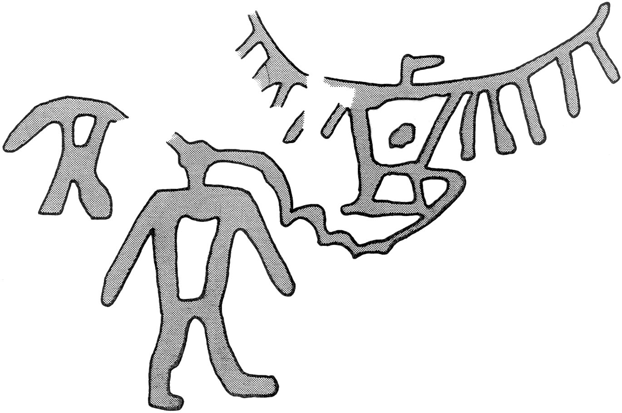
“Roche-A-Cri Rock Art Drawing”
(Courtesy of Wisconsin Historical Society, 2004).

Spring 2015

