PreK-K – give your students some items to create with and see what comes of it.
Firewood!
Next time, before you start the campfire, try stacking the firewood first!
Make sculptures. Let your child loose with their imagination.
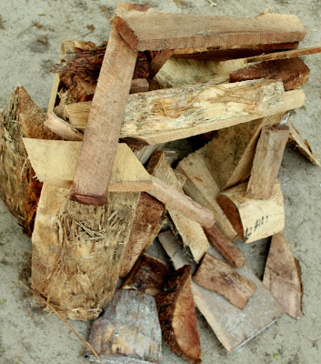
What is your child building?
… a road? … a house? … a hideout? … a tent?
Work with their imagination. Try utilizing what Jill talks about in her Mommy Fun Fact about Open Ended Questions and ask what it is they’re building instead of guessing and labeling it yourself.
Creating a firewood sculpture can provide some fun and easy learning opportunities.
Balancing the firewood takes thought and precision.
Add piece by piece in just the right place without making the entire sculpture tumble down.
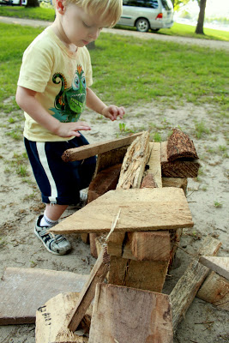
Kind of a life size Jenga game.
If there’s a piece in the wrong spot, do you dare move it?
Will it all come tumbling down?
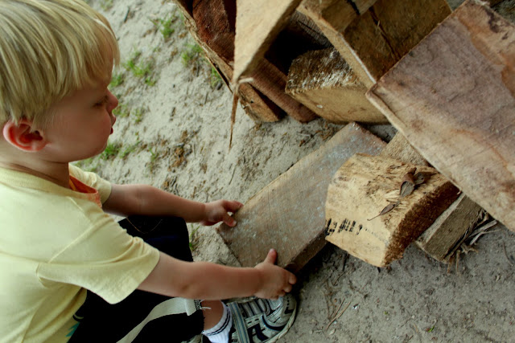
Letting your child in on the process of building teaches them how real-life structures are put together and will help them learn about stability and give them insight to why buildings are built the way they are.
Additional ideas to build off of your firewood sculpture:
- Create a small play space, add figurines and use your imagination.
- Add leaves and other natural elements [think rocks, dirt, sticks] and create a hideout!
- Line them up to build a road.
- Create letters or write your name on the ground with the pieces of firewood!

