Wausau Area (Location TBD)
- “Project Learning Tree for

Registration Information
Thanks to a WEEB grant, the workshop is only $15.00. Please call 715-498-7241 or email wcee-plt@uwsp.edu to register. The deadline to register is Friday, October 21st.

Important Details
This workshop will be spending some time outdoors. Please come dressed for the weather, and let us know if you will need special accommodations.

Secondary Educators”
Thursday, October 27th
4:00 pm to 6:00 pm

Participants in this workshop will receive hands-on training in the use of PLT’s secondary curricula, Focus on Forests, Forests of the World and Southeastern Forests and Climate Change. These guides provide an opportunity for hands-on study of forest resources while addressing concepts in biology, civics, ecology, economics, forest management, and other subject areas at the secondary level.

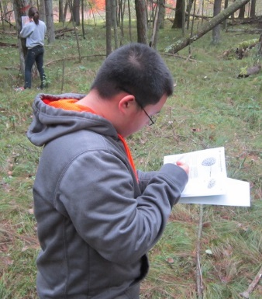
The modules are closely aligned with Common Core State Standards for Literacy in All Subjects, and special attention will be given to addressing these standards. For more information, visit https://www.plt.org/curriculum-offerings/high-school/
