HEALTHY LAKES PARTICIPATION PLEDGE 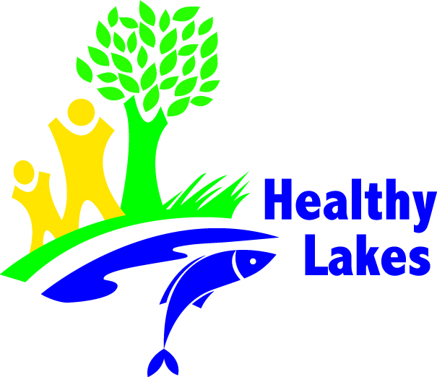

I/we Mr. and Mrs. Lake-Lover pledge to participate in Wisconsin’s Healthy Lakes initiative. More property owners implementing the suggested best practices over time may eventually add up to significant success and healthier lakes for current and future generations.

I/We pledge to work with DNR Lake Protection Grant sponsor Healthy Lakes Association to install the following best practice(s) to restore fish and wildlife lakeshore habitat and/or prevent storm water runoff and erosion. (check practices to be installed on the property)

- Fish Sticks
- 350 square feet native plantings
- Diversion practice(s)
- Infiltration practice(s)
- Rain garden

I/We understand that by signing this Pledge I/we am/are indicating a strong interest to follow through with a Healthy Lakes project on my/our property, but this is not a legal requirement to do so.

Describe Personal Participation Goal (optional):
________________________________________________________________________
________________________________________________________________________
________________________________________________________________________________________________________________________________________________

Name: John and Jane Lake-lover (please print)
Phone #: (123) – 456-7890
E-mail address: lovinglakes@yoohoo.com
Signed: John Lake-Lover and Jane Lake-Lover
Date: 01/01/2015

