Is a
Line Mechanic Career
right for you?

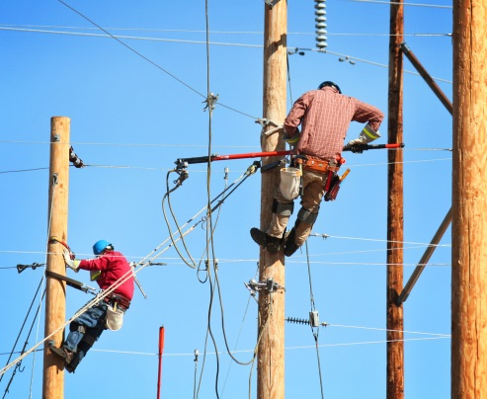

entry level positions start at $22/hour

Career requirements include:
Comfort working with heights and outdoors, the physical ability to climb poles, and be able to obtain a valid driver’s license

Find out at the Career Awareness &
Hands-On Demonstration Session.

Open to High School
Juniors and Seniors

OCTOBER 18, 2016
at

MATC Mequon Campus
5555 Highland Rd., Mequon
Parking in South Lot

If interested in participating,
please register by calling
414-297-6315

Agenda

9:00 am – Check In
Introduction Video
9:30 am – Yard Activities**
11:15 am – Debrief
11:30 am – Release (***Student Pick-Up)

**Please wear jeans, long sleeve shirt, and closed toe shoes.
***Self-arranged transportation

Students must bring the Release Form signed by a parent/guardian
to the event.

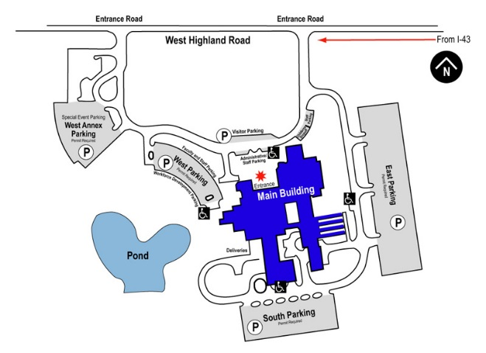
Parking
Mequon Campus Map

