**WISPER UPLOAD REFERENCE GUIDE**

Welcome to the new grant submission system called WISPER!

Please use this manual as a reference to help you along your process of grant submission.

**If a granting agency has a portal for submitting, the Principal Investigator/Project Director is responsible for uploading their grant information and/or documents on the agency portal. The final submission will take place after the WISPER record is approved. Sometimes the PI/PD does the final submission and sometimes the ORSP does the final submission – it depends on the grant.**

For federal grants, UWSP is already registered on Grants.gov and Sam.gov. Please contact the ORSP if you think you need to register on Grants.gov or Research.gov (formerly FastLane).

**Before attempting WISPER submission, please see the** [**Office of Research & Sponsored Programs (ORSP)**](https://www.uwsp.edu/acadaff/orsp/Pages/Proposal-Preparation.aspx) **website for instructions and helpful hints on gathering information for your grant proposal.**

***Please note:* The tabs *REQUIRED* to complete your submission are General, Attachments, and Approvals. Image below shows order of completion with these instructions. Put any notes under the Attachments Tab in the Attachment Notes section. Do NOT use the Projects tab.**



**2**

**3**

**1**

1. **Opening WISPER database**
   1. Go to SFS website and log in using your UWSP credentials
      1. <https://www.wisconsin.edu/sfs/> and click Take me to SFS

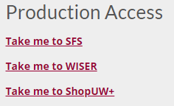

* 1. Select the tile for WISPER application

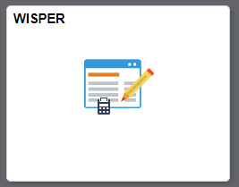

1. **Creating a New Submission**
   1. Once you have logged into WISPER you will see the main page with options along the left-hand menu and the main screen.
   2. Press the button “Create New Record”

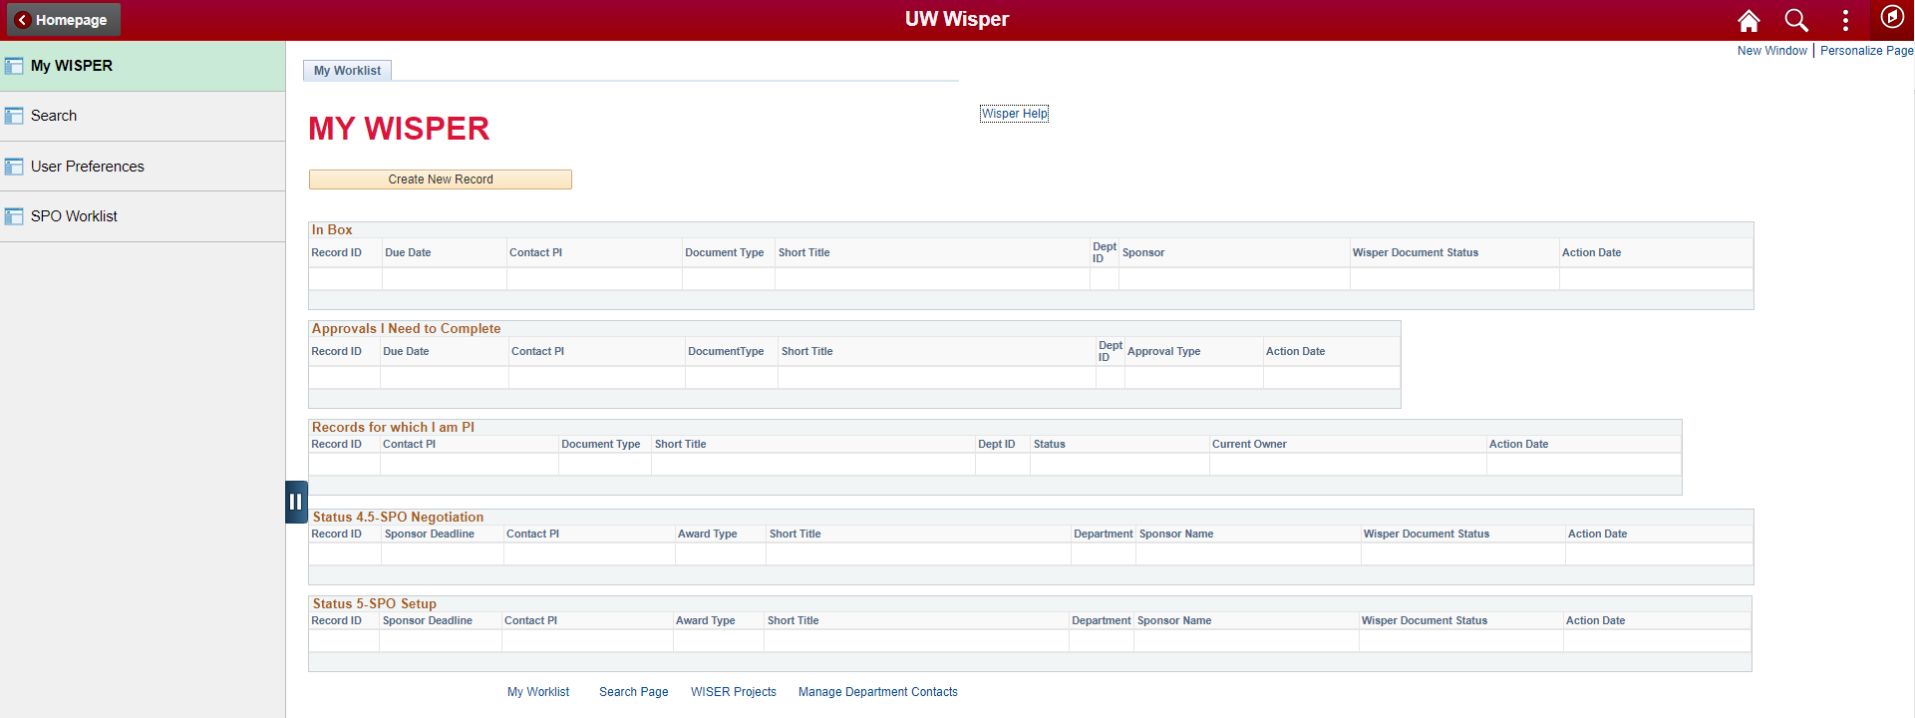

* 1. A pop-up will appear with the required info to create a new entry.

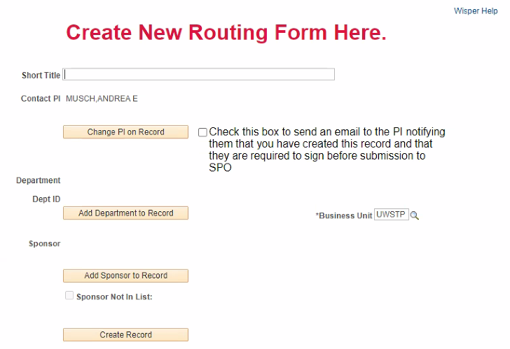

1. **Submission Entry Setup**
   1. Enter a title that will be used to distinguish your submission using the following criteria:
      1. Shortened version of your project’s full title, a distinctive aspect of the project.
      2. 30 characters or less.
   2. The system automatically lists you as the contact PI upon set up. If you are completing set up for someone else, please complete the following:
      1. Click on “Change PI on Record”
      2. A box will open allowing you to search for the intended PI in the system.

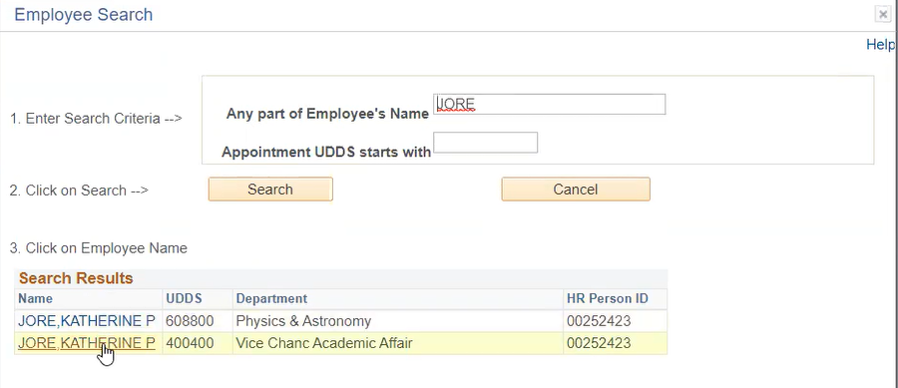

* + 1. Upon selection of the PI, you will be brought back to the main set up screen.
    2. You do **NOT** need to select the box to send an email to the PI if you are setting up for another user. An email will be sent once set up is complete to get PI signature on the proposal.
  1. Click the button reading “Add Department to Record”



* + 1. For departments you have 2 search options:
       1. Search by specific department number.
          1. Please see the listing below for optional departments under each college used for grants. Choose the one that reflects your project the most.



* + - 1. Search for a department under your college’s name if it is not listed above.
         1. Examples: Academic Affairs, CNR, COLS

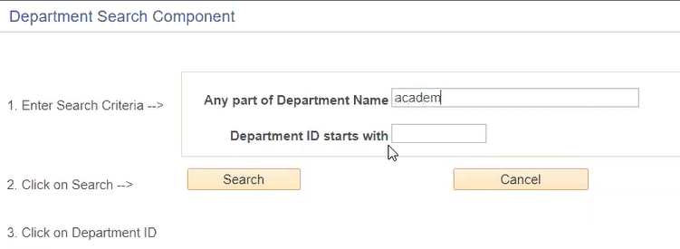

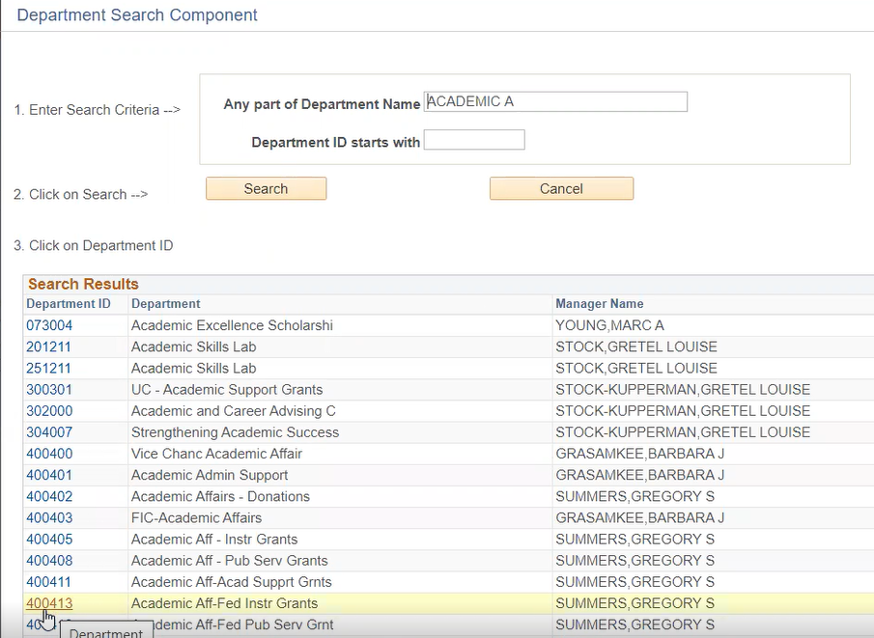

* + 1. Select the department which will be used as part of the funding string should the grant be awarded. *(Sponsored Programs Office will change any departments that may have been selected incorrectly)*
  1. Next click on “Add Sponsor to Record”
     1. If your grant is being funded by a brand-new entity, select the checkbox titled “Sponsor Not in List”. You will be given an option to add the Sponsor name in either upon selection or once the general setup has been initiated.
     2. Search for a sponsor (funding entity) using any part of its official title.
        1. i.e. Wisconsin Department of Natural Resources – Options:
           1. Natural
           2. Resources
           3. Wisconsin
           4. Department

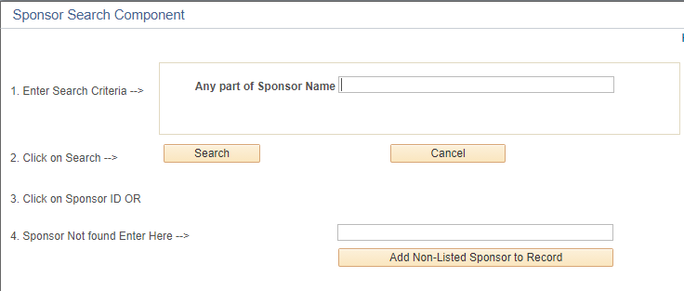

* + 1. Should your sponsor not appear in the search list, please enter the given title in #4 textbox “Sponsor Not found Enter Here -->”
       1. Upon filling in full title, please click “Add Non-Listed Sponsor to Record”
    2. If your sponsor is dispersing funds from another source, please list the initial source as the Primary Sponsor and the entity you are submitting to as just Sponsor.
       1. See also Section 4 – d – v.
  1. Your general set up will then be complete and should look like the following: 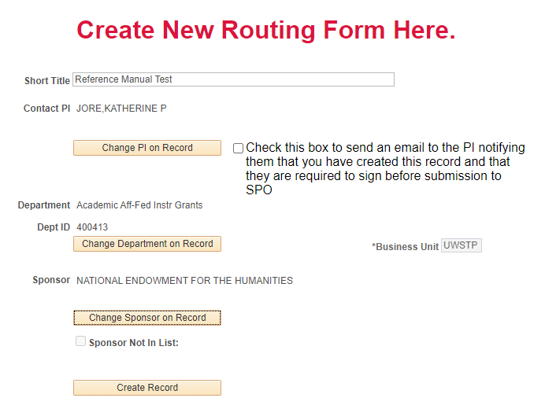
  2. Please then select to “Create Record”

1. **General Submission Detail Entry**
   1. Once your record has been created you will be brought to the “General” page of your grant submission.



* 1. The subsections of this page that need to be completed are as follows:
     1. Basic Info
     2. Submission Instructions
     3. Compliance
     4. Proposed Budget
     5. Keywords *(Optional)*

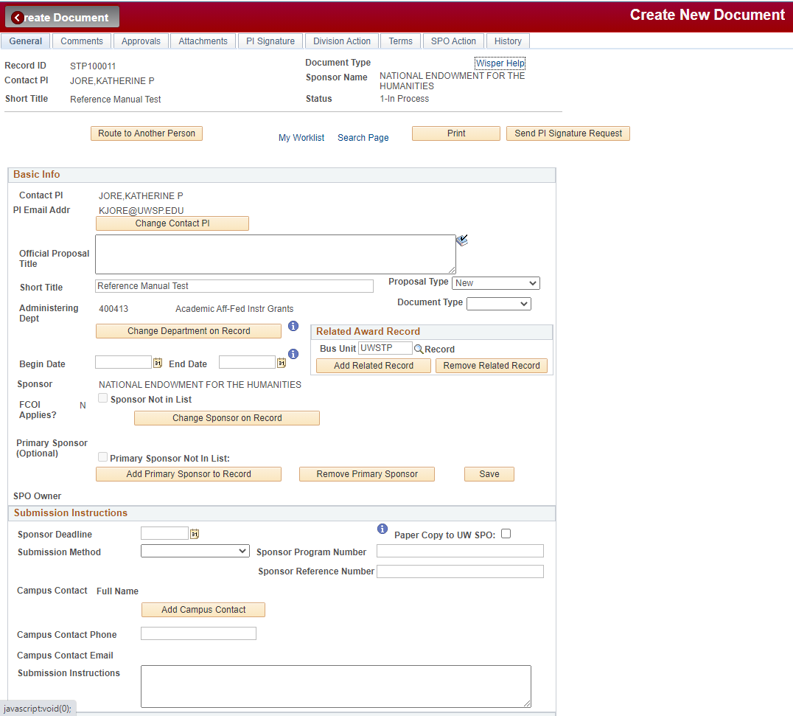

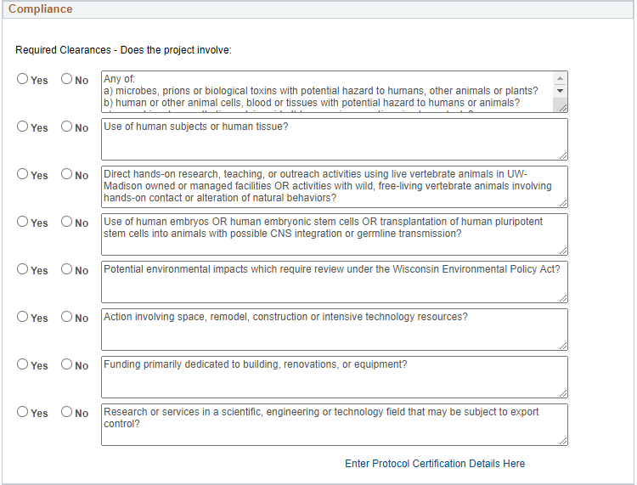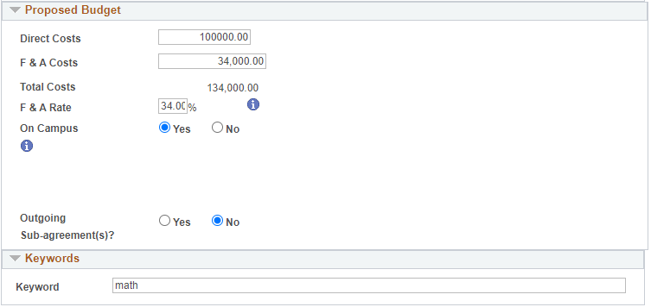

* 1. Please complete each section using the following steps:
  2. Basic Info
     1. Please verify any information already listed in this section as it is pulled from the Submission Setup
     2. Enter the full title of the grant project under “Official Proposal Title”
     3. In the dropdown menu titled “Proposal Type” please specify what category the grant falls under:
        1. Competing Continuation: Rarely applies, contact ORSP with questions.
        2. Continuation: Subsequent year awards for grants funded incrementally; for instance, “Year 2” of a multi-year proposal.
        3. **New: A funding opportunity that is not associated with any prior awarded grants or yearly submission grant.**
        4. Pre-proposal: Summary of a proposal with intent to apply for future funding opportunity.
        5. Resubmission: Submission of a grant previously denied.
        6. Revision: Submission of a grant previously submitted but needing adjustments to the structure of the grant.
        7. Supplemental: Additional funding for an already submitted grant.
     4. Enter the intended Start and End dates for the proposed grant project
     5. Primary Sponsor – If a secondary agency is providing funding through your Sponsor, you would enter the main funding source as the Primary Sponsor.
        1. i.e. The USDA granted WI Department of Natural Resources funds for a project and you are applying to the WDNR for funds.
           1. USDA would be your Primary Sponsor
           2. WDNR would be your Sponsor



* 1. Submission Instructions



* + 1. Sponsor Deadline: Enter date in which grant must be submitted to funding agency for review.
       1. If UWSP is a subrecipient, please enter the deadline that the Sponsor needs your documents by, which is usually at least a week before the Primary Sponsor’s deadline.
    2. Submission Method: Select which method the final approved grant proposal is submitted through for funding agency review.
    3. Sponsor Program Number: If listed in the Request for Proposals (RFP) – *optional*.
    4. Sponsor Reference Number: Leave blank when creating the record. It is the number the agency assigns to an award.
    5. Campus Contact: Optional for separate contact other than PI.
    6. Submission Instructions: Here you will specify if the PI will be submitting the finalized proposal or if they wish for the ORSP to complete the submission through the listed method. *(Most federal submissions must be submitted by the ORSP)*
       1. Please enter similar wording of one of the following into the comments box:
          1. PI will submit approved grant themselves through given submission method
          2. PI wishes to have the ORSP office submit approved grant for them with given submission method

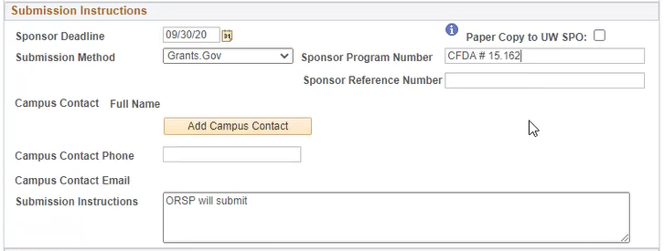

* 1. Compliance
     1. Please review and answer either “Yes” or “No” to the safety compliance regulations listed.
        1. If you select “Yes” to any of the first 4 questions, please select the blue hyperlink titled “Enter Protocol Certification Details Here”

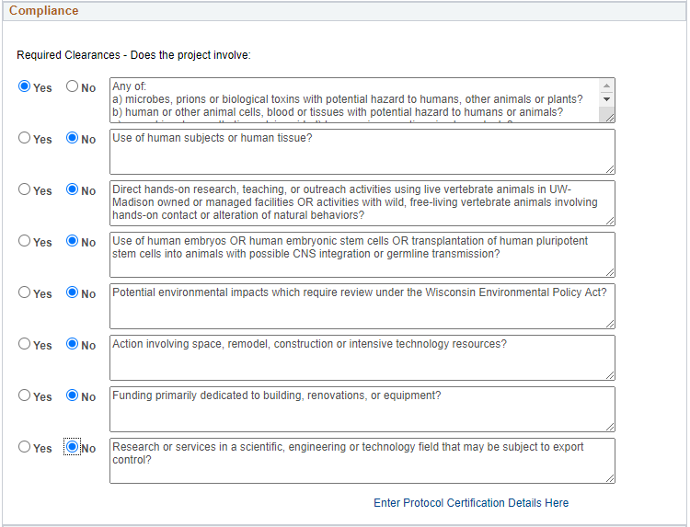

* + - 1. Select in “Approval to Add” dropdown which Protocol you will be entering above.
      2. Enter the Name/ Number of your given protocol approval
      3. Select the status of said protocol if it is “Approved”, “Denied”, or “Pending”
      4. Enter the approval and expiration dates to the requested protocol
      5. Select “Add Approval”
      6. Hit “Return” to go back to the General page.

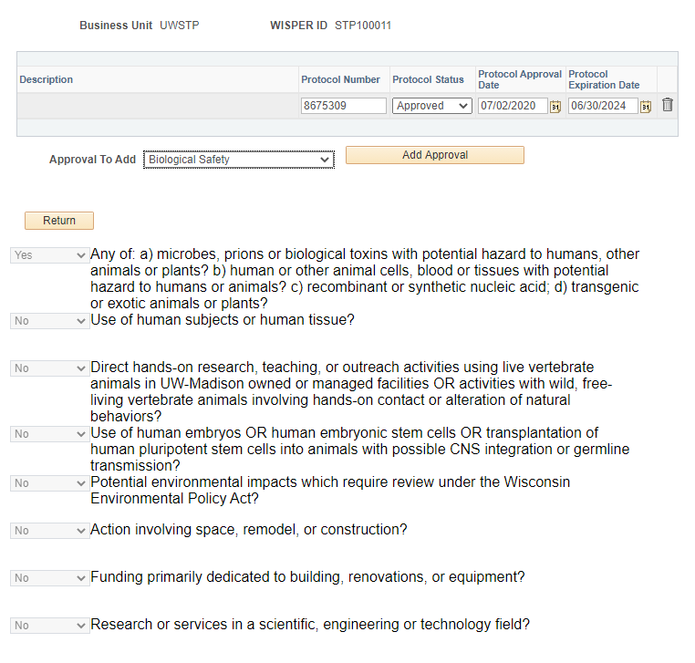

* 1. Additional Senior Personnel – LEAVE THIS SECTION BLANK FOR NOW. It is causing issues with TERs.
     1. ~~This section is for Co-PI’s to be entered. Search for and select individuals just as was done in step 2-b-ii~~

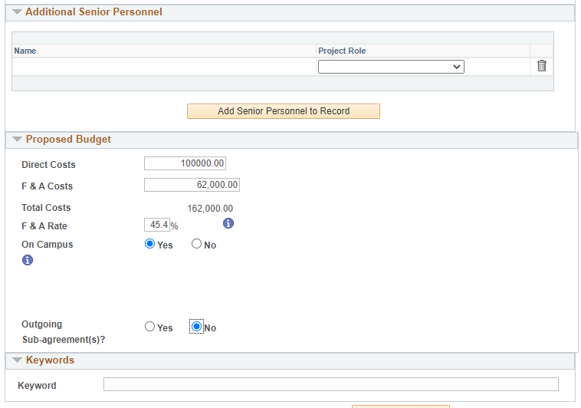

* 1. Proposed Budget
     1. Enter the total of direct costs in the proposed budget
     2. Enter total amount of **indirect/F&A costs** in proposed budget (F&A Costs are also known as Facilities & Administrative Costs or Indirect Costs)
     3. Enter the agreed upon **indirect cost/F&A rate** between university and funding entity
        1. If you are unsure of the rate please see the link below for more information.
           1. <https://www.uwsp.edu/acadaff/orsp/Documents/Indirect%20Cost%20Rate%20Agreement%202020-2024.pdf>
     4. Select whether there are subawards to be dispersed within the proposed budget.

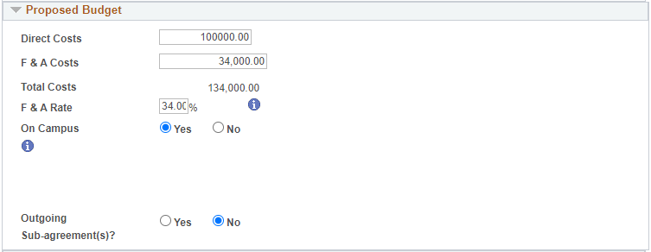

* 1. Keywords
     1. This section is available to add searchable keywords but is not a required step. If you have numerous grants within a singular entity, this keyword section will be of use to quickly single out the grant more quickly.



* 1. Upon completing all needed sections, please press “Save” before moving to the next page tab.

1. **Attachments**
   1. Below the page’s red banner please select the tab labeled “Attachments”



* 1. This tab provides the location to upload all documents requested by the funding entity and the ORSP.

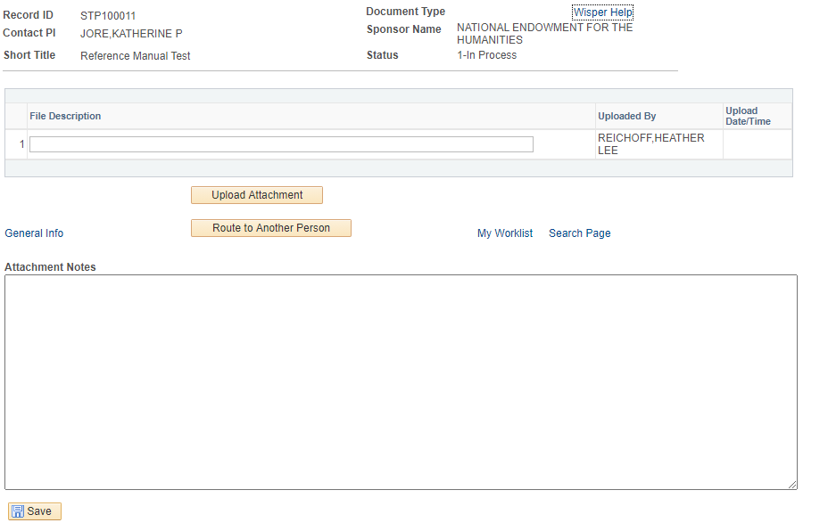

* + 1. Enter the file description in the given box
    2. Select “Upload Attachment” to open and browse your computer for documents needed to submit your grant for final approval
    3. The “Attachment Notes” section allows for any additional information needed regarding the attachments or the project. **Please enter any comments under “Attachment Notes” under the Attachments tab instead of under the Comments tab.**
       1. For the full list of **REQUIRED** attachments for grant submission please see the **External & UW System Support WISPER Attachments Checklist**:
          1. <https://www.uwsp.edu/acadaff/orsp/Pages/Forms-Documents-and-Resources.aspx>
          2. Please note that your proposal will be pushed back if all the required documents are not attached.

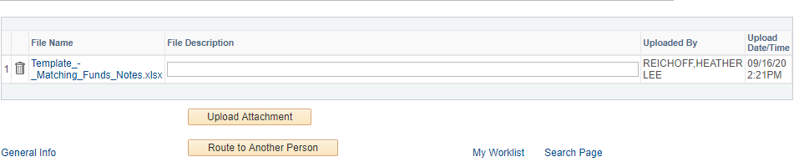

* 1. Upon completing all needed attachments, please press “Save” before moving to the next page tab.

1. **PI Signature**
   1. Once all sections and pages of the submission are complete and saved, please return to the General page tab.
   2. At this point you as the PI or the individual listed as the PI will need to sign the grant proposal before sending it off for review and approval.
      1. If you are the PI:
         1. At the top of the General page along the left side of the box reading “Route to Another Person” there should be a blue hyperlink stating, “Sign the Record”. Click the hyperlink. 
      2. If you are submitting for the PI:
         1. Select at the top right of the General page “Send PI Signature Request” and then select to “Send Email” on the pop-up.



* + 1. The PI will be routed to the PI Signature page which will list 2 signature requests.
       1. For submission of the proposal please sign and complete the first section titled “Principal Investigator Signature for Proposal”.

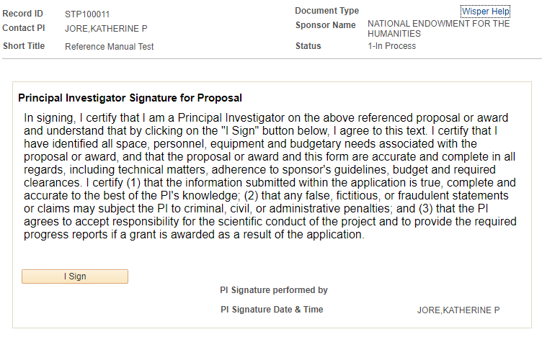

* + - 1. **It is recommended to sign both options at time of proposal creation.** However, the 2nd signature can be completed when the grant is awarded.

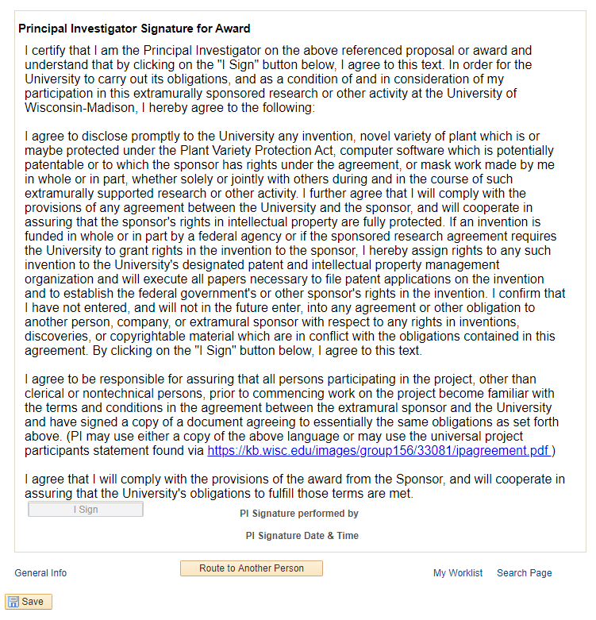

1. **Approvals**
   1. Upon completion of the PI’s signature, please select the Approvals tab if approvals are needed before your Dean’s or Line Officer’s approval.



* 1. Click “Initiate New Approval Request” to route the proposal on to the next person required in your College’s procedures.

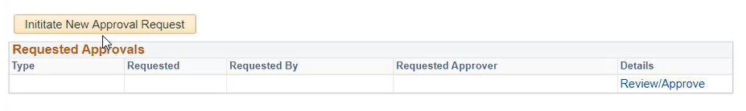

* + 1. Please consult with your Dean’s Office for list of require reviewers.
  1. Select the drop-down menu to choose the desired approval signature needed per your College. “Additional Dept Review” is fine.

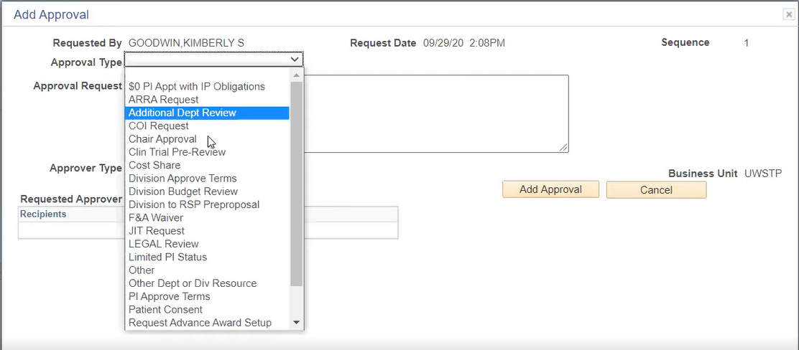

* 1. After choosing your approval type, then select the appropriate employee from the search. You may change the comments in the Approval Request box.

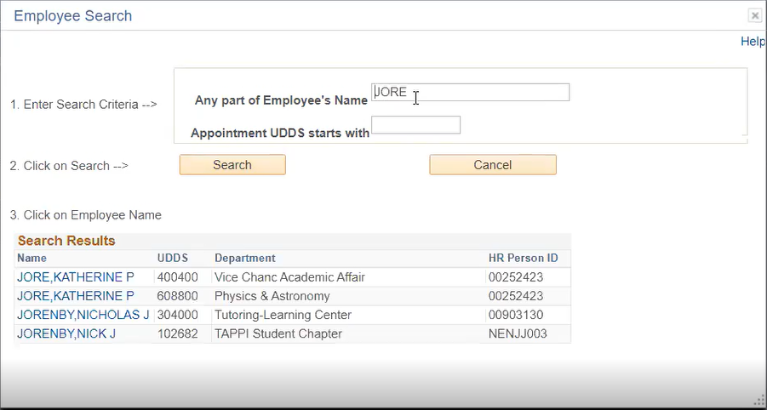

* 1. Click “Add Approval.” **Save and await approval from requested reviewer before routing it to your College or Division.** You should receive an automatic email after it is approved.

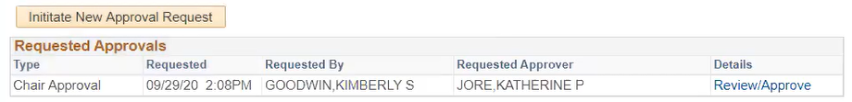

* 1. This process will repeat as necessary to complete your College’s delegated **internal** authority structure.
  2. Once the internal reviews have been completed, you will send the proposal to your College or Division (Dean or Line Officer) for final approval.



* + 1. Return to the General page to select the “Route to Another Person” button in the top left corner of the screen.

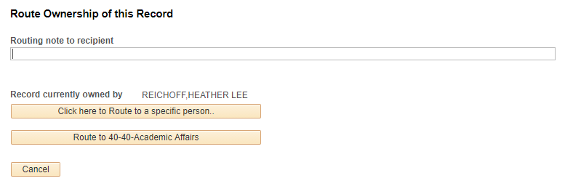

* + 1. You will receive a prompt with the option to write a note to your Dean or Line Officer before routing, which is not required.
    2. **Select the button to route to your College or Division (ex. 90-College of Natural Resources). Do not send it to a specific person’s name.**
    3. Upon selection of your College or Division, you will be prompted with a confirmation box to hand over control of the submission for full review.

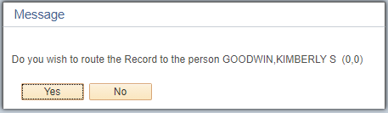

1. **History**



* 1. If at any time during or after submission you want to review the status of the grant or what has been completed, please select the History page tab which will give you a listing of events for the grant.

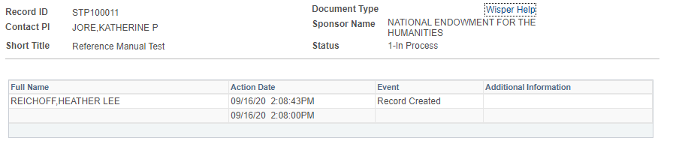

**If at any time you continue to have difficulties or an error occurs, please contact the ORSP at** [**office.of.research.and.sponsored.programs@uwsp.edu**](mailto:office.of.research.and.sponsored.programs@uwsp.edu) **for assistance or further training. Thank you!**